Avoiding faulty Pronoun Reference

A pronoun is a word used to stand for (or take the place of) a noun. It should refer clearly to one, clear, unmistakable noun coming before the pronoun. This noun is called the pronoun’s antecedent. Unfortunately, it is very easy to create a sentence that uses a pronoun WITHOUT a clear, unmistakable noun antecedent.

Clear Pronoun Reference

Do not use the pronouns this, that, which, and it without a clearly stated antecedent.
Unclear: Nina will sing at the assembly, which I always enjoy.
Clear: I always enjoy Nina’s singing at the assembly.
Sometimes a pronoun will seem to have more than one antecedent. In such instances, reword the sentence to make the antecedent clear or omit the pronoun.
Unclear: Raji had the wrestling advantage over Bob because he was heavier. (Raji or Bob could be the antecedent of he)
Clear: Raji, because he was heavier, had the wrestling advantage over Bob. (Raji is the antecedent of he)
Clear: Heavier than Bob, Raji had the wrestling advantage. (pronoun is eliminated)
The pronouns you and they should not be used as indefinite pronouns. Instead, name the performer of the action.
Indefinite: When the Hallelujah Chorus is performed, you should rise.
Clear: When the Hallelujah Chorus is performed, the audience should rise.
Clear: When the Hallelujah Chorus is performed, everyone should rise.

Example: 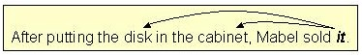
The pronoun it does not have a clear noun antecedent.
As a result, the reader cannot know for sure whether Mabel sold the disk or the cabinet. The pronoun reference is faulty here because the pronoun it has two antecedents.
Such errors, called FAULTY or VAGUE PRONOUN REFERENCE, can confuse readers and obscure the intended meaning.
There are three major pronoun reference errors.
Error #1: TOO MANY ANTECEDENTS
A pronoun should have only one antecedent. That antecedent should be clear and unmistakable.
Look at this sentence: 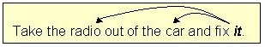
Anyone who reads this sentence would not know which item was to be fixed.
Does it refer to the radio or the car? The answer is unclear.
In the above example, faulty pronoun reference occurs because the pronoun it has two possible noun antecedents.
To fix the sentence, substitute a noun for the pronoun.
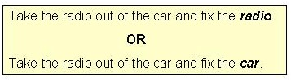
Here is another example of faulty pronoun reference caused by more than one noun antecedent:
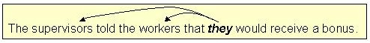
The pronoun reference is unclear: Who will get the bonus - the supervisors or the workers? They could refer to either group.
In this example, the best way to fix the pronoun reference problem is to rephrase the sentence.
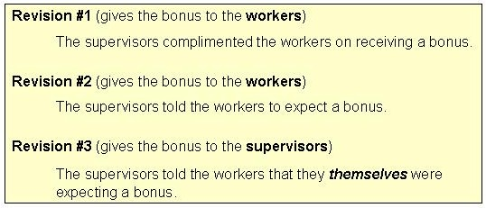
Error #2: HIDDEN ANTECEDENTS
Faulty pronoun reference errors also occur when the pronoun's antecedent functions as an adjective rather than a noun.
In such cases, the true antecedent is "hidden" or obscured from the reader because it has been subordinated to another noun.
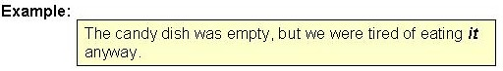
The reader of this sentence might think that the dish was being eaten because dish appears to be the antecedent for the pronoun it.
Obviously, people do not eat dishes. What this writer means to say is, "We were tired of eating candy."
However, candy cannot be the antecedent for it because candy, situated in front of the noun dish, is acting like an adjective. Only nouns can be antecedents.
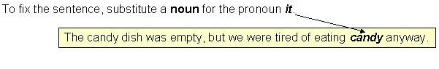
Here is another example of faulty pronoun reference caused by a hidden antecedent:
Obviously, she refers to Mary since a house would NOT be able to answer a phone.
However, Mary's modifies house - Mary's is a hidden antecedent and, thus, is not clear.
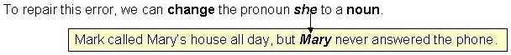
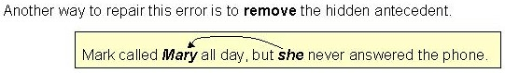
Still another way to repair this error is to rephrase the sentence. 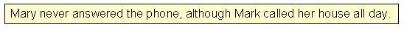
Error #3: NO ANTECEDENT AT ALL
Another kind of faulty / vague pronoun reference problem occurs when writers use a pronoun without giving the pronoun any antecedent at all.
Example:
In this example, the pronoun they has NO noun antecedent to which it can refer.
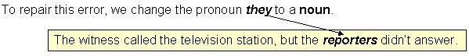
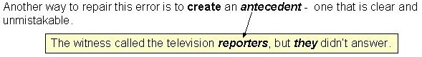
Here is another example of a pronoun without any antecedent at all.
In this example, the pronoun it has no antecedent to which it can refer.
The reader knows that Mrs. Smith is "wealthy," but it cannot refer to wealthy because wealthy is not a noun.
There are at least two ways to repair this error.
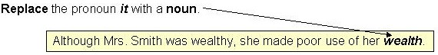
With a noun (wealth) in the place of the pronoun (it), no antecedent is needed.
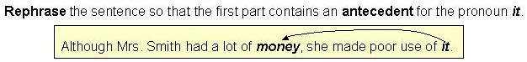
Now the pronoun it has a clear noun antecedent: money.
Here is another example of a pronoun without any antecedent.
It, which appears at the very beginning of the sentence, has no noun antecedent at all. In addition, the construction It says in the paper is unnecessarily wordy.
We can repair this error by writing a more DIRECT version of "It says in the paper."
Example:
Another way to repair the "It says in the paper" error is to rephrase this part of the sentence.
Example:
Both methods of repairing this faulty/vague pronoun error eliminate the pronoun and, thus, eliminate the need for an antecedent.
Below, another example shows how this error in pronoun reference occurs when a pronoun is used to stand for (refer to) a whole group of words INSTEAD OF one clear noun antecedent.
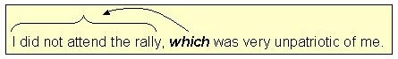
The word which has no single, clear antecedent.
Instead, it refers to the entire clause - "I did not attend the rally."
However, a pronoun must always refer to a single, clear, unmistakable NOUN ANTECEDENT.
We can repair this error in at least two ways.

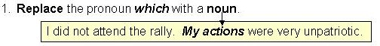
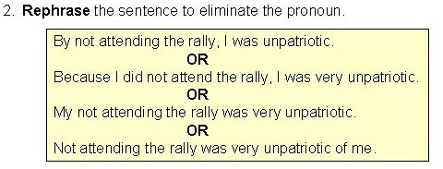
Here is another example of faulty pronoun reference where a pronoun is asked to refer to a whole group of words instead of a clear, single noun antecedent.
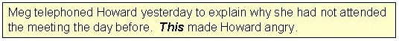
The problem here is This. Its antecedent is the entire preceding sentence.
The reader cannot be sure whether Howard is very angry because:
1. Meg telephoned,
2. Meg telephoned yesterday, or
3. Meg had not attended the meeting the day before.
There are at least two ways to repair this error and create a clear antecedent for this:

