First Term Oral Expression Examination
Name: ………………………………………………........... Group: …. Score: …..……../20
Setif 2 University, Faculty of Arts & Languages  English Department  Teacher: S. Mekhoukh | Date: ………… Time: …… Venue: Lab ………  2nd Year BA Level Academic year: 2023-2024  Time allotted: 45 minutes

Instructions: Copy down the answers in the grid below by shading the small circles fully. Do not fold or bend the sheet. Use pencil or dark pen. Do not use highlighters or light colours. Do not scribble, nor exceed the space provided. Read the questions carefully before you listen to the audio clips. The questions on the paper are not necessarily the same you hear in the recording. Choose only one option.
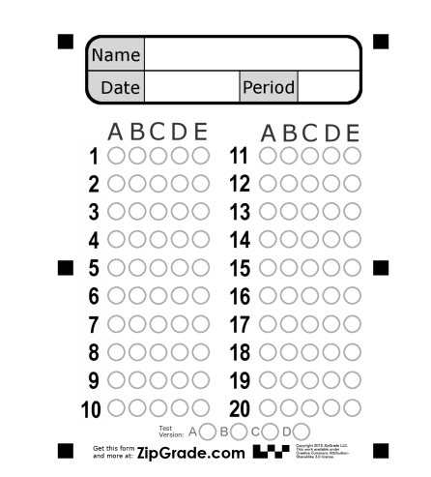

Part One
Listen to Katie and Donnie talking about shopping habits. Decide whether the following statements are A. True, B. False, or C. Not mentioned. Circle the right option. Listening task 1 Zappenglish.com (6 points)

- Katie thinks shopping is not that amusing. | A B C
- Katie go to one supermarket to do the shopping. | A B C
- Donnie is happy that he doesn’t have to do the shopping as he used to do in the past. | A B C
- Donnie has some good memories about old ads as a child. | A B C
- Katie and Donnie share the same point of view concerning their shopping habits. | A B C
- Both Katie and Donnie talked did their shopping from different shops. | A B C

Part Two

You are going to hear a conversation between four people discussing their New Year’s resolutions. Circle one best answer. Listening Task 5[begins at 09:29 - ends at 14:30] (4 pts)

- Donnie, Katie, Emma and Tom talked about:
- New Year’s Eve in USA
- New Year’s Eve in UK
- New Year’s Eve in the world

- Donnie and Emma could never achieve their new year’s resolutions, because:
- They are not achievable
- They are too many
- They are not serious about them

- Tom decided to:
- quit smoking
- go on a diet
- exercise regularly

- Which thing does Katie love?
- yummy food
- stuffed stockings
- decorations and ornaments

Part Three

Choose one best option (10 points)

- My friend Sheila is so cheerful and friendly, but sometimes she can be …
- a bit blunt
- really blunt
- so blunt
- not very blunt
- ‘I’m shivering! It’s quite nippy here!” ‘nippy’ is a slang word which means:
- cold
- hot
- mild
- unpleasant
- ‘pavement’ in American English is:
- side talk
- sidewalk
- pedestrian
- zebra
- lane
- ‘The others’ is a case of euphemism, which refers to:
- The other side of the globe
- People
- Aliens
- Spirit and ghosts
- A fortnight means:
- Ten days
- Four nights
- Fifteen days
- One night

- In Wh-questions, you can use:
- a rising tone
- a falling tone
- a fall-rise tone
- a rise-fall tone
- a level tone
- Which is the appropriate chunking:
- I woke/ up in the middle of/ the night lit the lights on and/ looked for my mobile under my bed.
- I woke up in the middle of the night/ lit the lights on/ and looked for my mobile/ under my bed.
- I woke up in the middle of the night lit the lights on/ and looked for my mobile under my bed.
- “The homework assignments are such a pain in my neck!”. It means:
- they are annoying
- they are easy to do
- they are difficult to do
- ‘In-laws’ is a gender-free word for:
A. Parents-in-law
B. Sisters-in-law
C. Brothers-in-law
D. All of them
20. “Let’s bury the hatchet” means:
A. Let’s forget the past
B. Let’s have party
C. Let’s go to the cemetery

Good Luck!

