Lec4

**Deductive vs inductive research**

Two main research approaches are distinguished: inductive and deductive approaches. Understanding induction and deduction requires considering the notion of theory.

Theory is a term central to the understanding of approaches.

**Deductive research:**

In deductive approach, the deductive reasoning is prioritised. First, researchers draw on theory to formulate a hypothesis; then, they seek to confirm or disconfirm it by observing specific cases. Data collected through this process will help in testing the hypothesis. It is also important in deductive approach to consider the generalizability of the results to other similar situations. *Confirmatory research* and *hypothesis-testing* research are other names used sometimes to refer to deductive research.

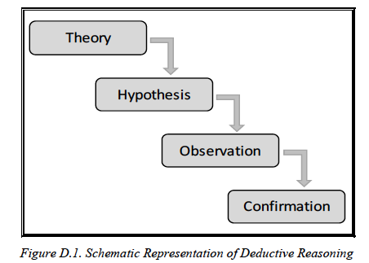

**Inductive approach:**

In this approach, theory is generated after data is collected and analysed. No relationships are confirmed or hypotheses are tested. Instead, research starts with the examination of particular cases, and then regularities are identified and general patterns emerge. Only after this, that possible hypotheses can be set to from a starting point for a deductive research. Hypothesis-generating research is another term used to refer to inductive research. This approach is associated with qualitative research.

