Mohammed Lamine Debbaguine University
English Department
Module: Phonetics Level 1st year LMD

Chapter Five: Phonemes and Symbols
1 .The Phoneme
Let’s consider the following questions:
What do we mean when we use the word "sound"?
How do we establish what are the sounds of English, and how do we decide how many there are of them?
In studying speech we divide this stream into small pieces that we call segments.
We can divide speech up into segments, and we can find great variety in the way these segments are made.
Just as there is an abstract alphabet as the basis of our writing, so there is an abstract set of units as the basis of our speech. These units are called phonemes, and the complete set of these units is called the phonemic system of the language.
- phoneme: a distinctive sound in a language capable of creating a distinction in meaning between two words /d/ dog /l/ log /f/ fog
One more technical term needs to be introduced: when we talk about different realisations of phonemes, we sometimes call these realisations allophones.
- t in the word 'tea' is aspirated .
- In the word 'eat', the realisation of t is unaspirated

phonemes | allophones
cat rat  cat cot  cat cap | top stop  pie spy  care scare

Phonemic Analysis
• A phoneme is a contrastive sound in a language
  - It may be used to distinguish between words in minimal pairs.
• Allophones are phonetic variants of a phoneme
  - Different allophones often occur in specific contexts.
- Phoneme: /t/
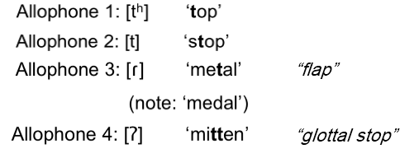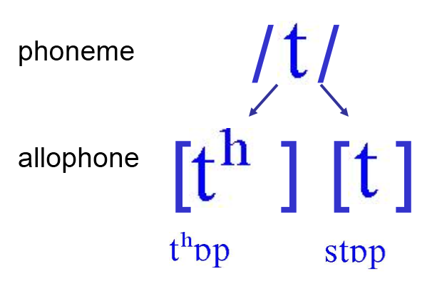
2 , Symbols and Transcription

Broad transcription (Phonemic transcription ) | Narrow transcription (Phonetic transcription )
- Represent only contrastive sounds (phonemes)  - Generally use only alphabetic symbols  - If you’re spelling out the (abstract) phonemes, use slashes: / / | - Capture as much phonetic detail as possible about the quality of sounds (PHONES)  - Generally require use of diacritics which are marks that modify the symbol in some way  - whenever you write out a phonetic transcription, enclosed the IPA symbols in brackets: [ ]

3. Phonology:
Phonetics: the comparatively straightforward business of describing the sounds that we use in speaking.
(Phonetics: studies the physical characteristics of sounds)
Phonology: When we talk about how phonemes function in language, and the relationships among the different phonemes - when, in other words, we study the abstract side of the sounds of language.
(Phonology describes the organization of the sound system of a language)
Only by studying both the phonetics and the phonology of English is it possible to acquire a full understanding of the use of sounds in English speech.
Study of the Phonemic System
It is sometimes helpful to think of the phonemic system as being similar to the set of cards used in a card game, or the set of pieces used in a game of chess. In a similar way, we have a more or less fixed set of "pieces" (phonemes) with which to play the game of speaking English. There may be many slightly different realisations of the various phonemes, but the most important thing for communication is that we should be able to make use of the full set of phonemes.

Phoneme sequences and syllable structure

In every language we find that there are restrictions on the sequences of phonemes that are used. For example, no English word begins with the consonant sequence zbf and no word ends with the sequence {h. In phonology we try to analyse what the restrictions and regularities are in a particular language, and it is usually found helpful to do this by studying the syllables of the language.
Suprasegmental phonology

Many significant sound contrasts are not the result of differences between phonemes. For example, stress is important: when the word 'import' is pronounced with the first syllable sounding stronger than the second, English speakers hear it as a noun, whereas when the second syllable is stronger the word is heard as a verb. Intonation is also important: if the word 'right' is said with the pitch of the voice rising, it is likely to be heard as a question or as an invitation to a speaker to continue, while falling pitch is more likely to be heard as confirmation or agreement. These examples show sound contrasts that extend over several segments (phonemes), and such contrasts are called suprasegmental. We will look at a number of other aspects of suprasegmental phonology later in the course.
