Source 1 : “The Fruits of Temperance”

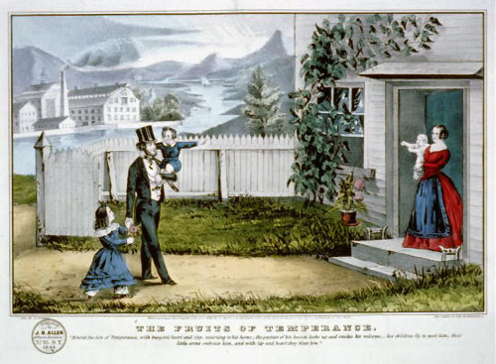

Source 2: “The Bar of Destruction”
Harpers Weekly
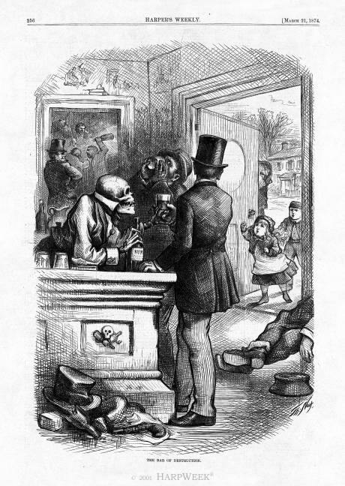

Source 3: “Women’s Holy War”
