University Mohamed Lamine Debaghine Setif 2
Faculty of Letters and Languages
Department of Letters and the English Language

Educational Psychology
Master 1 (Semester 1)
Presented by: Dr. ALMI

Introduction
- Educational psychology is a branch of psychology concerned with human learning (how it occurs and what it involves).
- It is concerned with teaching and instructional procedures, students’ outcomes and educational issues.
- Educational psychologists study how different variables influence individual students outcomes and academic achievement.
- They address topics and issues such as learning disabilities, giftedness, the instructional process and individual differences.
- “Educational psychology makes a psychological study of human development, maturity and learning, and applies the scientific conclusions of this study to actual teaching conditions to attain the ends of education.”
- Educational psychologists investigate mental processes and the changes that occur in individuals’ behaviours as consequences of undergoing various stages of development from childhood to adulthood via interacting with the environment.
- Educational psychology is a normative science that attempts to provide rational descriptions and explanations of individual differences in behaviour, intellect, personality and self-concept. The field depends on empirical findings yielded by testing, assessment, measurement, evaluation and training to optimise scholastic achievement.
- Educational psychologists are working side by side with psychiatrists, social workers, teachers, speech and language therapists, and couselors in an attempt to understand the questions being raised when combining behavioural, cognitive and social psychology in the classroom settings.
- Educational psychology intersects with multiple disciplines including
- philosophy,
- sociology,
- cognitive psychology,
- neuroscience,
- biology,
- medicine
● It equally informs various specialities within academia like
► instructional design,
► classroom management,
► the enhancement of educational technology,
► learners’ needs analysis,
►curriculum design,
► coping with students with special needs and leaning deficits.

2. The Major Learning Theories
- Learning is the process of acquiring new understanding, knowledge, behaviors, skills, values, attitudes, and preferences.
- The major learning theories include :
- Behaviourism.
- Cognitivism.
- Social-constructivism.

2.1. Behaviourism
Behaviourism, or the behaviourist approach, is an influential conceptual framework that dates back to the late 19th century. It is a systematic approach that scrutinizes learning in terms of the behaviour of animals and humans.
The fundamental principles underlying this learning theory are: :
- the association between observable behaviour (responses) and environmental events (stimuli),
- the consequences of rewards and punishments in the reinforcement of the way one acts.

Behaviourists generally ignore any mentalistic explanations based on thinking processes, and essentially consider environmental factors affecting behavioural changes in humans and animals. They define learning as a permanent change in behaviour as a result of experience. Behaviourists explained learning through the study of what is called classical conditioning and operant conditioning.

2.1.1 Classical Conditioning (Pavlov and Watson)
a) Pavlov’s Experiment with Dogs
● The Russian Psychologist conducted a laboratory experiment on dogs to observe their behaviour with food
- Pavlov noticed that dogs can salivate (unconditioned response) in the presence of food (unconditioned stimulus).
- Pavlov tried to induce salivation by means of ringing a bell (neutral stimulus); there was no response (unconditioned response).
- Pavlov paired food with ringing the bell (conditioned) which provoked salivation (unconditioned response).
- Pavlov finally found that using the bell alone (conditioned stimulus) induced salivation (conditioned response).
- So, Pavlov is said to have conditioned dogs to salivate.

b) Watson’s Experiment with Albert
- In 1925, The American psychologist John Watson conducted an experiment on an 11 month baby called Albert.
- At the beginning of the experiment, Albert never fears a a rat.
- Watson started to associate the appearance of a rat with a loud frightening noise.
- After a number of repititions, the apperance of the rat alone was sufficient to frighten the infant.
- Therefore, the loud noise classically conditioned the behaviour of Albert to show fear as a response to the appearance of rat.

2.1.2. Operant Conditioning (Punishment and Reinforcement)
- The American psychologist B.F. Skinner explained that someone’s behaviour is determined by the consequences of his acts.
- if act that leads to desirable consequences is positively reinforced (rewarded), it is highly likely that it is sustained (re-occurs again).
e.g. a mother who gives her son a praise or gift for doing homework may encourage him to sustain suh a habit.
- If an act that leads to unwanted outcomes is negatively reinforced (punished), the frequency of its re-occurrence decreases.
- e.g. A father is yelling at his child because he puts his fingers in the outlet to discourage such a bad behaviour; it would push the child to give up such a dangerous habit.

2.2. Cognitivism
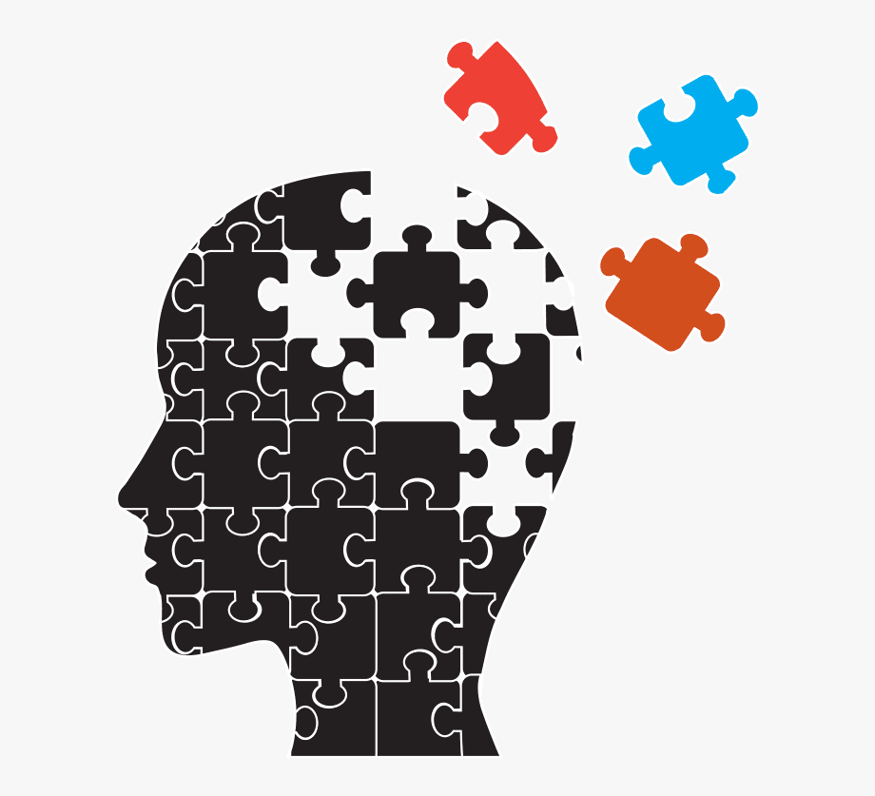

- cognition was defined as “thinking and the mental processes humans use to solve problems, make decisions, understand new information or experiences, and learn new things.”
- The cognitive approach, or shortly cognitivism, is a theoretical framework established in psychology that regards learning as information processing.

- By the late 1950s, psychologists started raising questions about what goes on in one’s mind to find out how humans process and store information as characteristic features of the learning process.
- This shift in focus, that reached its momentum in the 1970s, was recognized as the cognitive revolution; it was stimulated by reactions against behaviourits’ neglect of the fact that learning depends on intellectual or mental processes such as perception, reasoning, memory, building schemas, problem-solving, and intelligence.
- the fundamental issues that motivate cognitive enquiry include:
1.it is crucial to explore the nature of information processing, and to uncover the capacities and limits of memory.
2. As far as acquisition is a focal point in cognitive enquiries, it is necessary to comprehend the structure and organization of memory. How is knowledge mentally represented?
3.learners require taking control over their learning, so how could people be adequately aware (metacognition) of their own learning.
4.Learning is not conceived as a linear process during which people incrementally add to their knowledge; rather, it is a cyclical process of constantly going back to already established concepts that need to be refined or adjusted for misconceptions.

2.2.1. Piaget’s Theory of Cognitive Development

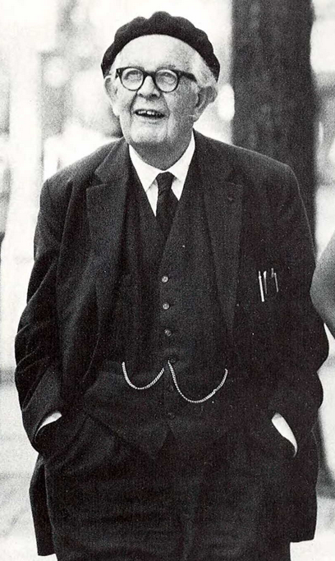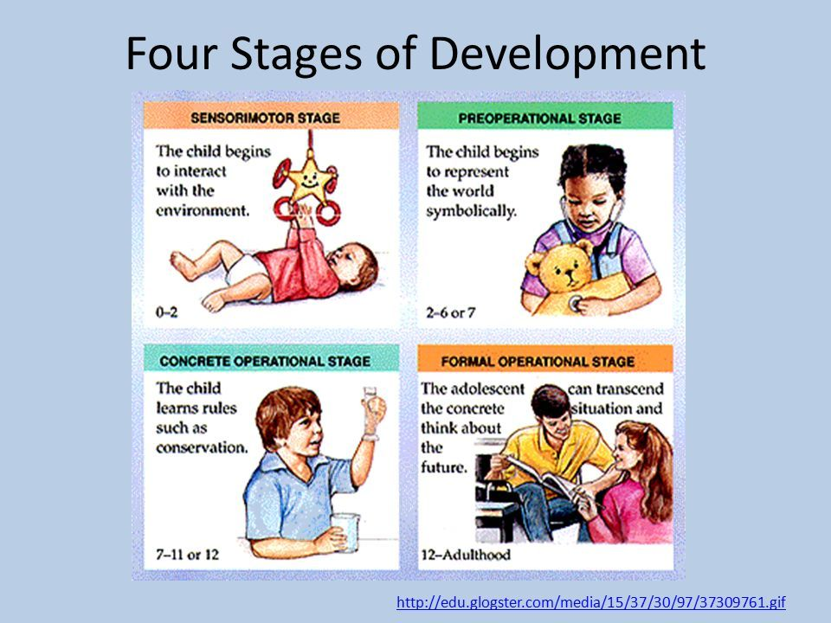

- The Swiss psychologist Jean Piaget (1886-1980) conducted a long-term scientific study examining the way in which children construct knowledge, a work that laid the foundations of cognitive development research.
- Piaget explained that children, from birth to about the age of 16 years, undergo a sequence of four cognitive developmental stages. Each stage is characterized by a particular way in which the child understands and interprets the world.
1- The sensory-motor stage
(birth to 2 years):
- This stage lasts from birth to the start of language acquisition.
- At the beginning, infants interact with the world via reflexes such as ‘the sucking reflex’.
- Afterwards, the infants start to depend on sensory motor activities through linking experiences (e.g. sight and touch) with physical interaction to explore the world and learn what they are capable of doing.
- By the end of the stage, they acquire an ability to imitate and integrate information to build knowledge of the world (a 2 years old child can use objects to refer to other objects; for instance, using a cup to represent a boat in a game).
- A key feature of this stage is the development of the concept of ‘object permanence’;i.e, infants become aware of the existence of objects even though they are out of the field of vision. This implies that they have developed mental representation of objects.
2- The pre-operational stage
(2 to 7 years):
- It is featured by a boost in language development, the use of symbols and internal representations, and the reliance on imagination.

- The children’s thinking is constrained by egocentrism— children perceive the world only from their perspectives and barely understand other perspectives.
- 2. The intuitive phase (4 to 6 years):
- characterized by acquiring an ability to mentally classify objects (e.g. animals).
3- The concrete operational stage
(7 to 12 years):
- Children develop strategies to mentally operate on concrete things. For example, a child can solve problems they can notice or manipulate (e.g. multiplying 71 x 22).
4- The formal operational stage
(12 to 16 years):
- The final stage in which the reliance on concrete objects decreases as children start to think abstractly.
- Accordingly, children become capable of using deductive reasoning (thinking in logic) to solve hypothetical problems in a systemic manner.

2.2.2. Major Mental Processes
a) Insight:
- Refers to a mental process characterized by a sudden change in the way one organizes and reinterprets a problem situation. For example, the ‘aha moment’ as a response to the comprehension of a joke or metaphor.
b) Perception:
- A mental process through which we make sense of our surrounding by interpreting the information captured by the sense organs.
- It entails extracting meaning from a received sensory input (visual, auditory, haptic, gustatory).
c) Memory
- A mental ability used to acquire (learn), store, or retrieve (remember information) of all sorts (visual, auditory, haptic, …etc).
- Memory involves encoding perceived information, storage (retaining information), rehearsal (reciting information to keep it active) and retrieval (recalling stored information to cope with a given situation).
- Memory is a framework made up of number of sub-components (mechanisms): Short-Term Memory (STM), Long-Term (LTM) Memory, the Working Memory (WM).
- STM is a store of a limited capacity that holds a small amount of information (max 7 items) received from senses.
- LTM is a store of an unlimited capacity (black box) that stores a large amount of information almost permanently.
- WM acts as an interface between STM and LTM. i.e, it manipulates information coming from both stores.
d) Reasoning :
- It is the mental ability to make judgements and decisions, to draw logically certain conclusions based on given evidence and principles.
- Reasoning is interchangeably used with thinking.
e) Problem-Solving
- It is the ability to use information to deal with situations that involve some sort of obstacles.
- It is an effortful cognitive activity of using strategies (actions) at one’s disposal to remove obstacles met on the path to solution.
The Problem-Solving Cycle (Sternberg and Sternberg, 2012)
1. Do we actually have a problem ? (identification).
2. What exactly is our problem ? (definition).
- 3. How can we solve the problem ? (strategy selection)
- 4. How much effort, time should I put into this problem ? (Resource allocation).
- 5. Am I on track
- 6. Did I solve the problem correctly ? (evaluation).
f) Decision-Making :
- It is a mental process of using informational knowledge to make plans, choices, judgements and evaluations in regard to different situations, particularly those of uncertainty.
- It is closely related to the process of reasoning and heavily depends on retrieval from memory.
g) Intelligence :
- it refers to the mental ability to perform on highly complex cognitive tasks.
- There is no single definition of the concept. Several modals have been proposed.
- Gottfredson( 1997) suggested an elaborate definition stating that intelligence refers to: A very general mental ability that involves the ability to reason, plan, solve problems, think abstractly, comprehend complex ideas, learn quickly and learn from experience. It is not merely book learning, a narrow academic skill, or test-taking smarts. Rather, it reflects a broader and deeper capability for comprehending our surrounding—“catching on,”, “making sense” of things, or “figuring out” what to do (pp-14-15).
- A number of theories about intelligence have been formulated. As a result several types of intelligences have been distinguished. These include:
Fluid Intelligence vs. Crystallized Intelligence
(Spearman)
- Fluid g has to do with the speed of mental processing of new information.
- Crystallized g has to do with the accumulation of acquired knowledge and skills.
Multiple Intelligences (MI) Theory (H. Gardner)
- 1. Linguistic Intelliegnce.
- 2. Mathematical (Logical) Intelligence
- 3. Bodily/kinesthetic intelligence
- 4. Interpersonal intelligence
- 5- Intrapersonal intelligence
- 6- Naturalistic intelligence:
- 7- Musical intelligence
- 8- Spatial intelligence
- h) Language
It refers to the mental ability to recognize, comprehend and use a language system to communicate with memebers of the same speech community. It has also to do with the mastery of its components: phonological, syntactic, semantic, pragmatic features.
3. Social Constructivism :
Constructivism is one of the most prevailing learning theories following cognitivism.
- It is an approach based on the principle that an individual constructs knowledge (learns) through interaction with others, his culture and society at large.
- It is is based on the views of the Russian psychologist Lev Vygotsky who emphasized the collaborative nature of learning.
- Vygotsky agreed that children undergo the stages of cognitive development (Piaget), then start to internalize experiences by observing their parents and other peers.
3.1. The Zone of Proximal development
It is defined as the distance between the child’s actual potential (developmental level) and the knowledge to be gained by assistance or guidance of other peers (e.g. teachers and parents).
3.2. Scaffolding
In the process of learning, the child undergoes a number of steps: the adults supplies initial support to enable children to construct their understanding and then this support is minimized gradually as the child develops independent abilities.

