Strong and Weak Syllables
One of the most noticeable features of English pronunciation is that some of its syllables are strong while many others are weak
What do we mean by "strong" and "weak"? When we compare weak syllables with strong syllables, we find the vowel in a weak syllable tends to be
shorter, of lower intensity (loudness) and different in quality.
For example
'data' delta the second syllable, which is weak, is shorter than the first, is less loud and has a vowel that cannot occur in strong syllables.
In a word like 'bottle' the weak second syllable contains no vowel at all, but consists entirely of the consonant . We call this a syllabic consonant.
Strong | Weak
strong syllables are stressed  strong syllable will have as its peak one of the vowel phonemes (or possibly a triphthong) but not a, i, u  If the vowel is one of then the strong syllable will always have a coda as well. | Weak syllables are unstressed  At the end of a word, we may have a weak syllable ending with a vowel (i.e. with no coda):  the vowel ("schwa");  a close front unrounded vowel in the general area of , , symbolised i;  a close back rounded vowel in the general area of , , symbolised u.

2.The vowel ‘schwa’ a. features."
- The most frequently occurring vowel in English is a
- In quality it is mid (i.e. halfway between close and open) and central (i.e. halfway between front and back). It is generally described as lax

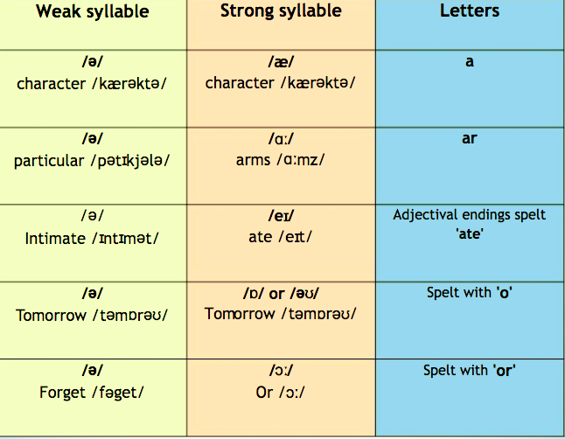
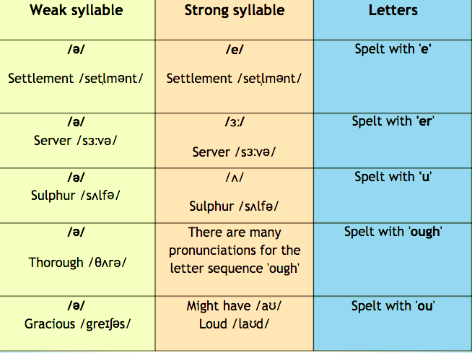
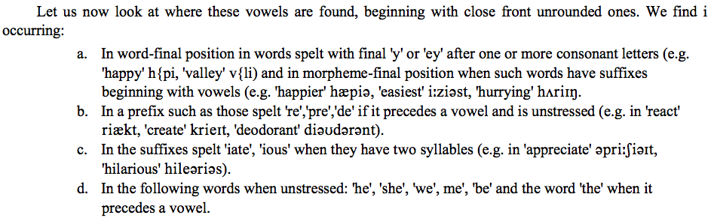

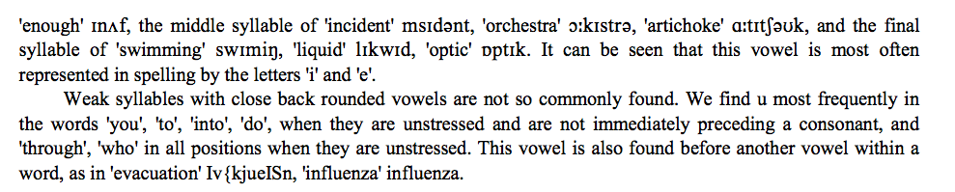

Syllabic Consonants:
We must also consider syllables in which no vowel is found.
In this case, a consonant, either l, r or a nasal, stands as the peak of the syllable instead of the vowel, and we count these as weak syllables like the vowel .
Where do we find syllabic l in the BBC accent?
It is useful to look at the spelling as a guide. The most obvious case is where we have a word ending with one or more consonant letters followed by 'le' (or, in the case of noun plurals or third person singular verb forms, 'les'). Examples are:
