Psychopedagogy (Semerster II)

1. Learning Styles
2. Learning Strategies
3. Motivation
4. Autonomy
5. Self-Regulation

1. Learning Styles
Do people learn the same way?
It is generally accepted that they do not. Individuals manifest differences in the ways they prefer to learn and the patterns they use to process information to approach learning situations.
- Learning is affected by many factors that lead to a diversity in the ways individuals prefer to learn. Such a diversity is the result of: brain structure, personalities, environment, culture, and educational history (background).
- Why is it important to understand learning styles?
1.1 Definition
The concept of learning styles refers to « the natural, habitual (tendencies), and preferred ways of absorbing, processing, and retaining new information and skills which persist regardless of teaching methods or content area. » (Kinsella, 1995).
1.2. Learning styles Theories
There have been a wide variety of theories and models formulated in educational research as to how learners differ in their learning styles.
1.2.1. Neil Fleming VAK/VARK Model
Learners are identified by whether they have a preference for:
- Visual learning: the learner needs to see information in order to process it. Visual learners can utilize pictures, graphs, charts, diagramms, movies and other forms of visual stimulation to effectively interpret information.
- Auditory learning: the learner prefers to learn by hearing, listening and discussing verbally- presented information (e.g. debates, lectures, audio recordings.)
- Reading learners: the learner prefers to take in information that is displayed as words and text (e.g. taking notes, making lists, and reading textbooks).
- Kinesthetic Learning: learning takes place by carrying out physical activities, rather than listening to lectures or watching demonstrations. It requires whole body movements to process information.
1.2.2. David Kolb’s Model
Kolb proposed a range of approaches commonly used by learners. It mainly involves:
1. Accomodators (activists): learn by doing, and tend to be extrovert people who get owith things, thriving on challenge and new concrete experience.
2. Divergers (reflectors): prefer to do a lot of preparation and think (reflect) on what they do before rushing into a decision as to how to do it (e.g. social workers).
3. Assimilators (theorists): natural problem-solvers, with an objective viewpoint, who adapt observations and inductive resoning into theories. They learn from systems, models and concepts (e.g. philosophers).
4. Convergers (pragmatists): practical learners who adopt the right strategy for the task in hand, enjoy problem-solving and learn by practical application of theory (e.g. engineers).
1.2.3. Cognitive Learning styles
They are related to differences attributed to intellectual potentials and capacities manifested by learners. They chiefly involve:
- 1. Analytic: The analytic thinker processes information into its components, looks at detail, is concerned with procedures, and is a logical thinker.
- 2. Wholistic (synthetic): The wholistic thinker is more likely to see the whole picture, be more intuitive, and notice similarities rather than differences. He learns by combining.
- 3. Verbalizer : recalls words.
- 4. Imager: recalls pictures, faces and shapes (visual intelligence and iconic memory).
1.2.4. Brain Dominance
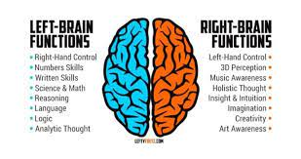

2. Learning Strategies
2.1. Definition
- Learning strategies refer to specific methods and techniques of approaching a problem or a learning task. They are specific actions, behaviours, steps that the learner employs to accomplish their learning.
- It is believed that the effective use of LS guarantees maximum academic achievement and best proficiency.
2.2. Language Learning Strategies
- LLS are thoughts and actions, consciously chosen and operationalized by language learners, to assist them in carrying out a multiplicity of tasks from the outset of learning to the most advanced levels of TL performance. (Cohn, 2011).
- They make learning faster, easier, more enjoyable and transferable to new situations.
2.3.Taxonomy of Learning Strategie (Rebecca Oxford)
2.3.1. Direct Learning Strategies:
They refer to strategies that directly involve the TL. They require mental processing of the language. They involve: memory strategies, cognitive strategies, and compensation stategies.
2.3.1.1. Memory Strategies:
They help learners to retain (store) and retrieve (remember) information. They consist of:
A. Creating Mental Linkeage,
B. Applying images and sounds,
C. Reviewing Well
D. Employing action.
2.3.1.2. Cognitive Strategies:
Enable learners to understand and produce language in different means. They involve:
- Practising
- Repeating (e.g. repeatedly listening to native speakers on a tape or recording).
B. Receiving and sending messages (e.g. techniques to understand text faster by relying on resources like dictionaries and word lists)
C. Analyzing and reasoning (e.g. using deductive thinking to grasp the meaning of the TL by breaking sentences and expressions into components—lexical, phon and syntactic
- Translating (drawing on the mother tongue to facilitate understanding TL input).
D. Creating structure for input and output
- Making own notes
- Summarizing
- Highlight the most important information.
2.3.1.3. Compensation Strategies:
Allow learners to use the TL despite the large gaps in knowledge (to compensate the missing knwoledge). They involve:
- Guessing intelligently (using clues to understand what is heard or read)
- Overcoming limitations in speaking or writing
- Using native language
- Asking for help (peer or teacher)
- Using gestures and mimic (body language)
- Text adjustment (paraphrase)
- Avoidance of conversation
- Topic selection
- Using synonyms, antonyms and description to fascilitate communication.

2.3.2. Indirect Learning Strategies:
ILS help learners to regulate and manage the learning process. They help to support and direct learning without direct engagement. They include: metacognitive strategies, affective strategies, and social strategies.
2.3.2.1. Metacognitive Strategies:
They go beyong the cognitive mechanisms. They are used to oversee, coordinate and self-direct learning. They have to do with setting goals and thinking about learning. They assist to plan and control progress in language learning in an effective way.
A. Centering learning (selecting what to focus on).
B. Arranging and planning learning (setting goals and objectives to attain).
C. Evaluating learning (measuring progress).

2.3.2.2. The Affective Strategies:
They have to do with managing emotions, attitude, motivation, and values that might influence learning achievement.
- Lowering anxiety and coping with stress.
- Encouraging oneself ( promoting self-esteem/self-confidence)
- Taking emotional temparature (readiness and motivation).

2.3.2.3. Social Strategies:
They have to do with methods employed to communicate more effectively with others (to maximize the flow of exchange).
- Asking Questions (clarification and to alleviate misunderstanding)
- Cooperating with others (peers and teachers)
- Empathizing with others (team work).

3.Motivation
3.1. Definition
- The word motivation derives from the Latin verb movere, which means to move
- Motivation the process that initiates, guides, and maintains goal-oriented behaviors. Motivation involves the biological, emotional, social, and cognitive forces that activate behavior. In everyday usage, the term "motivation" is frequently used to describe why a person does something.
- Motivation concerns what moves a person to make certain choices, to engage in action and to persist in action.
- It has to do with the drive, ambition, willpower, self-determination, self-efficacy and self-discipline.
3.2. Types of Motivation
3.2.1. Intrinsic Vs Extrinsic Motivation:
- Intrinsic motivation is also called motivation from-within. It has to do with doing something as an end in itself, for its own sake, self-sustaining pleasurable rewards of enjoyment, interest, challenge, or skill and knowledge development.
- Extrinsic motivation arises from outside. It has to do with doing something as a means to achieve separable outcomes, such as degrees and qualifications, getting a job, pleasing the teacher (seeking verbal rewards), or avoiding punishment (fear of failure).
- Educational research indicated that intrinsically motivated learners tend to be more successful.
3.2.2. Integrative Vs Instrumental Motivation
- Integrative motivation
- Learners want to learn L2 to be able to understand and get to know the people who speak that language (interest in the TL, people and culture).
- Usually for social purposes in order to take part in the social life of a community.
- Instrumental Motivation
- Learners want to learn the L2 for its practical value and advatages; for example, in order to obtain a school graduation or a job recruitment requirement.
3.3 Theories of Motivation
3.3.1. The Behavioural Theory
From a behavioural perspective, motivation simply the anticipation (expectation) of reward. Behaviour is driven to acquire positive reinforcement. It is also driven by previous experiences (the link between stimulus and response).
3.3.2. The Humanistic Theory
- Humanistic theories of motivation are based on the idea that people also have strong cognitive reasons to perform various actions. Once these needs have been met, the primary motivator becomes the need for self-actualization, or the desire to fulfill one's individual potential.
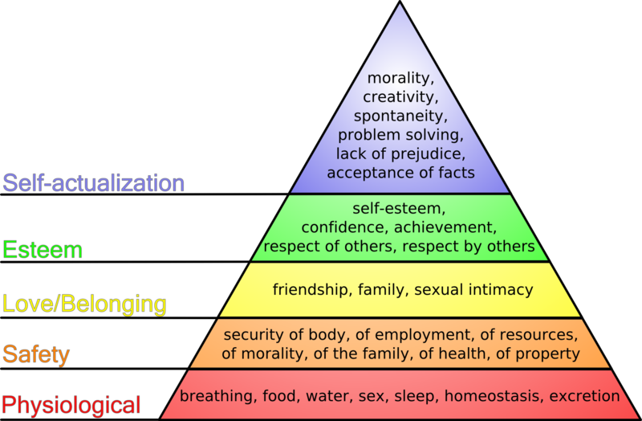

3.3.3. The Social Cognitive Theory
- It is based on the assumption that the outcomes of learning are the result of the interaction of three processes: personal, behavioural, and evironmental processes.

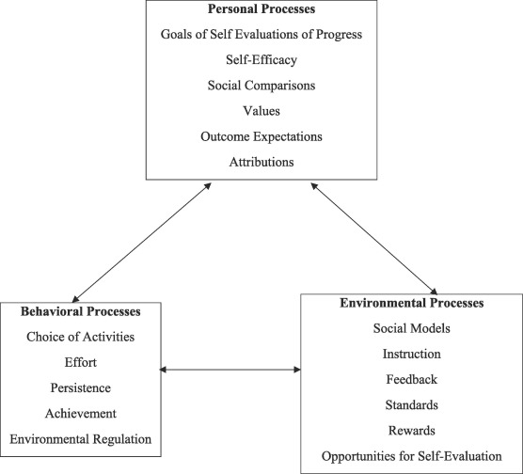
3.3.4 Sociocultural Theory
It was initially developed by Vygotsky based on the cognitive development theory. It shows that learning is being ingrained in social events and takes place when the learner is interacting with people, objects, and events within the environment.

4. Autonomy
- Autonomy (N): the ability to act and make decisions without being controlled by anyone else.
- Autonomous (Adj)
- Autonomously (Adv)
4.1 Definition
The term learner autonomy has been used in education since the early 1980s, when it was first used by the French educator Henri Holec. Holec defined learner autonomy as the learner's ability to take charge of his/her own learning in both methodological and psychological terms.
"In order to help learners to assume greater control over their own learning it is important to help them to become aware of and identify the strategies that they already use or could potentially use." (Holmes & Ramos, 1991, cited in James & Garrett, 1991: 198).
Autonomy in language learning depended on the development and exercise of a capacity for detachment, critical reflection, decision making, and independent action. autonomous learners assumed responsibility for determining the purpose, content, rhythm, and method of their learning, monitoring its progress, and evaluating its outcomes.
What Skills Do Autonomous Learners Need?
- In keeping with the definition above, which sees the autonomous learner as someone with the ability to be fully responsible for their own learning, there are a number of skills which are needed. The main ones which such learners require are:
- the ability to identify and set learning goals;
- the ability to plan and execute learning activities;
- the ability to reflect on and evaluate their learning;
- an understanding of the purpose of their learning;
- an understanding of their own learning processes;
- knowledge of a range of learning strategies and skills; clear motivation to learn.

4.2 Characteristics of the Autonomous Learner
According to Philip C. Candy, autonomous learners are:
- methodical/disciplined
- logical/analytical
- reflective/self-aware
- motivated/curious
- flexible
- interdependent/inter-personally competent
- responsible/persistent
- venturesome/creative
- creative/have positive self-concept
- independent/self-sufficient
- skilled in seeking/retrieving information
- knowledgeable about/skilled in learning
- able to develop/use evaluation criteria

5. Self-Regulation
5.1 Definition
Self-Regulation refers to the self-directive process through which learners transform their mental abilities into task related skills" (Zimmerman, 2001). This is the method or procedure that learners use to manage and organize their thoughts and convert them into skills used for learning.
5.2 What is self-regulated learning theory?
Self-regulated learning is a cyclical process, wherein the student plans for a task, monitors their performance, and then reflects on the outcome. The cycle then repeats as the student uses the reflection to adjust and prepare for the next task.
