Mohammed Lamine Debbaguine University
English Department
Module: Phonetics Level 1st year LMD
Teacher: Mrs Tiaiba Imane

Chapter Two: Articulators above the Larynx Division 2
Introduction
The different parts of the vocal tract are called articulators, and the study of them is called articulatory phonetics.
The vocal tract ends at the mouth and nostrils; we call the part comprising the mouth the oral cavity and the part that leads to the nostrils the nasal cavity.

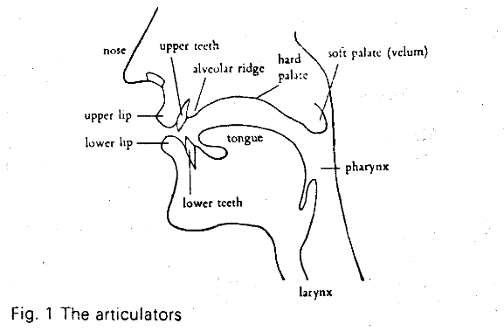

- The Pharynx | is a tube which begins just above the larynx. It is about 2 cm long in women and about 5 cm in men, and at its top end it is divided into two, one part being the back of the oral cavity and the other being the beginning of the way through the nasal cavity.
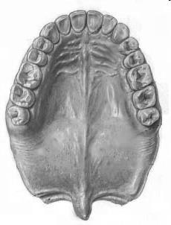  UVULA | - Uvula : the loose hanging end of the soft palate.
VELUM | - The soft palate or velum is seen in the diagram in a position that allows air to pass through the nose and through the mouth. Yours is probably in that position now, but often in speech it is raised so that air cannot escape through the nose.
HARD PALATE | - The hard palate is often called the "roof of the mouth". You can feel its smooth curved surface with your tongue.  A consonant made with the tongue close to the hard palate is called palatal. The sound j in 'yes' is palatal.
ALVEOLAR RIDGE | - Alveolar ridge : hard ridge behind upper front teeth. It is between the roof of the mouth and the upper teeth.  Sounds made with the tongue touching here (such as t, d, n) are called alveolar
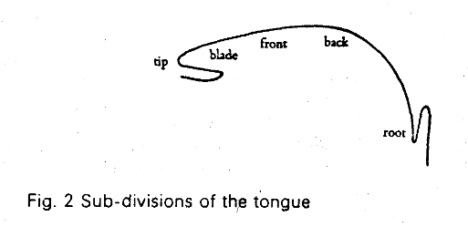 | - Tongue: The tongue is a very important articulator and it can be moved into many different places and different shapes. It is usual to divide the tongue into different parts, though there are no clear dividing lines within its structure. It is divided into tip, blade, front, back and root.
TEETH | - The teeth (upper and lower) .Sounds made with the tongue touching the front teeth, such as English T, D, are called dental.
LIPS | - The lips are important in speech. They can be pressed together (when we produce the sounds p, b), brought into contact with the teeth (as in f, v), or rounded to produce the lip-shape for vowels like u:. Sounds in which the lips are in contact with each other are called bilabial, while those with lipto-teeth contact are called labiodental.

English Sounds:
Vowels: are sounds produced without obstruction in the passage of airstream
Consonants : are sounds produced with obstruction in the passage of airstream

