Model verbs
A modal verb is a helping verb that is used along with the main verb to represent the ability, possibility and probability of a subject to do an action and emphasize on the necessity of an action. While using model verbs, remember that they:
1. Model verbs don't use an 's' for the third person singular.
2: They make questions by inversion ('she can go' becomes 'can she go?').
3: They are followed directly by the infinitive of another verb (without 'to).
Modal Verbs Function

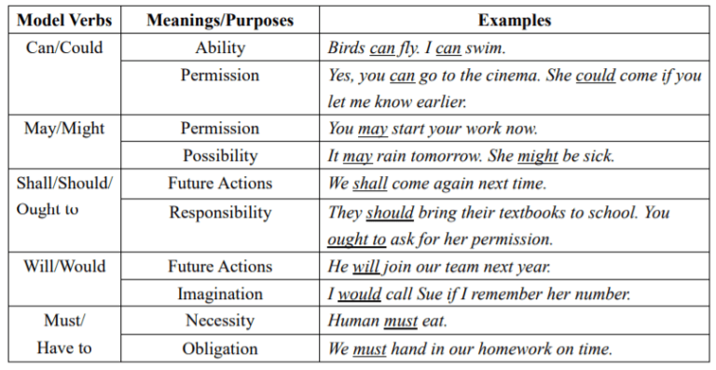

Activity: Fill in the blanks with the appropriate modal verb in the following sentences:
1. ________ you be able to bring your camera when you come?
2. Laila__________ apologise for the confusion that was caused yesterday because of her carelessness.
3. You _______ finish this first and then start with the other one.
4. ________ I make some tea for you?
5. I ______ make sure to keep everything ready by the time they reach the railway station.
6. You _______ see to it that the students are standing according to their roll numbers.
7. ______ I come in?
8. She _______ find it interesting as she likes reading adventure stories.
9. Do you have any idea how much all of this _______ cost?
10. ______ you please help me find my keys?

