Introduction
- The United Kingdom (UK):
The UK is short for the United Kingdom of Great Britain and Northern Ireland. It is a sovereign state, but is made up of four countries: England (London), Scotland (Edinburgh), Wales (Cardiff) and Northern Ireland (Belfast).
There is a long and complicated history that follows the formation of the UK, but here are the highlights:
- The Kingdom of England was established by the unification of Anglo-Saxon tribes across modern day England in 927 AD.
- The kingdom of England and Wales was created in 1536. A Bill enacted by king Henry VIII which effectively made England and Wales the same country, governed by the same laws.
- The Kingdom of Great Britain was created in 1707. The Kingdom of England (which includes Wales) joined with the Kingdom of Scotland to form the kingdom of Great Britain.
- The United Kingdom of Great Britain and Ireland was created in 1801. Ireland joins the union and once again the name changes.
- The United Kingdom on Great Britain and Northern Ireland was established in 1922. The Republic of Ireland withdraws from the union, leaving just the northern countries of Ireland. This is the UK that remains to this day.

- Great Britain: is not a country, it is a landmass. It is known as Great because it is the largest island in the British Isles. It contains England, Scotland and Wales. The name Britain derives from the Roman word Britannia.

- The British Isles: is the name of a group of islands situated off the north Western corner of mainland Europe. It is made up of Great Britain, Ireland, the Isle of Man, the Isles Scilly, the Channel Islands, as well as over 6000 other smaller islands.

- England: just like Wales and Scotland, England is commonly referred to as a country but it is not a sovereign state. It is the largest country within the UK. Both by landmass and population, has taken a significant role in the creation of the UK, and its capital London happens to be the capital of the UK.

Some Important Maps:

- Map of the United Kingdom and Ireland

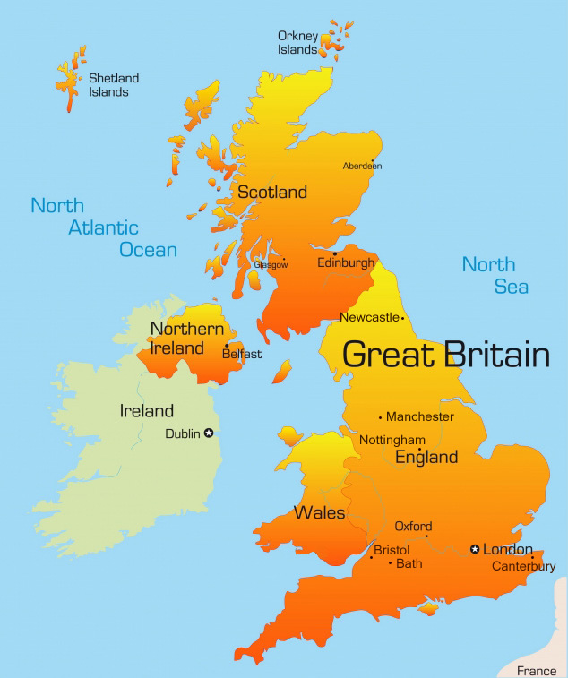

- Five Kingdoms of Ireland
The following map is for the five Kingdoms of Ireland created by the Celts. (for more details, please check the handouts)
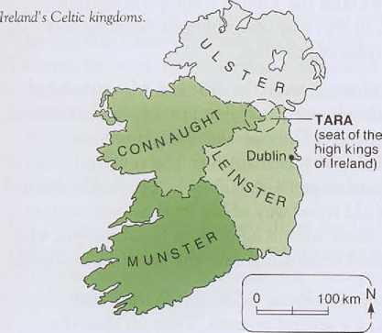
- Map Scotland:
The four groups which populated Scotland Map of Scotland with the Hadrian Wall
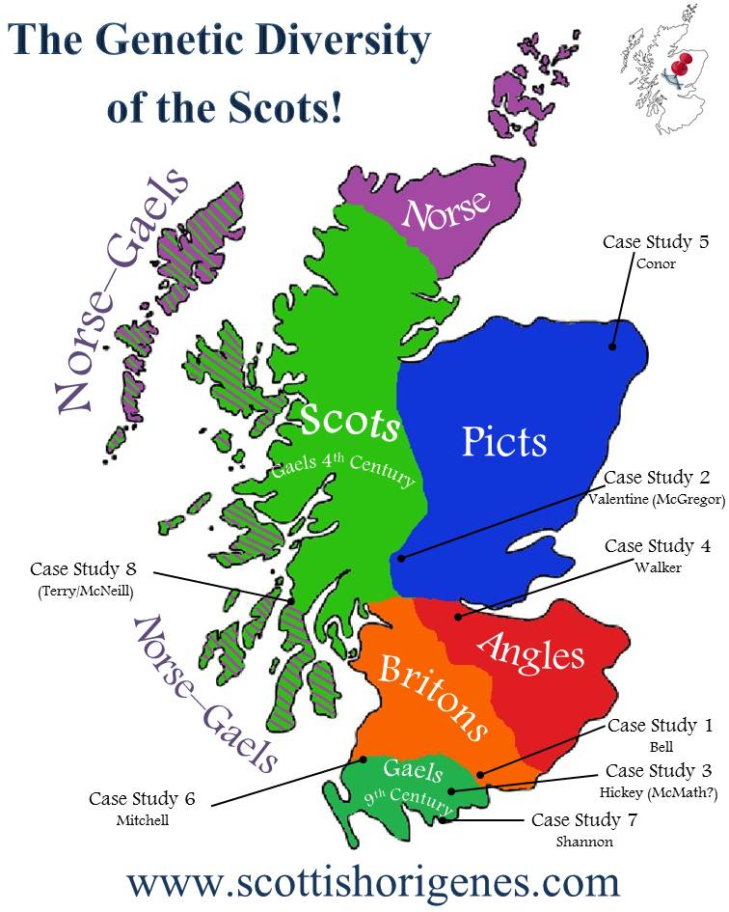
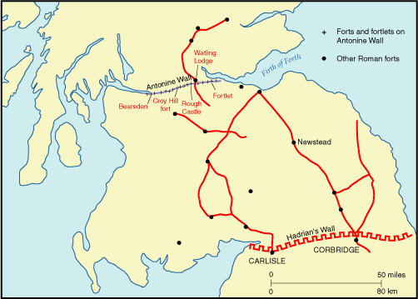
- The Anglo-Saxon Heptarchy:
