How to Write an Essay Introduction
The introduction paragraph of an essay is the first paragraph of the paper. Therefore, it is also the first thing your reader will see in your essay. A good introduction performs two functions. Firstly, it tells the reader what you are going to be talking about in your paper; simply put, it should identify the essay topic and give some insight into the essay’s main point. Secondly, it has to evoke interest and motivate the audience to read the rest of your paper.

What Makes a Good Introduction
A powerful introductory paragraph should meet all of these requirements:
- Have a hook at the beginning of the paragraph that grabs the reader’s attention.
- It should provide background information about your topic.
- It should give readers an idea about the main points and claims that will be discussed in your paper.
- At the end of your introduction, there needs to be a clear thesis statement that reflects the main idea of your essay.

What Are the 3 Parts of an Introduction Paragraph?

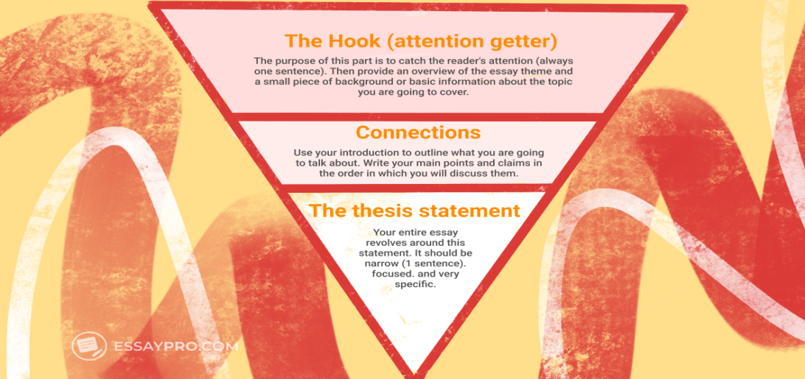

It usually consists of 3 parts: a hook, connections, and a thesis statement

Part 1: Essay Hook
A hook is one of the most effective introduction starters for an essay. A hook aims to catch the reader’s attention (always in a single sentence). In other words, it is an attention grabber.
Now, let’s answer the question “how to make an interesting hook?” There are several different strategies you can use to create a powerful hook:
- A shocking fact
- An anecdote
- A question
- A short summary
- A quote
After pitching an effective hook, you should provide a broad overview of your main topic and state some background information for the subject matter of your paper. If you are wondering how to start an essay introduction, the best way to do so is by providing a broad explanation of your theme and then leading your readers to specific points. Simply put, you should first give some general information and then gradually narrow it down to your specific points.
Example:“Although many falsely believe that people working from home are less productive – employees who get such work-life benefits generally work harder.”
Statistical data can be a perfect hook for persuasive essays and serious topics that require delving into numbers.
Example:“A recent study showed that people who are satisfied with their work-life balance work 21% harder and are 33% more likely to stay at the same company.”

Part 2: Connections
After you have provided a hook and some background information regarding your essay topic, move on to giving readers a better understanding of what you are going to talk about throughout your paper. In this part of your introduction, you should briefly mention your key ideas in the same order in which you will go on to discuss them, and gradually lead your reader(s) to your thesis statement.
Some of the key questions to answer in this part of your introduction are:
- Who?
- What?
- Where?
- When?
- How?
- Why?
- And so on.
Answering these questions in 2-3 sentences each will help you ensure that you provide your readers with complete information about the topic of your essay. However, be sure to keep these sentences concise and straight to the point.
Your main goal is to gradually move from general information about your subject matter to something more specific (i.e. your thesis statement). To simplify this process, think of your introduction as of an upside-down triangle. In this triangle, the attention grabber (read hook) is at the top, followed by a broader explanation of the topic, and ending with a very specific claim. Here is a simple tip for how to write an essay introduction following this “upside-down triangle” strategy:
- Make each sentence in your introduction a bit more narrow and specific than each previous one. This simple trick will help you draw your reader(s) into the main part of your paper gradually.
- Let’s say you are writing a paper about the importance of a good work-life balance. In this case, you can use a question like “Have you ever thought of how a good work-life balance can influence different spheres of your life?” or another hook, then you can continue by providing general facts and statistics, and finally, you can narrow down your topic to match your thesis statement.

Part 3: The Thesis Statement
a thesis statement provides your audience with a brief summary of the paper’s key claim. Your key claim is what you are going to be revealing or arguing about in the body section of your paper. As a rule, a good thesis statement is very concise (disclosed in one sentence), accurate, specific, clear, and focused. Your thesis should typically appear at the end of your introductory paragraph/section.
Thesis Statement Example:“ To boost the overall productivity of employees, large corporations should create comfortable and flexible working schedules for their workers, therefore, helping them have better work-life balance.”
Examples of an introduction
1.
A few years ago, before the advent of modern technology, people used traditional means. Telephones and letters were used for communicating over long distances.
Now with the advent of computers, many new tools for communicating have been developed. Video calls, instant messages, and social media have brought people closer.
While the means of communication both in conventional and modern ages serve the same purpose. They still differ with regard to their speed and range.

2.

