Target Situation Analysis (TSA)
Needs analysis was firmly established in the mid-1970s (West, 1998). In the earlier periods needs analysis was mainly concerned with linguistic and register analysis, and as Dudley-Evans and St. John (1998) suggest, needs were seen as discrete language items of grammar and vocabulary. With the publication of Munby’s Communicative Syllabus Design (1978) needs analysis moved towards placing the learner’s purposes in the central position within the framework of needs analysis. Consequently, the notion of target needs became paramount and research proved that function and situation were also fundamental. The term Target Situation Analysis (TSA) was, in fact, first used by Chambers in his 1980 article in which he tried to clarify the confusion of terminology. For Chambers TSA is “communication in the target situation” (p.29). In his work Munby (1978) introduced Communicative Needs Processor
(CNP). As Hutchinson and Waters (1987: 54) say:
With the development of the CNP it seemed as if ESP had come of age. The machinery for identifying the needs of any group of learners had been provided: all the course designers had to do was to operate it.
In Munby’s CNP, the target needs and target level performance are established by investigating the target situation, and his overall model clearly establishes the place of needs analysis as central to ESP, indeed the necessary starting point in materials or course design (West, 1998).
In the CNP, account is taken of “the variables that affect communication needs by organizing them as parameters in a dynamic relationship to each other” (Munby, 1978: 32).
Munby’s overall model is made up of the following elements:
1. Participants: information about the identity and language of the learners: age, sex, nationality, present command of target language, other languages known and extent of command;
2. Communication Needs Processor: investigates the particular communication needs according to sociocultural and stylistic variables which interact to determine a profile of such needs;
3. Profile of Needs: is established through the processing of data in the CNP;
4. In the Meaning Processor “parts of the socioculturally determined profile of communication needs are converted into semantic subcategories of a predominantly pragmatic kind, and marked with attitudinal tone” (Munby, 1978: 42);
5. The Language Skills Selector: identifies “the specific language skills that are required to realize the events or activities that have been identified in the CNP” (Munby, 1978: 40);
6. The Linguistic Encoder: considers “the dimension of contextual appropriacy” (Munby, 1978: 49), one the encoding stage has been reached;
7. The Communicative Competence Specification: indicates the target communicative competence of the participant and is the translated profile of needs. From the above-mentioned elements of the Munby model, the predominant one or at least the one that has been referred to by other researchers of needs analysis is the Communication Needs Processor (CNP) which is the basis of Munby’s approach to needs analysis and establishes the profile of needs through the processing of eight parameters the processing of which gives us a detailed description of particular communication needs (Munby, 1978). The parameters specified by Munby (1987) are:
• Purposive domain: this category establishes the type of ESP, and then the purpose which the target language will be used for at the end of the course.
• Setting: the physical setting specifying the spatial and temporal aspects of the situation where English will be used, and the psychological setting specifying the different environment in which English will be used.
• Interaction: identifies the learner’s interlocutors and predicts relationship between them.
• Instrumentality: specifies the medium, i.e., whether the language to be used is written, spoken, or both; mode, i.e., whether the language to be used is in the form of monologue, dialogue or any other; and channel of communication, i.e., whether it is face to face, radio, or any other.
Dialect: dialects learners will have to understand or produce in terms of their spatial, temporal, or social aspect.
• Communicative event: states what the participants will have to do productively or receptively.
• Communicative key: the manner in which the participants will have to do the activities comprising an event, e.g. politely or impolitely.
• Target level: level of linguistic proficiency at the end of the ESP course which might be different for different skills.
The aim of Munby’s CNP is to find as thoroughly as possible the linguistic form a prospective ESP learner is likely to use in various situations in his target working environment. The outcome of the processing data by means of Munby’s model is, as Hutchinson and Waters (1987) say, what the learner needs to know in order to function effectively in the target situation. Most subsequent target needs analysis research was based on Munby’s model for the reason that it offers comprehensive data banks and target performance (Robinson, 1991). Many researchers in the field of target situation needs analysis followed Munby’s CNP. Hutchinson and Waters (1987) provide a comprehensive target situation analysis framework, which consists of a list of questions the analyst should find answers to. For Hutchinson and Waters (1987) the analysis of target situation needs is “in essence a matter of asking questions about the target situation and the attitudes towards that situation of various participants in the learning process” Nevertheless, most of these questions relate to the Munbian model. These relations can be found summarized below:
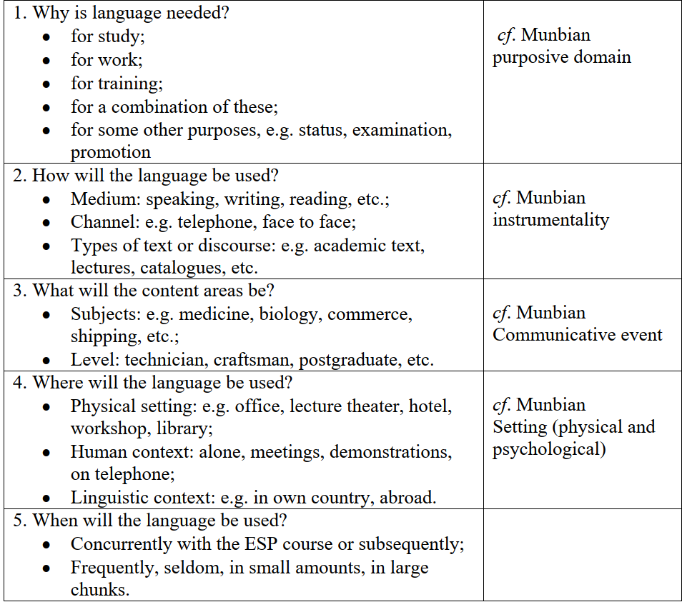
Like any other model/approach, however, Munby’s model is not without its critics. Munby provided detailed lists of microfunctions in his CNP. What he did not include was how to prioritize them or any of the affective factors which today are recognized as important (Dudley-Evans and St. John, 1998). West (1994: 9-10) mentions the shortcomings of the Munby’s model
in terms of four headings:
1. Complexity: Munby’s attempt to be systematic and comprehensive inevitably made his instrument inflexible, complex, and time-consuming.
2. Learner-centeredness: Munby claims that his CNP is learner-centered. The starting point may be the learner but the model collects data about the learner rather than from the learner.
3. Constraints: Munby’s idea is that constraints should be considered after the needs analysis procedure, while many researchers feel that these practical constraints should be considered at the start of the needs analysis process.
4. Language: Munby fails to provide a procedure for converting the learner profile into a language syllabus.
Hutchinson and Waters (1987) also point out that it is too time-consuming to write a target profile for each student based on Munby’s model. This model only considers one viewpoint, i.e. that of the analyst, but neglects others (those of the learners, user-institutions, etc.). Meanwhile, it does not take into account of the learning needs nor it makes a distinction between necessities, wants, and lacks.

