Needs analysis
Definitions
ESP courses set out to teach the language and communication skills that specific groups of language learners need or will need to function effectively in their disciplines of study, professions or workplaces. Because ESP focuses on teaching specific language and communication skills, ESP course design usually includes a stage in which the course developers identify what specific language and skills the group of language learners will need. The identification of language and skills is used in determining and refining the content for the ESP course. It can also be used to assess learners and learning at the end of the course. This process
is termed ‘needs analysis’. Over the years needs analysis has become increasingly sophisticated. In the early years of ESP, needs analysis tended to be construed as a fairly simple pre- course procedure involving analysis of the target situation. However, this is no longer the case (Garcia Mayo, 2000; Tajino, James and Kijima, 2005).
In the early days needs analyses focused largely on necessities or objective needs representing ‘the destination of the learner’s journey’. These analyses aimed to determine priorities, such as, which skills (reading, writing, listening, speaking), and which situations or tasks, such as speaking on the telephone or writing minutes from meetings, were more or less important in the target situation. Later the concept of needs analysis was expanded to include ‘deficiency analysis
deficiency analysis’ is lacks or the gap between what the learner needs to know to operate in the target situation and the learner’s present language proficiency). This analysis represented the point of departure for the language-learning journey.
Strategy analysis’ (the preferred approaches and methods in teaching and learning) was also included in needs analysis. This represented the means of travel.
Means analysis’ (identification of the constraints and opportunities in the teaching situation) was added. This analysis included gathering information on the classroom culture, learner factors, teacher profiles and the status of language teaching in the organization. Means analysis
represented the ESP journey.
Needs analysis refers to the activities involved in collecting information that will serve as the basis for developing a language program that will meet the needs of a particular group of students. Johns (1991) states that needs analysis is the first step in course design and it provides validity and relevancy for all subsequent course design activities. Needs analysis can include:
(a) target situation analysis (TSA) which is concerned with the ultimate purpose of a language course, i.e. learner necessities or objective needs,
(b) present situation analysis (PSA) which considers existing learner knowledge, strengths and weaknesses,
(c) strategy analysis which establishes the learners’ preferences in terms of learning styles and strategies or teaching methods,
(d) deficiency analysis which estimates the learning gap between present needs and target needs, i.e. lacks or deficiencies,
(e) means analysis which examines the teaching environment where the language course is to take place and establishes the constraints and opportunities of the course journey
Types of information to collect
In needs analysis the quality of the data collected depends in large part on selecting appropriate data collection techniques. Unless the course developers or teachers conducting the needs analysis have large quantities of time to devote to the project, they will need to be selective about what type of data to collect. Needs analysis can take a number of forms including questionnaires,
interviews, observations of interactions and analysis of language use in the target situation, tests of performance and observations of ESP learners carrying out tasks replicating those in the target situation. The figure brelow shows the questionnaire Bacha and Bahous (2008) developed for an investigation into the English language needs of business students at the Lebanese American University. Item 1 in the questionnaire inquires into the students’ perceptions of the relative importance of different language skills. Item 2 inquires into how they perceive their abilities in the various skills. The remaining items focus on the writing skill in particular.
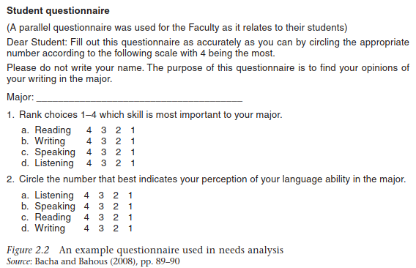
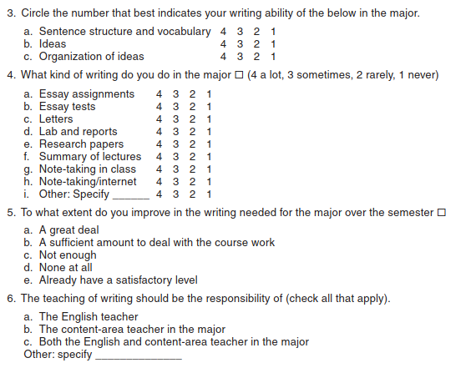
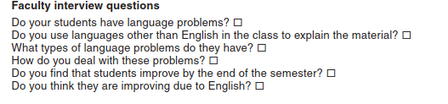
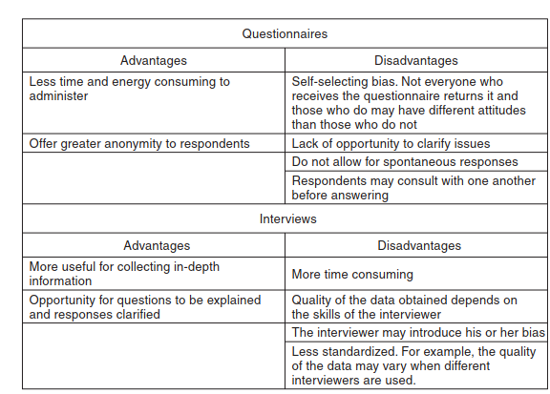
A scenario1
The Department of English Language Studies in a university decides to offer a discussion skills course to complement the existing English for General Academic Purposes programme for undergraduate students. The programme currently has courses on academic writing and listening. Students on the programme have mentioned that they are struggling to communicate orally and participate in their subject classes. Outline the steps you would take to investigate their English language needs.
Scenario 2. The writing course for overseas-trained dentists
A number of overseas-trained dentists have immigrated to an English-speaking country. They are preparing to sit the registration exams which, if they pass, will allow them to work as dentists. A government-sponsored bridging programme has been established to help them prepare for the exams. The course is run at a university. The programme provides courses on medical and dental topics, ethical issues and the law surrounding medical practices in the country. Outline the steps you would take to investigate their English language needs.
Scenario 3
You have been assigned to develop and teach an ESP course for bank tellers who will shortly be transferred to the foreign exchange sections of their banks in a country in the Middle East. Outline the steps you would take to investigate their English language needs.
Task2:
Select an article that reports a needs analysis, or an article that reports a course design but includes an account of the needs assessment on which the course was based. Possible sources of such published reports are English for Specific Purposes, the Journal of English for Academic Purposes, or journals published locally. Present a summary of what the needs analysis involved
(target situation analysis, deficiency analysis, present situation analysis…..and so on), the procedure followed and the types of data collected.

