Mohammed Lamine Debaghine University Setif 2
English Department
Module: Phonetics Level 1st year LMD
Teacher: Mrs Tiaiba Imane
Chapter Two: English Short Vowels
We begin the study of English sounds in this course by looking at vowels, and it is necessary to say something about vowels in general before turning to the vowels of English. We need to know in what ways vowels differ from each other. The first matter to consider is the shape and position of the tongue.
In the close front position we produce /i/ - peace | In the open front position we produce /æ/ - pat | In the back open position we produce /α:/ car | In the back close position we produce /u:/ school
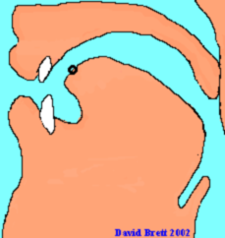 | 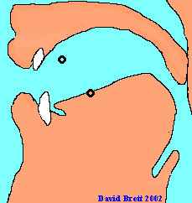 | 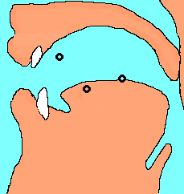

Connecting these points gives us a box called the Vowel Quadrilateral
All the vowel sounds that the human voice can produce may be plotted within the limits of the quadrilateral
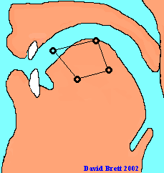 | 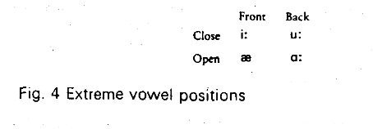
Here is the vowel quadrilateral divided into sectors with the IPA symbols at fixed points. These are called Primary Cardinal Vowels. | These are the places of articulation of English short vowels
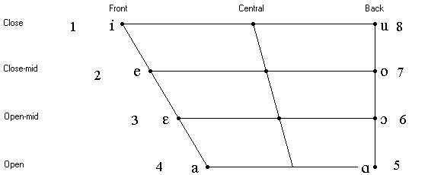 | 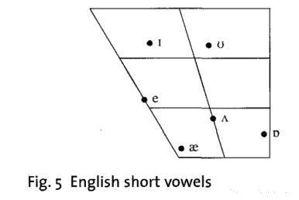

What makes vowels different?
They differ in lenght and quality. By quality we mean:
- Position of the tongue- close to the hard palate, mid –close, mid open or open
2) Part of the tongue: front, centre or back,
3) Shape of lips: rounded or unrounded (spread or neutral)

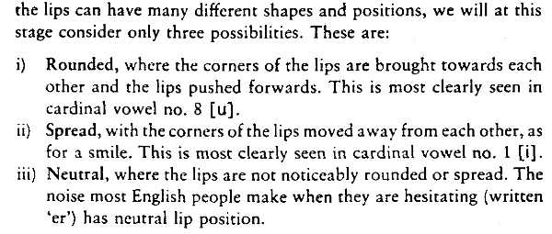
Description of English Short Vowels
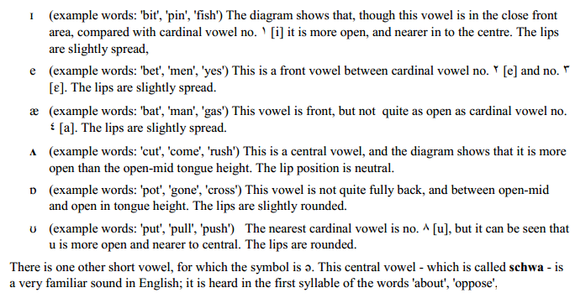
vowel | Position of the tongue | Part of the tongue | Shape of lips

