Stages in the ESP Teaching Process
Dudley-Evans and Johns (1998:121) maintain that “The key stages in ESP are needs
analysis, course (and syllabus) design, materials selection (and production), teaching and
learning, and evaluation.” ESP course design is the product of a dynamic interaction
between these elements which“… are not separated, linearly-related activities, rather, they
represent phases which overlap and are interdependent”.
Dudley-Evans and St. Johns illustrate the theory and the reality of the stages in ESP
process through these cyclical representations:
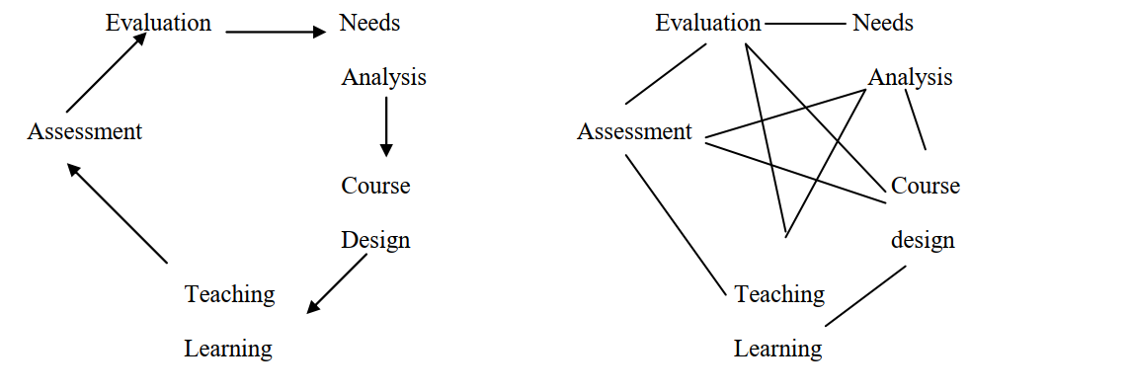
Figure 1.1: stages in the ESP process: Theory Figure 1.2: stages in the ESP process: reality
It is well demonstrated that the basic elements in the ESP teaching process are
interconnected and there is no differentiation between theory and reality “the simplicity and
clarity of figure 1 is in reality more like figure 2” (Dudley-Evans and St. Johns, 1998: 121).
Therefore, the achievement of ESP courses are: those where the syllabus and the material
are determined by the prior analysis of the communication needs of the learner (Mumby,
1978: 2), and those in which the aims and the context are determined principally
or wholly not by criteria of general education but by functional and practical English
language requirements of the learner (Strevens 1977 :90).
However, designing effective ESP course is governed by further parameters that have
to be examined first. According to Miliani (1994), after his exploration of the Algerian
context, stated that four essential points have to be studied and analysed as a pre-design
process, which consist of:
a-Situation analysis: it envelop the general requirements of both learners and institutions,
their profiles and attitudes, also the existing materials.
b-Setting Aims and Objectives: the results of learners needs identification and analysis
(NIA) lead to setting up general statements and what would be achieved at the end of the
courses.
c-Generating Syllabus Content: organising the syllabus content “through the sequencing of
materials whose layout and presentation should form a continuum”. (Benyelles, 2009:58).
d- Assessment: gathering data regarding syllabus before or during the course
implementation let to readjust the content of the syllabus.
From the quoted descriptions of ESP teaching process it is viewed that in the first
instance, learners‟ needs have to be identified and analysed. Therefore, the development of
an ESP course should be in line with learners‟ requests and wants. Thus, needs outcomes
will operate as a guide for the teacher in designing a suitable syllabus, producing course
materials as well as teaching and testing methods.

