**Important Maps**

1. Columbus Voyages’ Map :

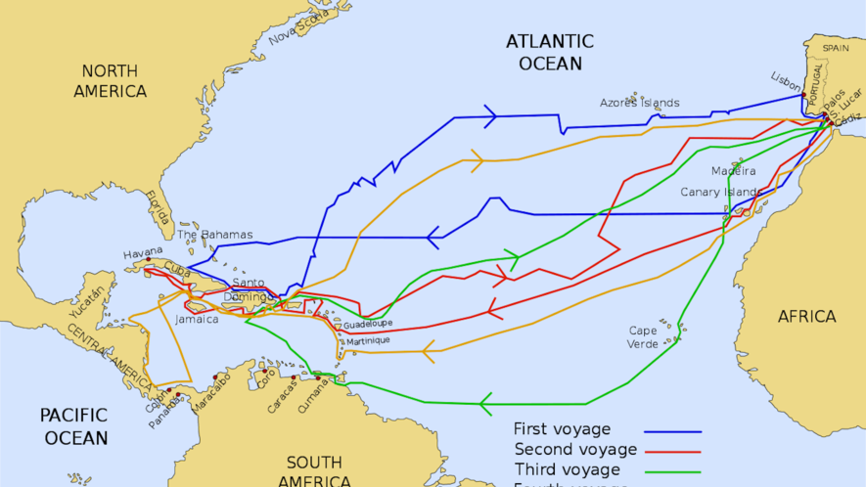

1. The Thirteen English Colonies in the New World :

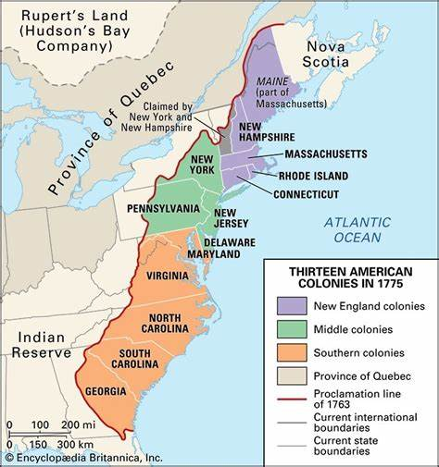

1. The United States of America:

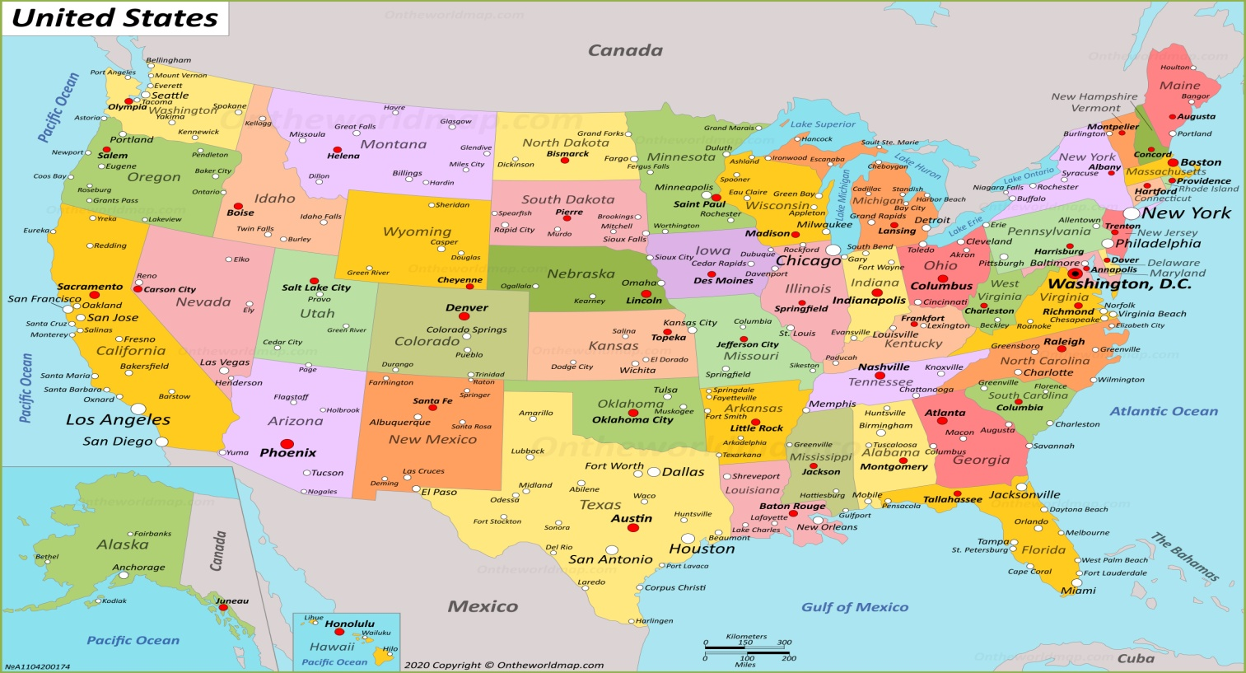

1. European Voyages to the Spice Islands :

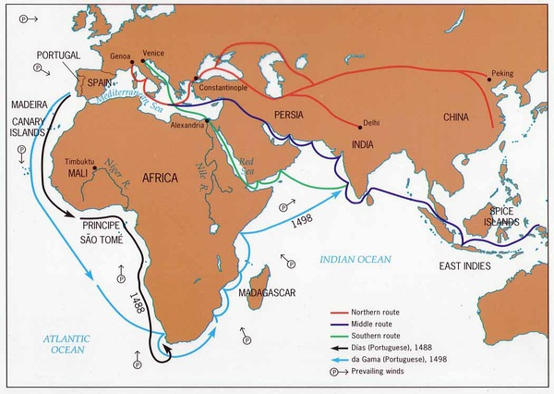

1. European Expansion in the New World:

