**Exercise 1**

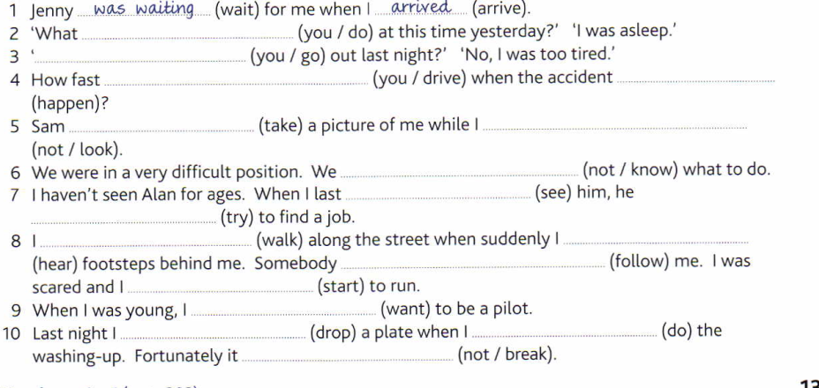

**Exercise 2**: Put the verbs in brackets into the simple past or the past continuous tense.

1 I lit the fire at 6.00 and it (bum) brightly when Tom came in at 7.00.  
2 When I arrived the lecture had already started and the professor (write) on the overhead projector.  
3 I (make) a cake when the light went out. I had to finish it in the dark.  
4 I didn't want to meet Paul so when he entered the room I (leave).  
5 Unfortunately when I arrived Ann just (leave), so we only had time for a few words.  
6 He (watch) TV when the phone rang. Very unwillingly he (turn) down the sound and (go) to answer it.  
7 He was very polite. Whenever his wife entered the room he (stand) up.  
8 The admiral (play) bowls when he received news of the invasion. He (insist) on finishing the game.  
9 My dog (walk) along quietly when Mr Pitt's Pekinese attacked him.  
10 When I arrived she (have) lunch. She apologized for starting without me but said that she always (lunch) at  
12.30.  
11 He always (wear) a raincoat and (carry) an umbrella when he walked to the office.  
12 What you (think) of his last book? ~  
I (like) it very much.  
13 I (share) a flat with him when we were students. He always (complain) about my untidiness.  
14 He suddenly (realize) that he (travel) in the wrong direction.  
15 He (play) the guitar outside her house when someone opened the window and (throw) out a bucket of water.

**Exercise 1 :** what were you doing , Did you go out, How fast were you driving , happened, took while I was not looking, We did not know Saw, was trying, was walking, heard, was following, started, wanted. Dropped, was doing, did not break.

**Exercise 2:**  was burning. 2 was writing. 3 was making 4 left. 5 was just leaving. 6 was watching, turned, went. 7 stood. 8 was playing, insisted. 9 was walking. 10 was having, lunched 11 wore, carried 12 did you think, liked 13 shared, was always complaining/always complained 14 realized, was travelling 15 was playing, threw.