**3.3.2. Approximants**

They are consonants produced where the only source of sound is vocal fold vibration, for they do not involve any physical noise; no plosion, friction, trilling or tapping can be heard. In approximants, the active and passive articulators *never become sufficiently close*; they are produced with a much wider passage of air resulting in a smooth airflow. They do not involve any kind of closure of the vocal tract; instead, the open approximation of the articulators alters the shape of the oral cavity, and leads to a production of a particular sound quality. English approximants are those in words such as wet, yet, let and retch with the IPA symbols / w, j, l, r / respectively; / w, j / are called glides and / l, r / are called liquids, and both groups are referred to as *frictionless continuants*.

**a. English Approximants (Phonetic description)**

|  |  |  |  |  |
| --- | --- | --- | --- | --- |
|  | **Labio-velar** or **labial-velar** | **Alveolar** | **Post-alveolar** | **Palatal** |
| **Voiced** | / w / | / l / | / r / | / j / |

* The labio-velar / w / is unique among the consonants of English, as it involves two places of articulation; the lips are approximated, and the back of the tongue is also bunched up.
* The / j / sound is articulated with the front of the tongue moving towards the hard palate.
* The / l / is articulated by making a complete closure between the centre of the tongue and the alveolar ridge altering the air from being released from the centre, and consequently, releasing it down the sides of the tongue. Thus, / l / is known as the lateral approximant, for it has a lateral airflow as opposed to all the other oral consonants which have central airflow.
* The last approximant /r/ has got different realizations in English accents; in RP (Received pronunciation) the tip of the tongue is curled back to a position approaching the rear of the alveolar which is known as the post-alveolar, **and the lips are slightly rounded. However, in some American accents, it is produced with the tip of the tongue curled upward and backward to the hard palate, thus it’s called the retroflexed approximant.**

**b. The phonological description**

* All the approximants can be word initial as in lot, rot, what and yacht / lɒt, rɒt, wɒt, jɒt /, and they follow all the consonants in syllable initial position-post-initials- like in the words blight, vroom, Gwen and news / blaɪt, vruːm, gwen, njuːz /.
* When being initial, preceded by a voiceless plosive or fricative, they become devoiced. Like in words play, clay, flow, slow, pray, tray, crayfish, shrew, threw, pure, tune, queue, few, sew, tweet, quit, swat and thwart. / pl̥eɪ**,**kl̥eɪ**,**fl̥əʊ**,**sl̥əʊ**,**pr̥eɪ**,**tr̥eɪ**,**ˈkr̥eɪfɪʃ**,**ʃr̥uː**,**tj̥uːn**,** kj̥uː**,** fj̥uː**,** [sj̥uː](https://tophonetics.com/)**,**tw̥iːt**,**kw̥ɪt**,**sw̥ɒt, θw̥ɔːt /.
* The approximants /r, w, j / can never be final in BBC English; however, /r/ could be in American English.
* **When the alveolar approximant /l/ is final followed by the dental fricatives, it becomes dentalised in connected and isolated speech; for example, in wealth and kill them**

**[ wel̪θ kɪl̪ ðəm ].**

* When being preceded by long vowels, the sound / l / becomes silent if followed by another consonant, as in the words half and chalk / tʃɔːk hɑːf /.

**c. Dialectal variation of / r / & / l /**

In BBC pronunciation, the / r / sound is only found before vowels as in red and around / red, əraʊnd / but never before consonants as in cart or before pauses as in car /kɑːt, kɑː/; whereas in American English and other dialects called rhotic dialects, / r / can occur in all environments. **In BBC English connected speech, if the / r / is final followed by a vowel, it should be pronounced; for instance, “over there” compared with “over and over” / əʊvə ðeə, əʊvər ənd əʊvə /; in this environment the /r/ is called *linking r*.**

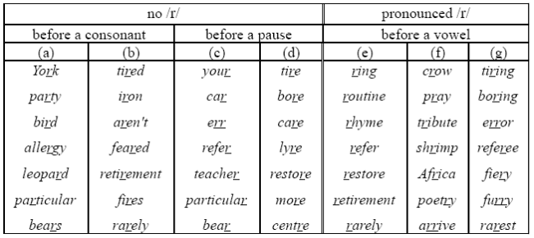

The lateral approximant in BBC English has got different realisations, unlike other English dialects. The realisations of the lateral approximant are known as clear and dark “l”.

* Clear l is articulated before vowels and the consonant / j / as in play, lay and value; it is produced with the tip of the tongue touching the alveolar ridge with no raising of the back of the tongue.
* Dark “l”, however, is produced with raising the back of the tongue towards the velum that is why it is called velarised / l /. It is realized before consonants or a pause like in the words belt and fall. In American English, the / l / sound is not clear but dark in all the environments. Clear and dark “l” have got the IPA symbols [ l ] and [ ɫ ] respectively.
* 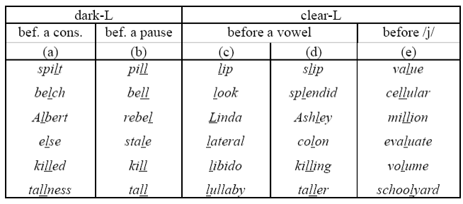

Task 1:

**Which of the medial consonants are devoiced in the following words?** Runner, stomach, passion, salute, mission, measure, pillar, either, ether

**Task 2: Identify dark ‘l’ and light ‘l’ in the following words:**  
Linear - Plato - polo -health - particular - parliament - example - lemonade -  
welsh

Task 3

- Give a symbol of the following:  
1- Voiced, post alveolar, approximant, oral.  
2- Voiceless, labiodentals, fricative, oral.  
3- Voiced, bilabial, nasal.  
4- A voiced sound that has the same place of articulation as /s/ and the  
same manner of articulation as /ʃ/.  
5- A voiceless consonant that has the same active articulator as /t/ and  
the same passive articulator as /f/

Task 4:

