**Speech sounds production**

Most of thespeech sounds are the result of movements of the tongue and the lips. Producing any sound requires energy and the basic source of this energy is the **respiratory system** pushing air out of the lungs. The air stream goes from the **lungs** up to the **windpipe** (trachea) and into the **larynx,** at this point the air passes through two small muscular folds known as the **vocal folds**. The larynx, together with the vocal folds, constitutes the **phonatory system**.

After passing through the larynx, the air goes through the **vocal tract** also known as the **articulatory system**, which ends at the mouth and nostrils and the air escapes into the atmosphere. The parts of the vocal tract that can be used to form sounds, such as the tongue and the lips are called **articulators**.

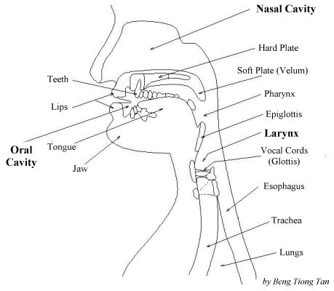

**Fig1. Speech mechanism**

**1. The phonatory system**

The main function of the larynx, along with the vocal folds, is to provide voice out of the air released from the lungs. The air passes from the bronchial tubes into the trachea, which consists of rings of cartilages, to reach the larynx which is a box-like organ that is also made of cartilages (See Figure2).

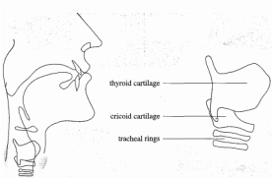

**Fig 2. Side view of the larynx (Roach 2009, P 22)**

Inside the larynx there are the vocal folds which are two flaps of muscles attached to the cartilages. A larynx top view (See Fig 3.) shows that the vocal folds at the front are attached to the thyroid cartilage and at the back they are attached to a pair of small cartilages known as the arytenoids which can move forward and backward, and from side to side allowing the vocal folds to move also. The opening between the vocal folds

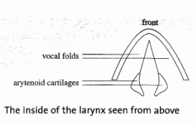

**Fig. 3 Top view of the larynx (Roach 2009, P 23)**

is known as the **glottis**. There are four positions of the glottis which determine to some extent the nature of the sound.

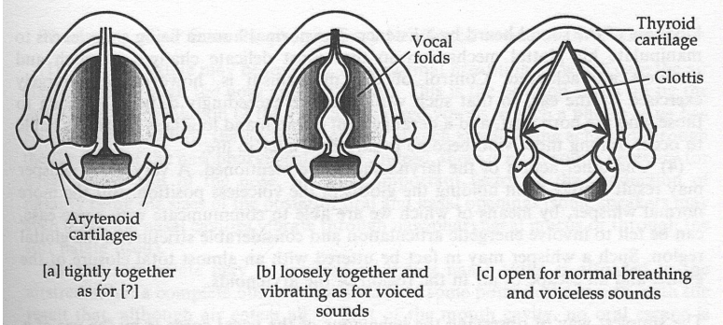

**Fig4.**

**STATES OF THE GLOTTIS**

**GLOTTAL STOP:**The entire glottis is closed (no air can pass through)  
2. **VOICELESS SOUNDS**: The glottis is open (the vocal folds are apart to  
a certain degree). The amount of airflow is greater for voiceless sounds  
than for voiced sounds.  
3. **VOICED SOUNDS**: The vocal folds vibrate and the cartilaginous glottis  
(space between the arytenoid cartilages) is closed.  
4. Intermediate positions of the glottis:  
a. **MURMUR** or **BREATHY VOICE** [Ó ] The vocal folds vibrate  
but there is also a breathy quality present -- the vocal folds are slightly apart

**2. The articulatory system (Vocal tract)** Figure (Fig5 below shows the articulators.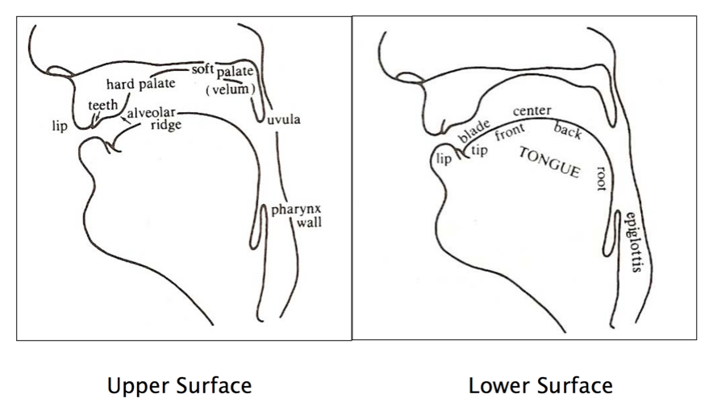**Fig 5 The Articulators**

The **lips** and the **teeth** are familiar-enough structures. Just behind the upper teeth is a small bumpy surface which is called the **alveolar** **ridge** which is followed by a larger bony structure which is the **hard palate**. At the back of the mouth with the fingertip or the tongue curled up, you can feel the **soft palate** or **velum** which is a muscular flap that opens and closes the passage that links the pharynx to the nasal cavity. At the lower end of the soft palate is a small organ hanging down that is known as the *uvula*. The part of the vocal tract between the uvula and the larynx is the **pharynx**. In the lower part of the vocal tract lies the **tongue** which is divided into the **tip**, the **blade**, the **front**, the **centre** then the **back** and finally the **root** as shown in the right side of fig 1 above.

The consonants produced by different articulators are labeled according to the organ which moved to produce them. The consonants produced with the lips’ movements are called **bilabials**, and those produced with the tongue coming against the teeth, the alveolar ridge, the hard palate and the soft palate the consonants are called **dental, alveolar, palatal** and **velar** sounds respectively. The sound produced by keeping the vocal folds spread somewhat or pressing the folds together is called the **glottal**.

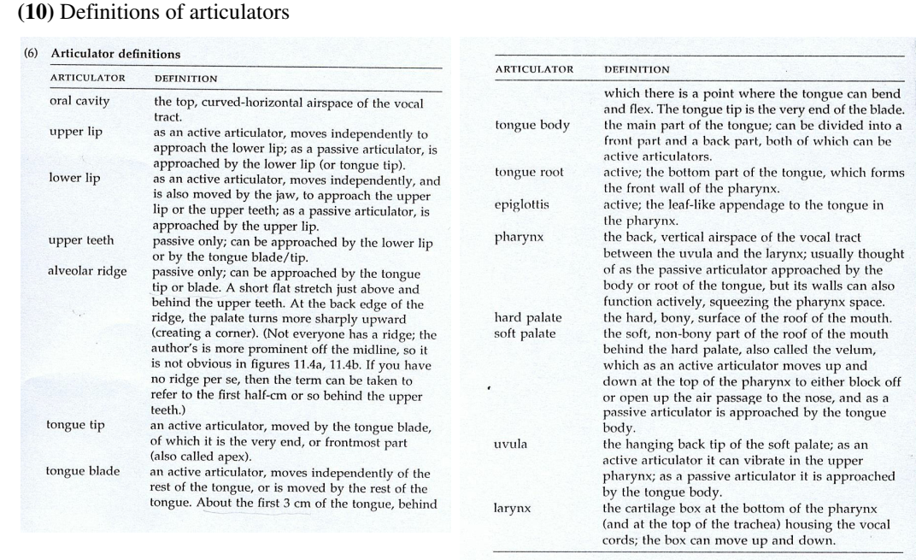

Table 1.Articulators Definition