**Exercise 1: Put the verbs in brackets into the simple present or the present continuous tense**   
1 Cuckoos (not build) nests. They (use) the nests of other birds.  
2 You can't see Tom now: he (have) a bath.  
3 He usually (drink) coffee but today he (drink) tea.  
4 What she (do) in the evenings? ~  
She usually (play) cards or (watch) TV.  
5 I won't go out now as it (rain) and I -(not have) an umbrella.  
6 The last train (leave) the station at 11.30.  
7 He usually (speak) so quickly that I (not understand) him.

8 Ann (make) a dress for herself at the moment. She (make) all her  
own clothes.  
9 Hardly anyone (wear) a hat nowadays.  
10 I'm afraid I've broken one of your coffee cups. —  
Don't worry. I (not like) that set anyway.  
11 I (wear) my sunglasses today because the sun is very strong.  
12 Tom can't have the newspaper now because his aunt (read) it.  
13 I'm busy at the moment. I (redecorate) the sitting room.  
14 The kettle (boil) now. Shall I make the tea?  
15 You (enjoy) yourself or would you like to leave now? -  
I (enjoy) myself very much. I (want) to stay to the end.  
16 How you (get) to work as a rule? ~  
I usually (go) by bus but tomorrow I (go) in Tom's car.  
17 Why you (put) on your coat? ~  
I (go) for a walk. You (come) with me?-  
Yes, I'd love to come. You (mind) if I bring my dog?  
18 How much you (owe) him?-  
I (owe) him Ј5. ~  
You (intend) to pay him?  
19 You (belong) to your local library? -  
Yes, I do. -  
You (read) a lot?-  
Yes, quite a lot. -

**Exercise 2: Put the verbs in brackets into the simple present or present continuous tense.**

What Tom (think) of the Budget? -  
He (think) it most unfair. ~  
I (agree) with him.  
2 What this one (cost)?-  
It (cost) forty pence.  
3 You (hear) the wind? It (blow) very strongly tonight.  
4 You (see) my car keys anywhere? -  
No, I (look) for them but I (not see) them.  
5 He never (listen) to what you say. He always (think) about something else.  
6 This book is about a man who (desert) his family and (go) to live on a Pacific island.  
7 You (understand) what the lecturer is saying? ~  
No, I (not understand) him at all.

8 What you (have) for breakfast usually? ~  
I usually (eat) a carrot and (drink) a glass of cold water.  
9 When the curtain (rise) we (see) a group of workers. They (picket) factory gate.  
10 Why you (walk) so fast today? You usually (walk) quite slowly. ~  
I (hurry) because I (meet) my mother at 4 o'clock and she (not like) to be kept waiting.  
11 I (wish) that dog would lie down. He (keep) jumping up on my lap. ~  
I (think) he (want) to go for a walk.  
12 You (recognize) that man? ~  
I (think) that I have seen him before but I (not remember) his name  
13 Look at that crowd. I (wonder) what they (wait) for.  
14 This message has just arrived and the man (wait) in case you (want) to send a reply.  
15 Stop! You (not see) the notice?

**Exercise 3**

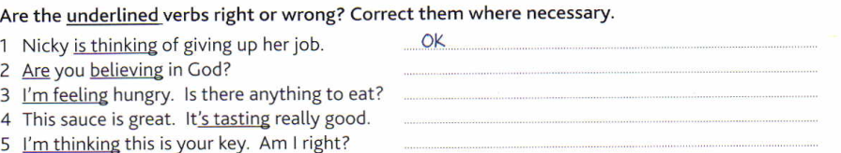

**Exercise 4**

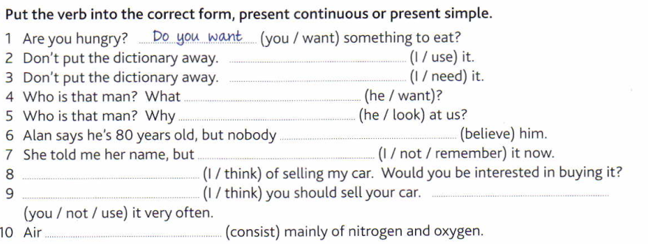

**Exercise 1**: 1 don't build, use 2 is having 3 drinks, is drinking 4 does she do, plays, watches 5 is raining, haven't 6 leaves 77 speaks, don't understand 8 is making, makes  
9 wears 10 don't like 11 am wearing 12 is reading 13 am redecorating 14 is boiling 15 are you  
enjoying, am enjoying, want 16 do you get, go, am going 17 are you putting, am going, are you coming, do you mind 18 do you owe, I owe, do you intend 19 do you belong, do you read, do you change, I change 20 learns, doesn't seem

**Exercise** **2**: 1 does Tom think, thinks, agree 2 does this one cost, it costs 3 do you hear, is  
blowing 4 do you see, am looking, don't see 5 listens, is always thinking 6 deserts, goes  
7 do you understand, don't understand 8 do you have, eat, drink 9 rises, see, are picketing 10 are you walking, walk, am hurrying, am meeting, doesn't like II wish, keeps, think, wants 12 do you recognize, think, don't remember 13 wonder, waiting for 14 is waiting, want 15 don't you see, see, am not wearing, does it say, says

**Exercise 3:** Do you believe, Ok (I feel is also correct), it tastes, I think

**Exercise 4:**

I am using , I need, doesn’t he want, is he looking, believes, I don’t remember or I can’t remember, I am thinking, I think…. You don’t use, consists.