**States Of The Glottis**

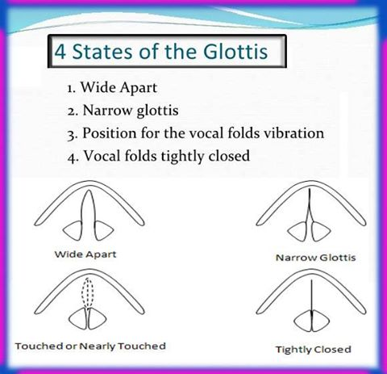

2. Pronunciation of final “s” and final “Ed”

1. In English, there are three different pronunciations of the –ed ending for regular past tense verbs. The pronunciation of the –ed ending depends on the final sound in the verb:
   * If the verb ends in a –d or a –t, the –ed ending is pronounced as a new syllable, /id/.
   * If the verb ends in a vowel sound or a voiced consonant (l, n, r, b, g, m, z, s, v), then the –ed ending sounds like a /d/ and does not create a new syllable.
   * If the verb ends in an unvoiced consonant (p, k, f, gh, sh, ch, ss, c, x), then the –ed ending sounds like a /t/ and does not create a new syllable.
2. The pronunciation depends on the sound at the end of the infinitve of the main verb and whether it is **voiced**
3. or not.

|  |  |  |
| --- | --- | --- |
| **/Id /** infinitives that end in the sounds  /t/ or /d/ | **/ d /** infinitives that end in a voiced sound | **/ t /** infinitves that end in an unvoiced sound |

The pronunciation of the S in plurals, 3rd person singular verbsThe pronunciation of the final S in plural words and verbs in the third person singular depends on the final consonant sound before that S.  
The ending is pronounced /s/ after a voiceless sound, it is pronounced /z/ after a voiced sound and is pronounced /ɪz after a sibilant sound:  
• Voiceless: helps /ps/ -- sits /ts/ -- looks /ks/  
• Voiced: crabs /bz/ -- words /dz/ -- gloves /vz/,  
• Sibilant: buses /sɪz / , bridges /dʒɪz / or wishes /shɪz /  
1. The /ɪz/ soundIf the last consonant sound of the word is a sibilant sound , the final S is pronounced as /ɪz/. This /ɪz/ sound is  
pronounced like an extra syllable.  
Examples of words ending in the /ɪz/ sound:  
• -CE: races (sounds like "race-iz") , embraces, places, convinces  
• -S / SE: buses, gases, rises, pauses, nurses  
• -X: fixes, mixes, boxes, taxes  
• -ZE: amazes, freezes, prizes, quizzes, seizes  
• -SS: kisses, misses, passes, bosses, glasses, dresses  
• -CH: churches, sandwiches, witches, teaches, watches, reaches  
• -SH: dishes, eyelashes, hairbrushes, wishes, pushes, crashes,  
• -GE: garages, wages, changes, ages, judges, arranges, challenges  
Remember: after verbs ending in -sh, -ch, -s, -ss and -x, we add the -es to the end of the verb (in third person) and th  
pronunciation is /iz/ as an extra syllable.  
2. The /s/ soundIf the last consonant of the word is voiceless, then the S is pronounced as /s/.  
NOTE: The consonants c, s, sh, ch and x are voiceless though they use the sibilants ending seen above.  
Examples of words ending in the /s/ sound:  
• -P/ PE : cups, stops, sleeps, landscapes, types, telescopes  
• -T/ TE: hats, students, hits, writes, graduates, institutes  
• -K/ KE: cooks, books, drinks, walks, likes, snakes  
• -F: cliffs, sniffs, beliefs, laughs, graphs, apostrophes (the -gh and -ph here are pronounced like a F)  
• -TH: myths, tablecloths, months (voiceless th /ɵ/), baths, earths  
3. The /z/ soundIf the last letter of the words ends in a voiced consonant (or sound), then the S is pronounced like a Z /z/(without  
creating another syllable). This Z sound is similar to the sound a bee makes zzzz.  
We also use this ending when the word ends in a vowel sound (e.g. bees, flies etc.)  
Examples of words ending in the /z/ sound:  
• -B/ BE : crabs, rubs, describes, tubes  
• -D/ DE : cards, words, rides, ends  
• -G: rugs, bags, begs  
• -L/ LE: deals calls, falls, hills, crocodiles, styles,  
• -M/ ME: plums, dreams, times, comes  
• -N/ NE: fans, drains, runs, pens, hormones, stones  
• -NG: kings, belongs, sings, meanings, things  
• -R/ RE: wears, cures, fires, signatures, figures  
• -VE: gloves, wives, shelves, drives  
• -Y: plays, cries, buys, boys, factories, says  
• -THE: clothes, bathes, breathes  
• -VOWEL SOUNDS: sees, seas, toes, photos  
**First Term Phonetics Practice Activities**

1. Classify the following verbs and adjectives according to their final –ed pronunciation.

Laughed freaked crammed damaged cleaned wicked watched faced needed tilted astonished amused wretched dogged acknowledged beloved breathed believed

|  |  |  |
| --- | --- | --- |
| **/t/** | **/d/** | **/ɪd/** |
|  |  |  |

1. Classify the following verbs and adjectives according to their final –s pronunciation.

Hedges boxes bosses bridges fixies tries misses Mrs houses climbs rights plays gigs makes mops doors runs shines Smith’s p’s workers

|  |  |  |
| --- | --- | --- |
| **/s/** | **/z/** | **/ɪz/** |
|  |  |  |