***Lesson 03 : pronunciation of final s***

***Miss : Laouamen .f***

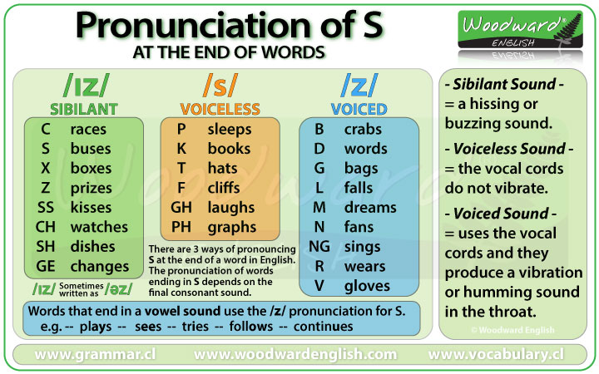

***Task 01 : classify the following words :***  likes , calls , works , classifies , hopes , finishes , sings , dances , looks , eats , goes , kisses , flashes , news , refuses , baths ,taxes , stops , brings , catches

|  |  |  |
| --- | --- | --- |
| /s/ | /iz/ | /z/ |
|  |  |  |