Lec2 Research Types
Lecture2: Research types
Questions guiding the lecture
- What are the principles/ criteria of research classification?
- Introduction to research onion
- What is the difference between primary and secondary research?
- What is the difference between applied and basic research?
- What is the difference between cross-sectional and longitudinal research?

Research has a multifaceted nature; it differs in terms of theoretical framework, aim, data collected, methods of data analysis and time scale. The distinction between applied research and basic research results from the aim that guides any investigation. The research that aims at providing solutions to existing problems is classified as applied research. It is contrasted with research that adds to the theoretical knowledge without having any immediate practical use in everyday situations. If examined from the perspective of the role of theory, research can be grouped into two types: inductive and deductive research. The type of data is a further criterion based on which research can be referred to as quantitative or qualitative.

Criterion | Type of research
Aim from acquiring knowledge | Basic/ applied
Empirical investigation | Primary / secondary
Paradigm | Positivist/ interpretivist
Way of reasoning/ role of theory | Inductive / deductive
Type of data | Quantitative / qualitative
Purpose from conducting the study | Exploratory/ descriptive/ explanatory
Time horizon | Cross-sectional/ longitudinal

The research onion
The research onion is a model that can be visually represented in terms of layers; each layer helps in situating research in terms of a particular criterion. Because planning research requires making choices as to methods to use, the whole range of choices should be made clear. According to Saunders, Lewis and Thornhill (2008), the outer layers in the diagram represent the paradigms followed by the research approaches, strategies, and choices. The inner layers are relevant to the choices made about the data collection and analysis techniques.

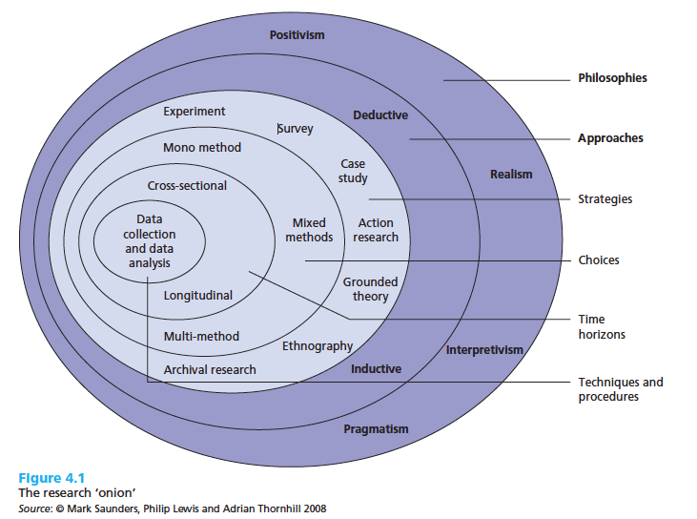
1. Basic vs applied research
Basic, also called pure, research adds to the theoretical understanding that people have. In this type, the scope of research can be a concept or an issue that contributes to the overall intellectual inquiry. It does not necessarily respond to immediate problems faced by people. The value of this research is not perceived in everyday problems; instead, it is in generating new knowledge. Knowledge is acquired for its own sake and not for a practical objective. One example of pure research is the inquiry made by cosmologists (astronomy) to understand how the universe has started and how it expands. Their studies help them develop the theoretical knowledge about the universe. Likewise, the studies physicians conduct on molecules are examples of knowledge acquired for the sake of knowledge. In Second Language Acquisition (SLA), basic research is illustrated by the attempts to define language learning theoretically, or more particularly, to examine the importance of input when learning language in general.
Applied research attempts to address the problems faced by people in real world contexts. It is guided by practical questions and the solutions brought at the end are eventually adopted in real settings. It generates practical knowledge that provides help to people in particular problematic situations. In the language teaching for example, a study dealing with forms of feedback on students writing, or a study on classroom dynamics can be classified as applied research. In both cases, a problem requires a solution. In the first case, accuracy errors of the paragraph writing or coherence flaws urged teachers and researchers to find solutions to be used in specific contexts with particular learners. Similarly, in the second example, the reluctance of students to have a more active role in the learning process needed to be dealt with.

2. Primary research vs secondary research
Primary research and secondary research are types of research that differ in terms of data and the way they data were collected .
In primary research, the investigation is guided by a research question posed by the researcher himself. As a result, all the steps of the research aim at answering the initially posed research question. Because answering a research question requires the systematic procedure of collecting data and analysing it, the product of research (article, dissertation ….) includes a ‘Methods’ section or chapter. This part explains how data collection and analysis were conducted. It also gives details about the sample from which data were gathered and the characteristics of the participants. Examples of primary research include research articles, research projects…
Secondary research: this type of research can also be referred to by library research. In this type, the researcher often provides a summary or interpretation of research conducted by others. The data used is considered second-hand data because the producer of secondary research limited his research work to the compilation, summarising, or critiquing of primary research. The most illustrative example of secondary research is the literature review. Obviously secondary research does not include a Methods section explaining from whom and how data was collected.
Primary research | Secondary research
- They are first hand reports written by the researchers themselves who conducted research  - The researcher is the origin of the research idea and research question.  is conducted to answer a question.  - Involves the collection of original data specific to that particular research project  - Examples of PR include  Research articles published by scholars in educational research.  - Content  Methods section/ chapter describes the participants, their characteristics, and explains what has been done in the study to obtain data and to analyse it. | - They are summaries of other people’s primary research. They can be critiques or analyses of other researchers studies.  - the idea of research is not generated by the writer of the written work.  - No original data is collected  - Examples of SR include Textbooks, Theoretical papers presented at conferences, literature reviews, position papers, books, handbooks, encyclopaedias, journal articles that summarise research.  - Content  No method section/ chapter is included.  Literature review compares and contrasts many studies.

3. Cross-sectional vs longitudinal research
The time horizon is a further criterion that distinguishes between research types. In cross-sectional research, data collection occurs in one point in time while in longitudinal research the collection extends over a different points in time.
A cross-sectional study gathers data examines the samples’ characteristics at given point in time without any attempt to check any developmental differences due to time factor. If a researcher is , for example, studying the way first grade children react to their teacher’s rewards, the objective is limited to one period of time, and the data collected will not be compared, in the same study, with data collected previously or subsequently.
Longitudinal research is more suited to studies whose objective is to investigate changes occurring over time and the effect on time variable on the development of a particular aspect. The period of time could be relatively short extending over a number of week or relatively long extending over years. Whether it is a short term or long term study period, longitudinal research investigators involve in comparisons of data gathered in different periods. On example of longitudinal research is the study of how children react to teachers verbal rewards at different points in time. In a similar study, children are examined in preschool period, at first grade , second grade and third grade for example.

