is known as the **glottis**. There are four positions of the glottis which determine to some extent the nature of the sound. The positions of the glottis will be tackled in the next chapter.

**2. The articulatory system (Vocal tract)** Figure (Fig) 2.1 below shows the articulators.

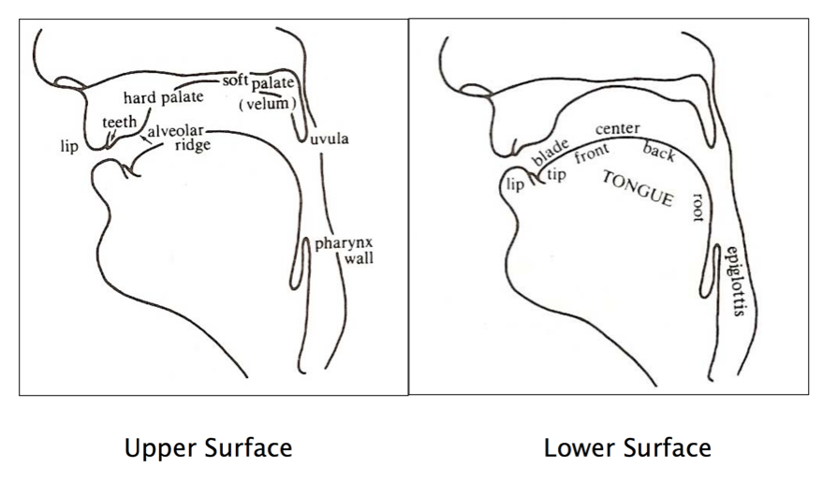**Fig 2.1 The Articulators**

The **lips** and the **teeth** are familiar-enough structures. Just behind the upper teeth is a small bumpy surface which is called the **alveolar** **ridge** which is followed by a larger bony structure which is the **hard palate**. At the back of the mouth with the fingertip or the tongue curled up, you can feel the **soft palate** or **velum** which is a muscular flap that opens and closes the passage that links the pharynx to the nasal cavity. At the lower end of the soft palate is a small organ hanging down that is known as the *uvula*. The part of the vocal tract between the uvula and the larynx is the **pharynx**. In the lower part of the vocal tract lies the **tongue** which is divided into the **tip**, the **blade**, the **front**, the **centre** then the **back** and finally the **root** as shown in the right side of fig 1 above.

The consonants produced by different articulators are labeled according to the organ which moved to produce them. The consonants produced with the lips’ movements are called **bilabials**, and those produced with the tongue coming against the teeth, the alveolar ridge, the hard palate and the soft palate the consonants are called **dental, alveolar, palatal** and **velar** sounds respectively. The sound produced by keeping the vocal folds spread somewhat or pressing the folds together is called the **glottal**.