**What are the components of a computer?**

A computer consists of several essential components, each playing a specific role in its functioning. Here are the main components:

1. **Central Unit (CU)**
   * **Processor (CPU)**: The "brain" of the computer, responsible for processing instructions.
   * **Motherboard**: The main board that connects all components together and allows communication between them.
2. **Memory**
   * **RAM (Random Access Memory)**: Used to temporarily store data and programs currently in use.

RAM is volatile memory, meaning that the information that is stored in the modules is erased when you restart or shut down your computer. As the information is stored in electrical form in transistors, when the power is cut off, the data disappears. Each time you request information, it is retrieved from the computer's storage drive or from the Internet. The data is stored in RAM, so every time you move from one program or page to another, the information always remains available instantly. When the computer is turned off, the memory remains empty until the process starts again. Volatile memory can be easily changed, upgraded, or added by users. Find out if your computer needs more memory.

* + **ROM(Read Only Memory)**

The ROM is a non-volatile memory, which means that the information is permanently stored in the chip. Data storage does not depend on an electrical current, instead, the information is written in individual cells in binary language. Non-volatile memory is used for computer components that don't change, such as the software that's responsible for booting, or the firmware instructions that run your printer. Turning off the computer has no effect on the ROM. Nonvolatile memory cannot be modified by users.

**Cache Memory**

**Cache memory** is a special type of high-speed memory located close to the CPU in a computer. It stores frequently used data and instructions, allowing the CPU to access them quickly, thereby improving the overall speed and efficiency of the computer. Cache memory is faster and smaller than primary memory (RAM) and acts as a buffer between the CPU and the main memory.

**Hard Drive (HDD) or SSD (Solid State Drive)**:

A hard disk drive (HDD) is an internal or external computer component that stores data, such as the operating system, applications, and user files. HDDs are “non-volatile” storage devices, meaning they retain stored data even when power isn't being supplied.

SSDs (Solid State Drives) are a newer computer storage technology. They use flash memory to digitally read and write data. Since they don't have to mechanically search for data, SSDs offer near-instantaneous boot and load times.

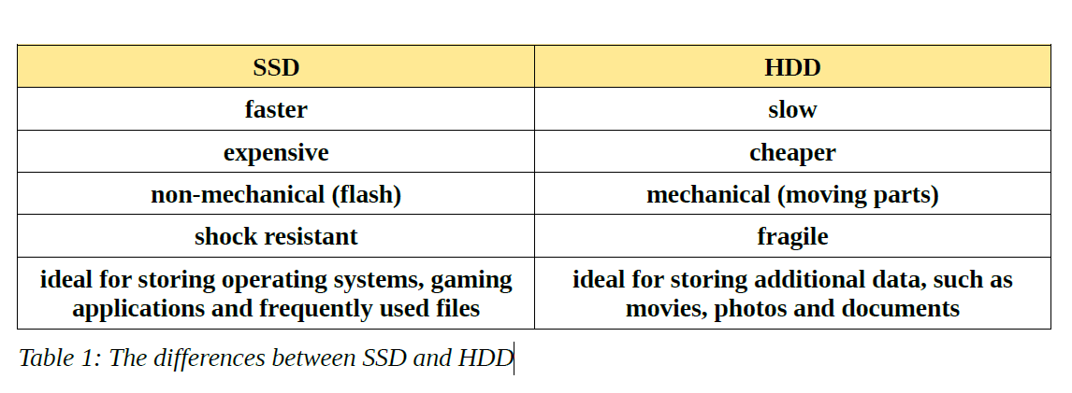

1. **Power Supply**
   * **Power Supply Unit (PSU)**: Converts electricity from the mains into a usable voltage for the computer components.
2. **Devices**
   * **Keyboard**: Allows data entry and command input.
   * **Mouse**: Used to navigate the computer's graphical interface.
   * **Scanner, webcam, microphone**: Other devices for data input.
3. **Output Devices**
   * **Monitor**: Displays the user interface and information.
   * **Printer**: Produces physical copies of documents.
   * **Speakers**: For audio output.
   * **Projectors**:

**Input and output devices: Storage devices, Touch screen**

1. **Expansion Cards**
   * **Graphics Card**: Manages graphics and display, essential for gaming and graphic applications.
   * **Sound Card**: Enhances audio quality of the computer.
   * **Network Cards (modems, WIFI key)**: Allow connection to the Internet or local networks.
2. **Chassis**
   * **Case**: Houses and protects all the computer components.
3. **Cooling System**
   * **Fans, heat sinks**: Maintain an adequate temperature to prevent overheating of components.

Each of these components plays a crucial role in the overall functioning of the computer.

**Factors affecting computer performance:**

• processor clock speed, amount of cache and number of kernels

• the amount of installed RAM

• graphics card- its memory and processor

• clockbus

• number of running applications

**Types of storage devices**

Now we will discuss the different types of storage devices available in the market. These storage

devices have their own specifications and uses. Some of the commonly used storage devices are:

1. **Primary Memory:** It is also called internal memory and main memory. It is a section of the processor that contains program instructions, input data and intermediate results. Its size is generally smaller. RAM (Random Access Memory) and ROM (Read Only Memory) are examples of primary storage.

2. **Secondary Memory:** Secondary storage is memory stored outside the computer. It is mainly used for permanent and long-term storage of programs and data. Hard drives, CDs, DVDs, USB sticks, SSDs, etc. are examples of secondary storage.

3. **Cloud and Virtual Storage:** Nowadays secondary memory has been upgraded to virtual storage devices or what is called cloud. We can store our files and other items in the cloud and the data is stored for as long as we pay for the cloud storage. Many companies provide cloud services, mainly Google, Amazon, Microsoft, etc. We can pay the rent for the amount of space we need and we get many benefits from it. Although it is actually stored on a physical device located in the service provider's data centers, the user does not interact with the physical device or its maintenance. For example, Amazon Web Services offers AWS S3 as a storage type where users can store data virtually instead of storing it on physical hard

drives.

There are also virtual storage services (cloud) that offer us the possibility of storing data for free, but with a limited quantity.

**3.1.2. Software**

Software is, unlike hardware, intangible part of the computer. It consists of a sequence of commands, written according to strict rules. Programs are written by programmers, in various programming languages.

**Software types:**

➔ **Operating system**

Operating system is a program which manages computer hardware. First computers did not have operating systems; they had programs that were directly loaded into the computer (e.g. punchcards).

Today, computers have an operating system which loads into the computer's memory during its startup. Computer functions are based on its operating system.

The most famous operating systems are:

1. **Linux** (Debian, Ubuntu, Fedora, Knoppix,...) - open source software

2. **Microsoft** Windows (XP, Vista, 7,...) - proprietary software

3. **Mac OS** (Cheetah, Panther, Snow Leopard,...) - proprietary software

**Application Software (Utility programs)**

Application Software (Utility programs) are all programs that users use to perform different tasks or

for problem solving. Users, according to his/her needs, install the appropriate utility software.

Computer functions and tasks that computers can perform are defined by the installed utility

software. Utility software can often cost more than computer hardware unless the software is open

source.

**Common utility softwares are:**

 **Text processing** software is used for creating and forming text documents and nowadays,

they can contain images, charts and tables. Examples of such programs are LibreOffice

Writer (open source software) and Microsoft Word (proprietary software).

 **Spreadsheet calculations** software is used for performing various calculations and

presentation of results in charts. Examples of such programs are LibreOffice Calc Writer

(open source software) and Microsoft Excel (proprietary software).

 Software for **presentations** is used to create professional presentations that consist of slides

with graphical and textual elements. Such a presentation can afterwards be displayed as a

"slide show” by using a projector. Examples of such programs are LibreOffice Impress

(open source software) and Microsoft PowerPoint (proprietary software).

 Software for **creating and managing database** helps to manage a collection of structured

data. Examples of such programs are OpenOffice.org Base (open source software) and

MicrosoftAccess (proprietary software).

**Common utility software installed on a computer:**

 **office programs** - LibreOffice Microsoft Office

 **antivirus programs** – Avira, Sophos, Kaspersky, Antivir etc.

 **Internet browser**: Mozilla Firefox, Microsoft Edge, Opera, Safari, Google etc.

 **programs for image editing**: Adobe Photoshop, Canvas, CorelDraw, Draw etc.

**4. Networks**

Computer network is comprised of at least two, connected, by wire or wireless, computers that can exchange data i.e. communicate. There are many reasons for connecting computers into a network, and some of them are:

• exchange of data between users that have network access,

• access to shared devices, such as network printers, network disks, etc.,

• enables user communication and socializing, etc.

**Internet** is the most famous and most widespread network with nearly 5.2 billion users and the number of users is still growing.

**4.1. Types of Networks**

Types of networks according to their size:

• **LAN (Local Area Network)** - a network that covers a relatively small geographical area- it connects computers within a firm or household by wire,

• **WLAN(Wireless Local Area Network)** - a network that covers a relatively small

geographical area - it connects computers within a firm or household wirelessly,

• **WAN (Wide Area Network)**- a network that covers a relatively large geographical area – it connects a greater number of computers and local networks.