Mark Cartwright

Domesday, Feudalism & the Peasantry

There was no particular feeling of outraged nationalism following the conquest - the concept is a much more modern construct - and so peasants would not have felt their country had somehow been lost. Neither was there any specific hatred of the Normans as the English grouped all William’s allies together as a single group - Bretons and Angevins were simply ‘French speakers’.  In the Middle Ages, visitors to an area that came from a distant town were regarded just as ‘foreign’ as someone from another country. Peasants really only felt loyalty to their own local communities and lords, although this may well have resulted in some ill-feeling when a lord was replaced by a Norman noble in cases where the Anglo-Saxon lord was held with any affection. The Normans would certainly have seemed like outsiders, a feeling only strengthened by language barriers, and the king, at least initially, did ensure loyalties by imposing harsh penalties on any dissent. For example, if a Norman were found murdered, then the nearest village was burnt - a policy hardly likely to win over any affection.

At the same time, there were new laws to ensure the Normans did not abuse their power, such as the crime of murder being applied to the unjustified killing of non-rebels or for personal gain and the introduction of trial by [**battle**](https://www.ancient.eu/battle/) to defend one’s innocence. In essence, citizens were required to swear an oath of loyalty to the king, in return for which they received legal protection if they were wronged. Some of the new laws would be long-lasting, such as the favouring of the firstborn in inheritance claims, while others were deeply unpopular, such as William’s withdrawal of hunting rights in certain areas, notably the New Forest. Poachers were severely dealt with and could expect to be blinded or mutilated if caught. Another important change due to new laws regarded slavery, which was essentially eliminated from England by 1130 CE, just as it had been in Normandy.

**[[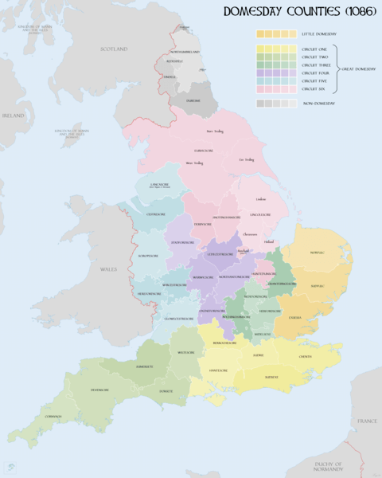](https://www.ancient.eu/image/9474/map-of-domesday-book-circuits/)](https://www.ancient.eu/image/9474/map-of-domesday-book-circuits/" \o "Map of Domesday Book Circuits)**

[Map of Domesday Book Circuits](https://www.ancient.eu/image/9474/map-of-domesday-book-circuits/" \o "Map of Domesday Book Circuits)

[by XrysD (CC BY-SA)](https://www.ancient.eu/image/9474/map-of-domesday-book-circuits/" \o "Map of Domesday Book Circuits)

Perhaps one area where hatred of all-things Norman was prevalent was the north of England. Following the rebellions against William’s rule there in 1067 and 1068 CE, the king spent the winter of 1069-70 CE 'harrying' the entire northern part of his kingdom from the west to east coast. This involved hunting down rebels, murders and mutilations amongst the peasantry, and the burning of crops, livestock, and farming equipment, which resulted in a devastating famine. As Domesday Book (see below) revealed, much of the northern lands were devastated and catalogued as worthless. It would take over a century for the region to recover.

Domesday Book was compiled on William’s orders in 1086-7 CE, probably to find out for tax purposes exactly who owned what in England following the deaths of many Anglo-Saxon nobles over the course of the conquest and the giving out of new estates and titles by the king to his loyal followers. Indeed, Domesday Book reveals William’s total reshaping of land ownership and power in England. It was the most comprehensive survey ever undertaken in any medieval kingdom and is full of juicy statistics for modern historians to study such as the revelation that 90% of the population lived in the countryside and 75% of the people were serfs (unfree labourers).

A consequence of William’s land policies was the development (but not the origin of) feudalism. That is, William, who considered all the land in England his own personal property, gave out parcels of land (fiefs) to nobles (vassals) who in return had to give military service when required, such as during a [**war**](https://www.ancient.eu/war/) or to garrison castles and forts. Not necessarily giving service in person, a noble had to provide a number of knights depending on the size of the fief. The noble could have free peasants or serfs (aka villeins) work his lands, and he kept the proceeds of that labour. If a noble had a large estate, he could rent it out to a lesser noble who, in turn, had peasants work that land for him, thus creating an elaborate hierarchy of land ownership. Under the Normans, ecclesiastical landowners such as monasteries were similarly required to provide knights for military service.

**[[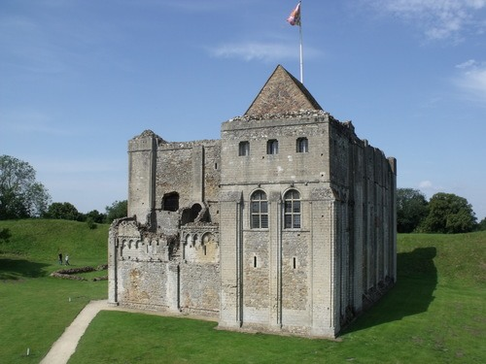](https://www.ancient.eu/image/9883/castle-rising-castle/)](https://www.ancient.eu/image/9883/castle-rising-castle/" \o "Castle Rising Castle)**

[Castle Rising Castle](https://www.ancient.eu/image/9883/castle-rising-castle/" \o "Castle Rising Castle)

[by Elliot Brown (CC BY)](https://www.ancient.eu/image/9883/castle-rising-castle/" \o "Castle Rising Castle)

The manorial system developed from its early Anglo-Saxon form under the Normans. Manorialism derives its name from the ‘manor’, the smallest piece of land which could support a single family. For administrative purposes, estates were divided into these units. Naturally, a powerful lord could own many hundreds of manors, either in the same place or in different locations. Each manor had free and/or unfree labour which worked on the land. The profits of that labour went to the landowner while the labourers sustained themselves by also working a small plot of land loaned to them by their lord. Following William’s policy of carving up estates and redistributing them, manorialism became much more widespread in England.

Trade & International Relations

The histories and even the cultures to some extent of France and England became much more intertwined in the decades after the conquest. Even as the King of England, William remained the Duke of Normandy (and so he had to pay homage to the King of France). The royal houses became even more interconnected following the reigns of William’s two sons (William II Rufus, r. 1087-1100 CE and  Henry I, r. 1100-1135 CE) and the civil wars which broke out between rivals for the English throne from 1135 CE onwards. A side effect of this close contact was the significant modification over time of the Anglo-Saxon Germanic language, both the syntax and vocabulary being influenced by the French language. That this change occurred even amongst the illiterate peasantry is testimony to the fact that French was commonly heard spoken everywhere.

One specific area of international relations which greatly increased was trade. Before the conquest, England had had limited trade with Scandinavia, but as this region went into decline from the 11th century CE and because the Normans had extensive contacts across Europe (England was not the only place they conquered), then trade with the Continent greatly increased. Traders also relocated from the Continent, notably to places where they were given favourable customs arrangements. Thus places like London, Southampton, and Nottingham attracted many French merchant settlers, and this movement included other groups such as Jewish merchants from Rouen. Goods thus came and went across the English Channel, for example, huge quantities of English wool were exported to Flanders and wine was imported from France (although there is evidence it was not the best wine that country had to offer).