**UNIVERSITY MOHAMED LAMINE DEBAGHINE– SETIF 2**

**Faculty of Arts and Languages**

**Department of English Language and Literature**

**Course: Translation**

**Level: 3rd Year**

**-------------------------------------------------------------------------------------**

**CAT Versus MT**

Many people have used translation software or translation tools to help them translate texts, but actually the term “translation software” is vague because any software related to translation can be called a **translation software**, no matter how different they are. So,**what do you really mean by saying “translation software”?**

There are two kinds of translation software:

1. **Machine Translation (MT, or automated translation, instant translation)**: software that generate translations totally by computer without human touch.
2. **Computer-assisted translation (CAT)**: software for professional translators who mostly translate on their own.

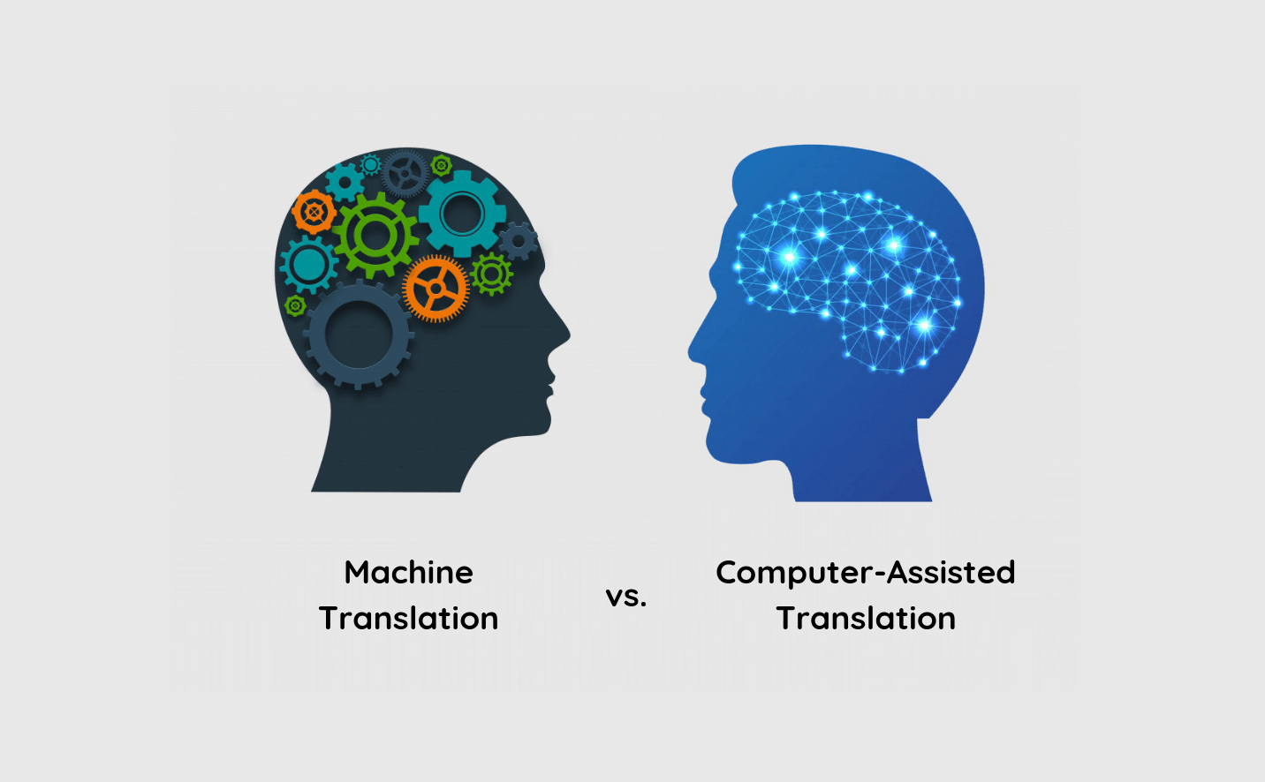

# What is Machine Translation (Traductique/Traduction automatique – الترجمة الآلية)?

# People have long dreamed of fast, accurate, and affordable translations. With the advancement of computer technology in the modern age, we hope that this dream would be 100% fulfilled by MT.

A machine translation application is a program that feeds a text to a computer algorithm which automatically translates it into another language. So no human is involved in the translation process.

Source texts (ST) are completed translated by machines (computer algorithms), with no humans involved throughout the process. Since humans are not part of the translation process, the accuracy of the translated text is often subpar and require human post-editing.

The advantages of MT include cost and speed. Computers can process a large amount of text almost instantly. But always remember that the accuracy of the MT is still limited today and it is not a good idea to use the translation you get from it in formal occasions, such as pitching or lecturing and some translators refuse to use these on ethical grounds or because they think it will lead to a poorer translation and dilute the craft.

## We differentiate between [three types of machine translation methods](https://translationjournal.net/journal/63mtquality.htm):

**1) Rules-based machine translation (Traduction automatique à base de règles - الترجمة الآلية القائمة على القواعد):**This method relies on grammar and language rules developed by language experts, and on highly customisable dictionaries.

For example, "sit on something = siéger à quelque chose" when the "quelque chose" is not an object.

**2) Statistical machine translation (Traduction automatique statistique “TAS” – الترجمة الآلية الإحصائية):**This method does not rely on linguistic rules and words; instead, it learns by analysing large volumes of existing human translations.

For example, in speech recognition, the following sentence presents two homophonic ambiguities for a software program: “Je me dirige vers le mur”. The software, even if it recognises my voice perfectly, will have to decide whether it is « vert », « verre », « vair » ou « vers », and then whether it is "mur" or " mûre'".

In the lists in the language model, he will probably find that “vers le mur” is much more frequent than all the other possibilities. In the end, he will probably find that “vers” is more frequent than its homophones. The model probably also contains 'le mur' but not 'le mûre'.

**3) Neural machine translation (Traduction automatique neuronale – الترجمة الآلية العصبية):**This method teaches itself how to translate by using a large neural network; it is becoming more and more popular because it provides better results than the other two methods. It is a technology based on artificial neural networks. It has made considerable progress in recent years thanks to artificial intelligence and can now be used as a basis for certain professional translations. Google MT and Microsoft Translator, for example, rely on neural networks.

## Some popular machine translation programs are:

* Amazon MT
* Google MT
* Omniscien Technologies
* Tilde MT
* Microsoft Translator
* Systran

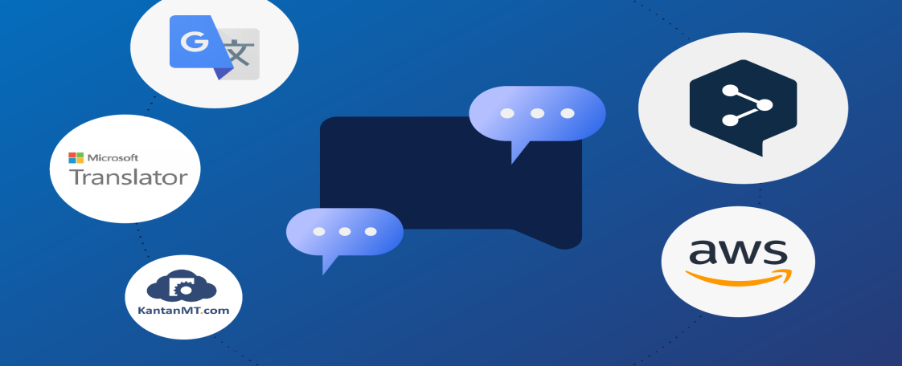

*If you are an end user of machines translation, you can go to any of the MT website, i.g., Google Translate to get your translation for free.

**What is a CAT tools (Traduction assistée par ordinateur “TAO” – الترجمة بمساعدة الحاسوب)?**

A CAT (computer-aided translation or computer-assisted translation) tool is software that [supports translators in preparing translations](https://www.academia.edu/18135325/Integration_of_Machine_Translation_in_CAT_Tools_State_of_the_Art_Evaluation_and_User_Attitudes). It converts a text to be translated, segments it, and then makes these segments (Segment – مقطع) available for translation in its own editor.

Source texts (ST) are translated by humans, who are aided by functions that can improve the speed and accuracy of the translation in the process. The most well-known function for improving the efficiency of the translation process is the**translation memory (Mémoire de traduction – ذاكرة الترجمة)**(TM, databases of texts in multiple languages) which collects individual translation units in a database; **terminology databases (base de données terminologiques/Banque de terminologie – قاعدة بيانات المصطلحات)** (to help translators save and reuse terminology efficiently, locate the correct terminology for that field), **terminology managers (Gestionnaire de terminologie – مسير المصطلحات/إدارة المصطلحات)** (that help translators maintain consistent terminology throughout the translation) and **bitext aligners (Aligneurs de bitexte – تصفيف "بايتكست" أو دمج النص وترجمته)** (which align the source text and the translation for side-by-side comparison), and more.

Today, CAT tools are available as desktop versions, and server-based or cloud-based. Server-based versions are usually used by larger language service providers as they allow multiple translators to work on a project simultaneously.

## Some of the most popular CAT tools on the market are:

* memoQ
* SDL Trados Studio
* Across
* OmegaT
* Wordfast
* Smartcat

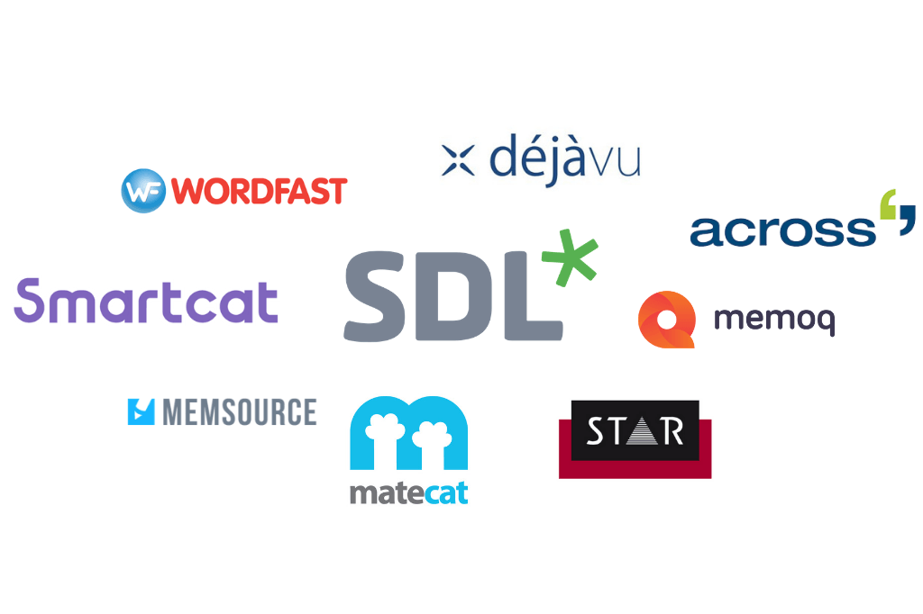

*You probably already use some of these tools yourself. For example, nearly every word processor, and many web browsers, have a built-in spell checker and/or automatic spelling correction function. This saves writers and translators a lot of time looking up words in the dictionary!

A CAT tool or Translation Memory, therefore, does not translate independently, unlike machine translation programs, but only serves to support a human translator and stores the created translations in a database. In fact, studies have shown that [translators work up to 28% faster](https://www.aclweb.org/anthology/W14-0314.pdf) when using a CAT tool.

It’s important that we don’t confuse CAT tools with machine translations programs.

-------------------------------------------------------------------------------------------

**Retrieved from:**

* <https://medium.com/termsoup/differences-between-machine-translation-mt-and-computer-assisted-translation-cat-163af675c678>
* <https://towardsdatascience.com/computer-assisted-translation-systems-versus-machine-translation-fa73fc9db4ed>
* <https://www.ulatus.com/translation-blog/machine-translation-vs-computer-assisted-translation-whats-the-difference/>