**Microsoft PowerPoint: Tool for Presentations**

**Introduction**

Microsoft PowerPoint is a graphic presentation software developed by Microsoft. It has become an industry standard for creating compelling and informative slideshows, used in a multitude of contexts, ranging from corporate meetings to academic conferences, training sessions, and sales presentations. Its popularity stems from its ease of use, rich feature set, and ability to transform complex ideas into clear and engaging visual messages.

**I. Key Functionalities of PowerPoint**

PowerPoint offers a comprehensive array of functionalities designed to facilitate the creation, customization, and delivery of effective presentations. Among the most important are:

**A. Slide Creation and Organization**:

* ***1- Intuitive Interface***: PowerPoint's ribbon interface is user-friendly, providing easy access to various tools and options. The logical organization of tabs and commands streamlines the workflow for both beginners and experienced users.

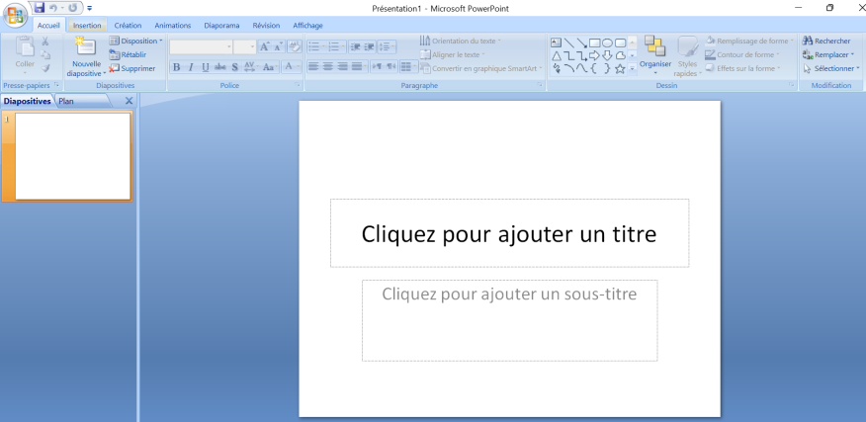

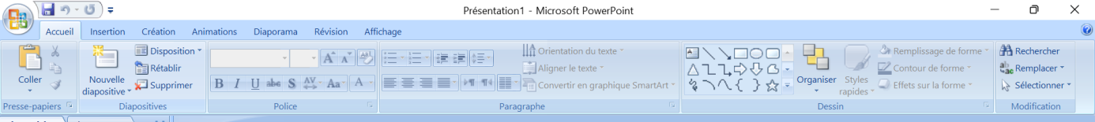

* ***2- Templates and Themes***: An extensive library of pre-designed templates and themes offers a visually appealing and professional starting point for any presentation. These templates are fully customizable, allowing users to adapt them to their specific branding or aesthetic preferences. Beyond the built-in options, users can also download or create custom templates.



* ***3- Flexible Layouts***: PowerPoint provides various slide layout options to organize content effectively on each slide (title slide, title and content, section header, two content, comparison, picture with caption, blank, etc.). Users can also create and save custom layouts tailored to recurring content structures. The "Slide Master" view allows for consistent design elements across all or selected slides.

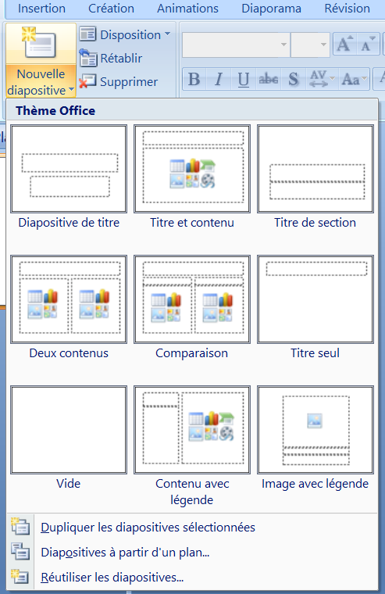

* ***4- Slide Management***: The Slide Pane offers a visual overview of all slides in the presentation, enabling easy reordering through drag-and-drop, duplication, hiding (useful for tailoring presentations to specific audiences), and deletion. The "Outline View" provides a text-based representation of the slide content, facilitating content organization and flow.



* ***5- Sections system***: For longer presentations, the sections feature allows users to organize content into logical groupings, making navigation and management significantly easier. Sections can be collapsed and expanded in the Slide Pane, and they help structure the presentation flow during delivery.

**B. Multimedia Content Integration**

* ***Text:*** PowerPoint offers advanced text formatting tools (font type, size, color, alignment, bullet points and numbering, indentation, line spacing, text boxes, WordArt for stylized text effects) to structure information clearly and legibly. Users can also adjust text box properties like shape, fill, and outline.
* ***Images/ Photos:*** Inserting images (from local files or online sources like Bing Image Search or stock photo libraries) is straightforward. PowerPoint provides basic image editing tools (corrections for brightness and contrast, colour adjustments, artistic effects, picture styles, cropping, resizing, and compressing images to reduce file size). Users can also remove image backgrounds and add borders or effects.
* ***Shapes and Smart-Art***: A wide range of pre-drawn shapes (rectangles, circles, arrows, connectors, callouts, etc.) and Smart-Art graphics (organizational charts, process diagrams, cycle diagrams, hierarchy charts, etc.) enables the visual representation of concepts and data in an engaging manner. Smart-Art graphics are easily customizable in terms of layout, colours, and text.
* ***Charts***: PowerPoint facilitates the creation of various chart types (column, line, pie, bar, area, scatter, stock, surface, radar, tree-map, sunburst, histogram, box and whisker, waterfall, funnel, map, combo) from manually entered data or data imported seamlessly from Microsoft Excel. These charts are highly customizable in terms of style, colours, labels, axes, and data series. Dynamic linking to Excel ensures charts update automatically when the source data changes.
* ***Videos and Audio***: Embedding video and audio files (from local files or online platforms like YouTube or Vimeo) enriches presentations and allows for dynamic information delivery. Playback controls, trimming, volume adjustments, and looping options are available. Background audio can be set to play across multiple slides.
* ***3D Objects and Icons***: Recent versions of PowerPoint offer the ability to insert and manipulate 3D models (from a library or imported files) and scalable vector graphics (SVG) icons to modernize and illustrate points. 3D objects can be rotated and animated for added visual impact.
* ***Links and Action Buttons***: Hyperlinks can be added to text or objects to navigate to other slides within the presentation, external websites, or specific files. Action buttons (pre-defined shapes with built-in actions like "Next Slide," "Previous Slide," "Home," "Video," etc.) provide interactive navigation elements.

**C. Animations and Transitions**:

* ***Animations***: Applying animations to individual elements on a slide (text, images, shapes) allows for the gradual revelation of content, highlighting key points, and making the presentation more dynamic and engaging. Different animation types are available, categorized as entrance, emphasis, exit, and motion paths, with various options and customization settings for each. Animation Painter allows users to easily copy animations from one object to another. The Animation Pane provides a timeline view for managing and reordering animations.

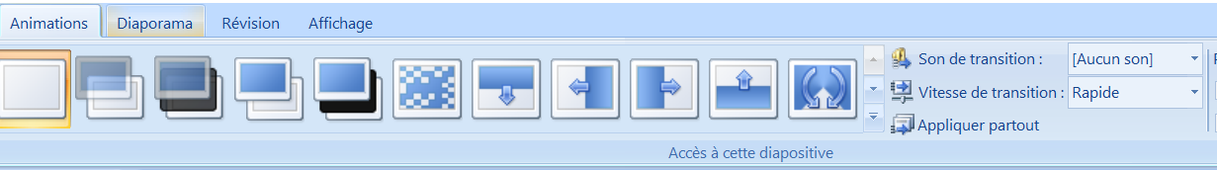

* ***Transitions***: Transitions are visual effects that occur when moving from one slide to the next. They contribute to the flow and visual appeal of the presentation, maintaining audience attention. A wide variety of transition effects are available (fade, wipe, push, split, reveal, random bars, shape, uncover, zoom, etc.), with options to control their speed, direction, and sound.

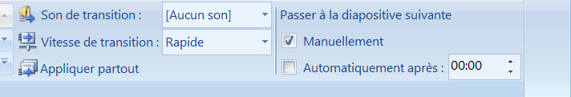

**D. Presentation Tools**:

* ***Presenter View***: This invaluable feature allows the presenter to see their notes, the next slide, elapsed time, and other controls on their monitor while the audience only sees the current slide projected. Presenter View enhances delivery confidence and engagement.
* ***Inking and Annotation***: During a presentation, the presenter can use digital inking tools (pen, highlighter) to annotate directly on the slides in real-time, emphasizing important points, drawing attention to specific areas, or responding to audience questions. Annotations can be saved or discarded after the presentation.
* ***Slide Recording***: PowerPoint enables the recording of audio and/or video narration along with slide timings and ink annotations to create self-running presentations or training materials. This is particularly useful for asynchronous communication or online learning.
* ***Rehearse Timings***: This feature allows presenters to practice their delivery and automatically record the duration spent on each slide, ensuring a smooth and well-paced presentation. The recorded timings can then be used for automatic slide advancement.
* ***Polls and Q&A***: Integration with Microsoft Forms allows presenters to embed interactive polls and Q&A sessions directly into their presentations, fostering audience engagement and gathering feedback in real-time.

**E. Collaboration and Sharing**

* ***Real-time Collaboration***: Integration with OneDrive and SharePoint enables multiple users to work simultaneously on the same presentation, with changes being automatically synced. Co-authors can add comments and track revisions.
* ***Easy Sharing***: PowerPoint offers various sharing options, including sending via email, sharing a link with different permission levels (view only, edit), and presenting online via Microsoft Teams or other platforms.
* ***Exporting to Different Formats***: Presentations can be exported to a wide range of formats, including PDF (for easy sharing and printing), video (MP4, WMV) with or without narration and timings, images (JPEG, PNG) of individual slides, animated GIFs, and as a self-running slideshow (PPSX).
* ***Version History***: When stored on OneDrive or SharePoint, PowerPoint presentations benefit from version history, allowing users to review and revert to previous versions of the file.

**Conclusion**

In conclusion, Microsoft PowerPoint is far more than just a tool for creating slideshows. It is a comprehensive and versatile platform that empowers users to structure, illustrate, and deliver information in an effective and engaging manner. Its rich feature set, ease of use, seamless integration with the Microsoft ecosystem, and adaptability to various contexts make it an invaluable asset for anyone seeking to communicate their ideas with impact and professionalism in today's professional and academic landscape. Mastering PowerPoint is therefore an essential skill in the modern world.