APPROACHES IN ESP COURSE
- LANGUAGE-CENTRED APPROACH: (PERFORMANCE)
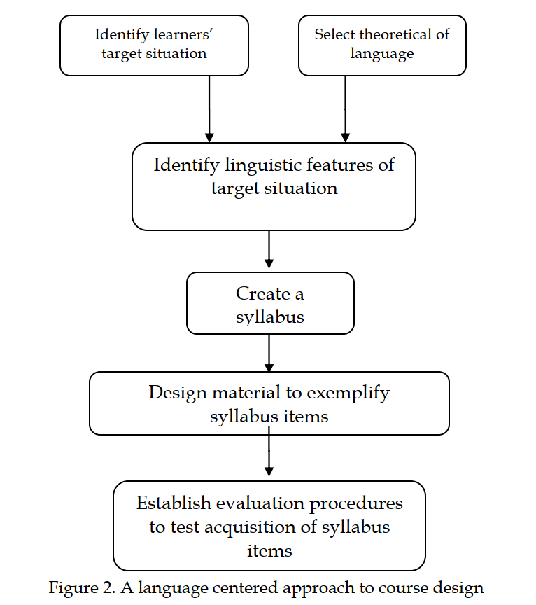

- SKILLS-CENTRED APPROACH (COMPETENCE)
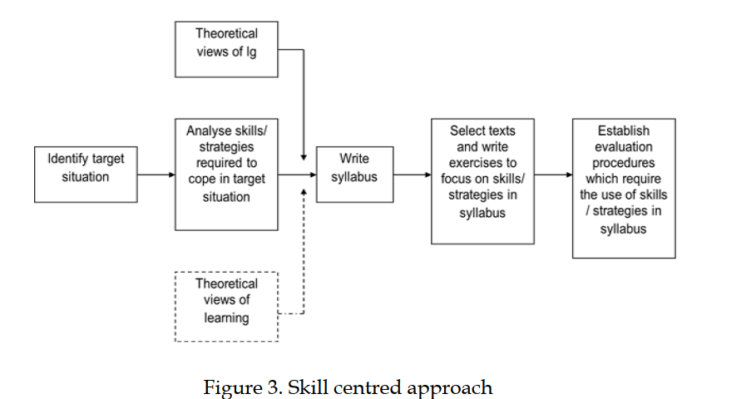
3. Learner-centred approach
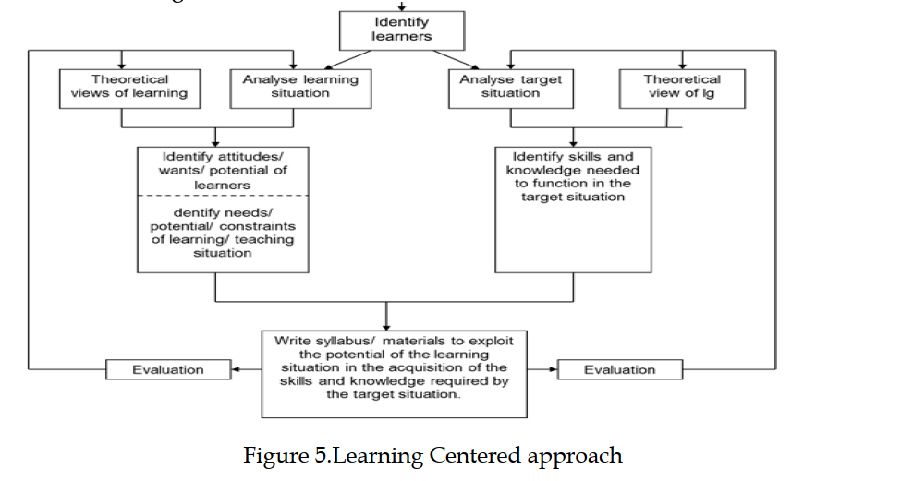

INTEGRATED APPROACH
