Mohammed Lamine Debbaguine University
English Department
Module: Phonetics Level 1st year LMD

Chapter Seven: Approximants
7.2 The consonant l
Laterals are sounds where the air escapes around the sides of the tongue. There is only one lateral in English, [l], a voiced alveolar lateral.
We find l initially, medially and finally, and its distribution is therefore not particularly limited.
In BBC pronunciation, the consonant has one unusual characteristic: the realization of l found before vowels sounds quite different from that found in other contexts.
Phoneme l
Allophone “Clear l”  is pronounced with the top of the tongue raised | Allophone “Dark l”  it is the back of the tongue which is raised.
Occurs before vowels, light, long, | In the other cases eg: ill, heal
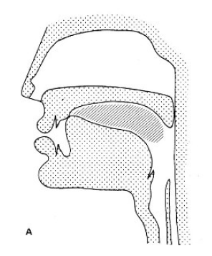 | 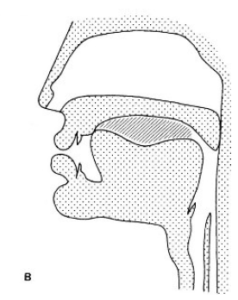

  - Approximants are sounds where the tongue only approaches the roof of the mouth, so that there is not enough obstruction to create any friction. English has three approximants, which are all voiced.

alveolar | palatal | velar
[r] | [j] | [w]
right, brown, sometimes called post-alveolar, because it is slightly further back that the other alveolar sounds [t,d,s,l]. | use, youth, | why, twin, square. [w] always has lip-rounding as well, and therefore it is sometimes called labio-velar.

- The semivowels or glides /w/ and /j/ are phonetically similar to vowels, but phonologically they behave like consonants because they precede vowels in syllables and require the indefinite article “a” rather than “an”.
e.g. A young man /j/
a wet carpet /w/
- /l, r/ are also called liquids
- [r] only occurs before vowels in southern British English, whereas other accents, e.g. Scottish, Irish, and most American ones, also can have it after vowels. Therefore those accents can make a distinction between e.g. saw and sore, which are pronounced exactly alike in southern British English.
- The important thing about the articulation of r is that the tip of the tongue approaches the alveolar area but never actually makes contact with any part of the roof of the mouth. This is, of course, very different from the "r-sounds" of many other languages where some kind of tongue-palate contact is made. The tongue is in fact usually slightly curled backwards with the tip raised; consonants with this tongue shape are usually called retroflex.
- The tongue tip is not raised and the tongue is not curled back. The "curling- back" process usually carries the tip of the tongue to a position slightly further back in the mouth than that for alveolar consonants such as t, d, which is why this approximant is called "post-alveolar".
- One final characteristic of the articulation of r is that it is usual for the lips to be slightly rounded.

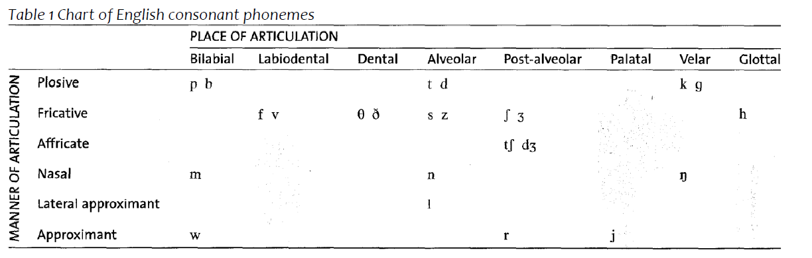
Exercise 01 : transcribe the following words:
Airing rewrite terrorist arrow
Herring mirror roaring year
Yown way wear you
Exercise 02: Give the spelling forms to the following words
