***Lesson 02 : prononciation of final ed***

***Miss : Laouamen. f***

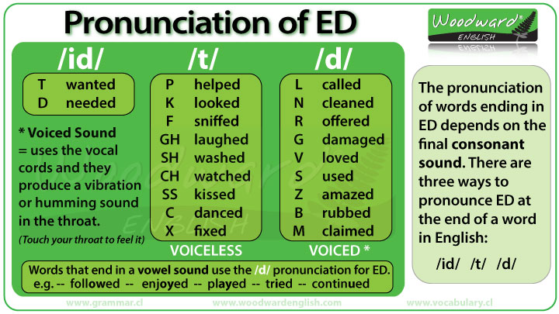

***Exercise :***  classify the following words according to the final ed.

Enjoyed , looked , showed , worked , suffered , loved , waited , liked , finished , cleaned , rained , smiled , learned , helped , chewed , appeared , warmed , expelled , deserved

|  |  |  |
| --- | --- | --- |
| /D/ | /T/ | /ID / |
|  |  |  |