**WORD**

1. **Introduction to Microsoft Word**

Microsoft Word is a comprehensive word processing program that allows users to create, edit, format, and share text documents. It is a vital tool for professionals, students, and individuals who need to produce high-quality documents. Let's delve deeper into the key features and functionalities of Word.

1. **Getting Started with the Interface**

When you launch Microsoft Word, you'll encounter a user-friendly interface designed to facilitate document creation and editing. Here are the main components:

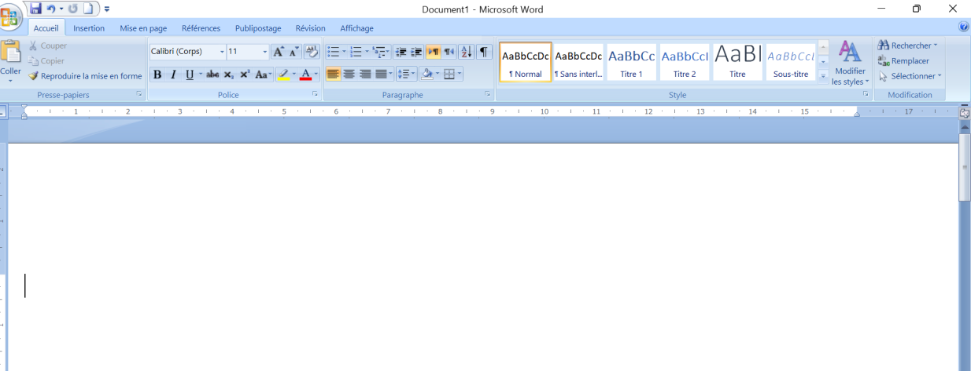

- **Ribbon**: The Ribbon is located at the top of the window and consists of multiple tabs, each containing related groups of commands and tools. Common tabs include:

- **Home**: Basic text formatting, clipboard functions, and style options.

- **Insert**: Options to add tables, pictures, shapes, charts, headers, footers, etc.

- **Design**: Tools to modify the overall design and theme of the document.

- **Layout**: Page setup options including margins, orientation, and spacing.

- **References**: Features for adding citations, bibliographies, and tables of contents.

-**Review**: Tools for proofreading, including spell check, grammar check, and comments.

- **View**: Options to change the document view and manage windows.

- **Quick Access Toolbar**: A customizable toolbar that provides quick access to frequently used commands, such as Save, Undo, and Redo.

-**Document Area**: The main workspace where you enter and edit text. This area dynamically displays the content of your document.

- **Status Bar**: Located at the bottom of the window, the status bar provides information such as page number, word count, and language.

1. **Creating and Managing Documents**

Creating a document in Word is straightforward. You can start with a blank document or choose from various templates to suit your needs, such as resumes, letters, reports, and flyers.

* **Creating a Document**

- **Blank Document**: Click on "New" and select "Blank Document" to start from scratch.

- **Saving a Document**:

- **Save**: Save your document by clicking the Save icon or using the keyboard shortcut (Ctrl +

S). Choose a location on your computer or cloud storage (OneDrive). 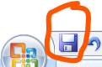

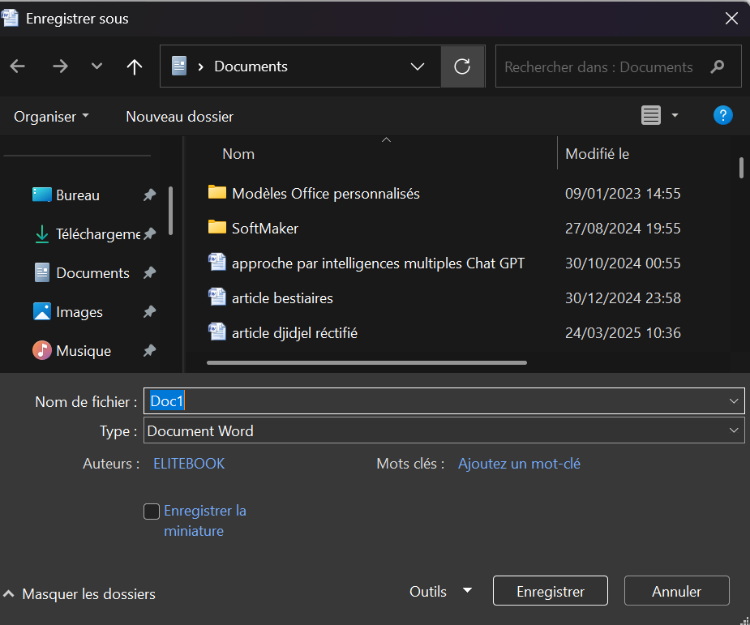

-choose a name of the document

Choose the type of the document

Choose a location: desktop, documents, donlowns, photos, vidéos, local disk ©, disk D, drive…

* **Opening and Closing Documents**

- **Open**: Click on "File" > "Open" to access existing documents stored on your computer or in the cloud. You can access directly to a document by clicking on his icon.

- **Close**: Close the document without exiting the application by clicking "File" > "Close." You can close a file by clicking on **×** situated at the Wright of the page.

- **Managing Versions**: Word supports version history, allowing you to review and revert to previous versions of your document. This is particularly useful for collaborative projects.

* **Formatting Text and Layout**

Formatting text enhances the readability and appearance of your document. Word provides an extensive array of formatting options:

a- **Font** :

- **Font Size**: Adjust the size of the text to improve readability.

- **Font Styles**: Apply styles such as bold, italic, underline, and strikethrough for emphasis.

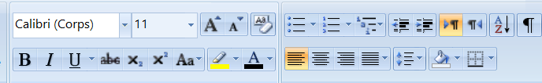

B Bold

*I Italic*

U Underline

~~Abc~~  strikethrough

 Augmented the size

 Lesser the size

 Create a small letter in the beyond the line of writing. Example: XX**e**

 Manipulate capital and small letters. Many choices are given to you:

* Capital letter in the beginning of the sentence
* Small letters
* Capital letters
* First letter of each word in capital
* inverting

 Online the text

 Modify the colour of the text

 Started a list of puce

 Enumeration

 Alignment of the text

 Adjust the space between lines to enhance readability Modify the interline

 Add a colour of background

B- **Styles**:

- Predefined Styles: Use predefined styles to apply consistent formatting throughout your document. This includes heading styles, body text, and quotes.

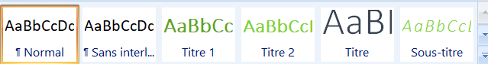

- **Custom Styles**: Create and save custom styles to suit your specific needs.

**C- Layout**:

- **Page Setup**:

Configure page margins, 

orientation (portrait or landscape), 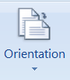

page size 

- **Columns**: Divide text into columns for newsletters, brochures, and more. 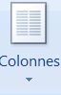

- **Manage the background** of pages by adding a watermark, a colours and borders

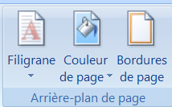

* **Inserting Images, Tables, and Charts**

Enhance your document by incorporating various visual elements:



**a-** **Insert a cover-page:** Word offers several cover pages 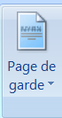

**b- Insert Images/ photos:** 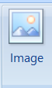

- **Inserting Images**: Add images from your computer or online sources. Click "Insert" > "Pictures" or "Online Pictures."

- **Formatting Images**: Adjust image size, position, and apply styles such as borders and effects.

**b- Tables**:

- **Creating Tables**: Insert tables to organize data in rows and columns. Click "Insert" > "Table" and choose the desired dimensions. 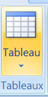

- **Formatting Tables**: Customize table design, including borders, shading, and cell alignment. Use table styles for a polished look.

**c- Charts (Graphics) :**

- **Inserting Charts:** Visualize data by inserting charts. Click "Insert" > "Chart" and select the chart type (bar, line, pie, etc.).

- **Customizing Charts**: Modify chart elements such as titles, labels, and data series to fit your needs.

d- Insert a header, a footer, and page numbers: 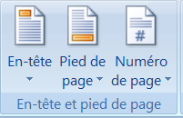

e- Insert an equation or a symbol: 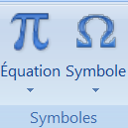

* **Printing and Sharing Options**

Once your document is ready, you have several options for printing and sharing:

**a- Printing:**

- Print Preview: Before printing, use Print Preview to see how your document will look on paper. Click "File" > "Print."

- Print Settings: Adjust print settings such as print range (specific pages), number of copies, and orientation.

**b- Sharing:**

- Email: Share your document via email directly from Word. Click "File" > "Share" > "Email."

- Cloud Services: Save and share your document using cloud services like OneDrive. Collaborate with others in real-time by generating a shareable link.

**c- Exporting:**

- **Save as PDF**: Save your document in PDF format for easy sharing and compatibility. Click "File" > "Save As" and choose PDF.

- **Other Formats**: Export your document to other formats such as HTML, plain text, or XML as needed.