is known as the glottis. There are four positions of the glottis which determine to some extent the nature of the sound. The positions of the glottis will be tackled in the next chapter.
2. The articulatory system (Vocal tract) Figure (Fig) 2.1 below shows the articulators.
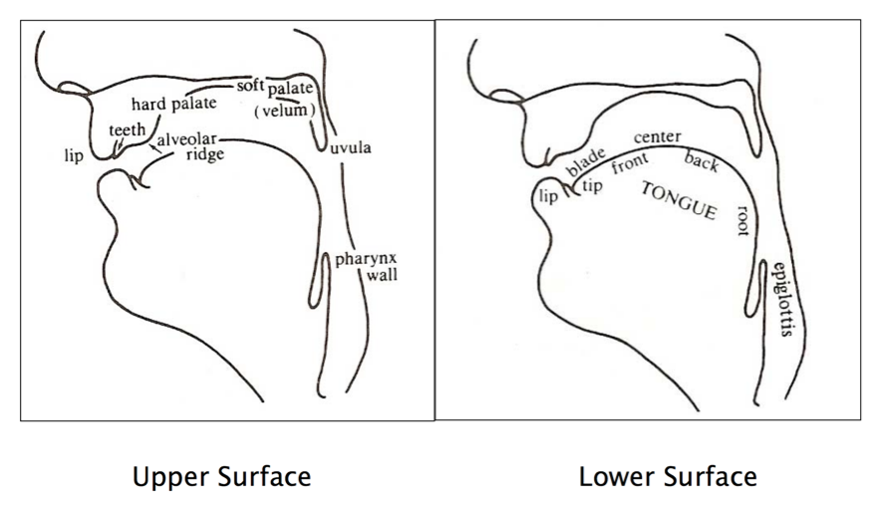Fig 2.1 The Articulators
The lips and the teeth are familiar-enough structures. Just behind the upper teeth is a small bumpy surface which is called the alveolar ridge which is followed by a larger bony structure which is the hard palate. At the back of the mouth with the fingertip or the tongue curled up, you can feel the soft palate or velum which is a muscular flap that opens and closes the passage that links the pharynx to the nasal cavity. At the lower end of the soft palate is a small organ hanging down that is known as the uvula. The part of the vocal tract between the uvula and the larynx is the pharynx. In the lower part of the vocal tract lies the tongue which is divided into the tip, the blade, the front, the centre then the back and finally the root as shown in the right side of fig 1 above.
The consonants produced by different articulators are labeled according to the organ which moved to produce them. The consonants produced with the lips’ movements are called bilabials, and those produced with the tongue coming against the teeth, the alveolar ridge, the hard palate and the soft palate the consonants are called dental, alveolar, palatal and velar sounds respectively. The sound produced by keeping the vocal folds spread somewhat or pressing the folds together is called the glottal.

