ICT/ICTE
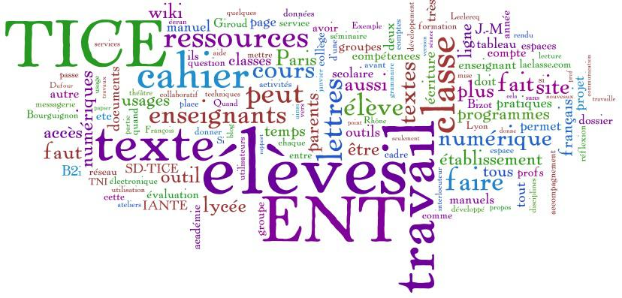

The terms ICT and ICT E (or ICT in Education) refer to different aspects of Information and Communication Technology. Here are the key differences:
1. Definition
- ICT (Information and Communication Technology)
- Refers broadly to all technologies that facilitate communication and the processing of information. This includes hardware (computers, smartphones), software (applications, operating systems), networks (the Internet, telecommunications), and other tools used in various sectors (business, healthcare, entertainment, etc.).
Information and Communication Technologies (ICT) represents all the means or equipment (hardware and software or programs) ensuring the automatic processing of Information The term automatic data processing means:
a- Calculation (arithmetic i.e. using arithmetic operators: +,-, /,* and calculation
logic for propositions i.e. using logical operators: AND, OR, IF, NO...)
b- Data management and recording.
c- Communication and exchange of data: the transmission and reception of news.
The advent of the Internet, and mainly the Web, as a medium for the masses and the success of the blogs, wikis or Peer to Peer technologies give ICTs a societal dimension. - ICT is also referred to as "new information and communication technologies".
- (NICT) which is a term used in the 1990s, to differentiate the Internet-based technologies of traditional means of telecommunication. - Moreover, these technologies are no longer really new, given the speed of evolution of ICTs hence the name ICT. - The corresponding English acronyms are IT, for "Information Technology" and NICT, for " New Information and Communication Technology/Technologies" or ICT for " Information Communication Technology/Technologies".
What does it include?
ICT brings together a set of resources necessary to manipulate information and
computers, programs and networks needed to convert it,
store
manage it, transmit it and find it.
ICT can be grouped into the following sectors:
  - Computer equipment, servers, computer equipment (PC, printer, switch, etc.);
  - Microelectronics and components (transistor, diode, integrated circuit, etc.);
  - Telecommunications and computer networks;
  - Multimedia;
  - IT services and software
  - E-commerce and electronic media.

ICT uses and applications
- Administration and governance;
- Education;
- Training;
- Health;
- Commerce: Websites can be used to make online purchases;
- Geolocation;
- Transport: Electronic ticketing and online booking
- Environment…

Communication tools: The most important and the most used are
- Email Communication : The exchange of messages via electronic mail services.
(Gmail, Outlook, Yahoo Mail).It’s used in Professional correspondence, announcements, and document sharing. It’s Fast, organized, and widely accepted for formal communication.

Instant Messaging (IM) Real-time text communication through applications (WhatsApp, Messenger, Slack, Telegram).
It’s quick updates, allow group chats, and enhausse collaboration in teams. it’s main advantages are : Instant feedback, supports multimedia sharing, and works globally.

Video Conferencing: Live video communication over the internet.
( Zoom, Microsoft Teams, Google Meet, Skype).
It’s used in Online meetings, virtual classrooms, and interviews.
This kind of communication facilitates face-to-face communication remotely, allows screen sharing, and supports large groups of participants.

Social Media Platforms: Websites and applications for sharing content and interacting with others.(Facebook, Instagram, Twitter, TikTok, LinkedIn). They are used in Social networking, brand promotion, news sharing, and collaborative learning.They allowed to reaches large audiences, encourages engagement, and provides multimedia capabilities.

Online Learning Platforms: Platforms for delivering educational content digitally (Moodle, Coursera, Udemy, Edmodo). They are employed in Online courses, training programs, and virtual classrooms. The most important characteristics of these tools are: Flexible, scalable, and supports multimedia learning.
ICT E (ICT in Education)
- Specifically focuses on the application of ICT in educational contexts. This includes the use of technology to support teaching, learning, and educational administration. It encompasses e-learning platforms, educational software, digital resources, and tools that enhance the learning experience.
TICE tools

1. Learning Management Systems (LMS)
Learning Management Systems are essential tools for managing online education. Moodle, for instance, is an open-source platform that allows teachers to create courses, share content, and track students’ progress. Similarly, Google Classroom simplifies classroom management by distributing assignments, collecting work, and maintaining communication between students and teachers. Platforms like Blackboard and Canvas are widely used in higher education to organize classes and assessments efficiently.

2. Tools for Creating Educational Content
Tools like H5P enable educators to design interactive learning materials such as quizzes, interactive videos, and presentations. Prezi stands out for creating dynamic, non-linear presentations that capture attention. For more diverse and engaging content, Genially is ideal, offering options like infographics and interactive lessons. Software like Camtasia is particularly useful for recording educational videos and tutorials.

3. Communication and Collaboration Tools
In the digital age, communication tools are vital for connecting students and teachers. Zoom offers robust options for video conferencing, screen sharing, and interactive whiteboards. Microsoft Teams combines chat, video calls, and file sharing in a collaborative space, while Slack is ideal for organized discussions through dedicated channels. Discord, initially designed for gamers, has evolved into a powerful tool for collaborative education.

4. Tools for Assessments and Evaluations
Platforms like Kahoot! and Quizizz gamify assessments, making quizzes interactive and engaging. Google Forms allows teachers to create surveys and gather feedback or test results quickly. For real-time assessments, Socrative enables the creation of interactive quizzes, tracking student responses and understanding.

5. Educational Content Resources
Platforms like Khan Academy provide free online courses in various disciplines, helping both teachers and students. Open Educational Resources (OER) serve as a repository of free and open learning materials. Edpuzzle lets educators turn videos into interactive lessons by embedding questions. Similarly, TED-Ed combines inspirational video content with tools to build educational lessons.

6. File Sharing and Cloud Storage Tools
Tools like Google Drive make it easy to store and share files while collaborating in real-time. Dropbox is another popular choice for file sharing and syncing between devices. OneDrive, integrated into Microsoft 365, ensures seamless storage and sharing options for teachers and students.

7. Interactive Whiteboards and Collaborative Tools
Digital whiteboards are vital for brainstorming and visual teaching. Jamboard, from Google, serves as an interactive whiteboard for collaborative lessons. Miro is another robust platform for organizing ideas visually. Microsoft Whiteboard provides an intuitive space for drawing and note-taking during virtual meetings. Explain Everything enhances lesson delivery with its interactive visual tools.

8. Tools for Language Learning
Several tools are designed to improve language acquisition. Duolingo gamifies the process of learning new languages. Quizlet helps learners build vocabulary through customizable flashcards and games. Memrise supports language learning with video-based and spaced-repetition exercises. AI-based tools like ChatGPT simulate conversations and provide language practice opportunities.

9. Tools for Creativity and Expression
Platforms like Canva enable students and teachers to create visually appealing presentations, posters, and infographics. Book Creator allows users to write and publish digital books. Padlet provides a collaborative digital wall for sharing ideas and resources, while Storybird encourages creative writing by letting users illustrate their stories online.

10. Tools for Virtual Reality (VR) and Augmented Reality (AR)
Immersive technologies like VR and AR enhance experiential learning. Nearpod integrates interactive simulations and virtual field trips into lessons. ClassVR is specifically designed for educational VR experiences, allowing students to explore subjects in an immersive way. Google Expeditions offers virtual tours of historical sites, museums, and natural wonders.

11. Tools for Programming and Digital Skills
Introducing programming to students is made easier with tools like Scratch, a visual language that helps beginners understand coding. Code.org is widely used for teaching computer science basics. Tynker is another excellent tool for teaching children coding skills through fun challenges. For more advanced collaborative coding, Replit provides a shared environment for real-time programming.

12. AI Tools for Education
Artificial intelligence is revolutionizing education. ChatGPT can simulate discussions, provide writing feedback, and answer student queries, making it a valuable educational assistant. Grammarly helps students improve their writing by checking grammar and suggesting improvements. Speechify converts text into speech, supporting learners who prefer audio-based materials. ScribeSense digitizes handwritten assignments and grades them automatically, saving time for teachers.
Conclusion
While ICT refers to the broad field of information and communication technologies applicable across various domains, ICT E is a subset that focuses specifically on the application of these technologies in education.

