WORD
- Introduction to Microsoft Word
Microsoft Word is a comprehensive word processing program that allows users to create, edit, format, and share text documents. It is a vital tool for professionals, students, and individuals who need to produce high-quality documents. Let's delve deeper into the key features and functionalities of Word.
- Getting Started with the Interface
When you launch Microsoft Word, you'll encounter a user-friendly interface designed to facilitate document creation and editing. Here are the main components:
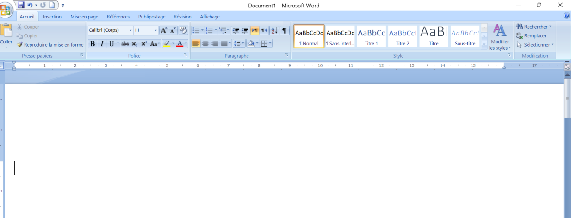
- Ribbon: The Ribbon is located at the top of the window and consists of multiple tabs, each containing related groups of commands and tools. Common tabs include:
- Home: Basic text formatting, clipboard functions, and style options.
- Insert: Options to add tables, pictures, shapes, charts, headers, footers, etc.
- Design: Tools to modify the overall design and theme of the document.
- Layout: Page setup options including margins, orientation, and spacing.
- References: Features for adding citations, bibliographies, and tables of contents.
-Review: Tools for proofreading, including spell check, grammar check, and comments.
- View: Options to change the document view and manage windows.
- Quick Access Toolbar: A customizable toolbar that provides quick access to frequently used commands, such as Save, Undo, and Redo.
-Document Area: The main workspace where you enter and edit text. This area dynamically displays the content of your document.
- Status Bar: Located at the bottom of the window, the status bar provides information such as page number, word count, and language.
- Creating and Managing Documents
Creating a document in Word is straightforward. You can start with a blank document or choose from various templates to suit your needs, such as resumes, letters, reports, and flyers.
- Creating a Document
- Blank Document: Click on "New" and select "Blank Document" to start from scratch.

- Saving a Document:
- Save: Save your document by clicking the Save icon or using the keyboard shortcut (Ctrl +

S). Choose a location on your computer or cloud storage (OneDrive). 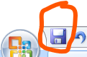

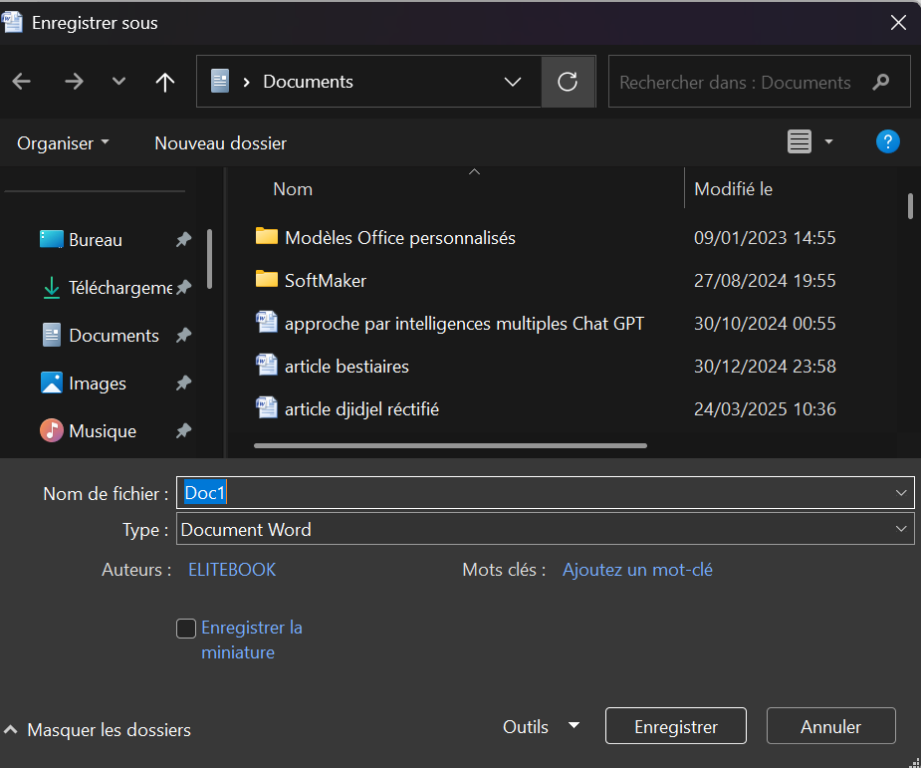
-choose a name of the document
Choose the type of the document
Choose a location: desktop, documents, donlowns, photos, vidéos, local disk ©, disk D, drive…
- Opening and Closing Documents
- Open: Click on "File" > "Open" to access existing documents stored on your computer or in the cloud. You can access directly to a document by clicking on his icon.
- Close: Close the document without exiting the application by clicking "File" > "Close." You can close a file by clicking on × situated at the Wright of the page.
- Managing Versions: Word supports version history, allowing you to review and revert to previous versions of your document. This is particularly useful for collaborative projects.
- Formatting Text and Layout
Formatting text enhances the readability and appearance of your document. Word provides an extensive array of formatting options:
a- Font :
- Font Size: Adjust the size of the text to improve readability.
- Font Styles: Apply styles such as bold, italic, underline, and strikethrough for emphasis.
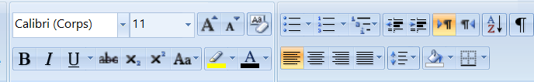
B Bold
I Italic
U Underline
Abc strikethrough
Augmented the size
Lesser the size
Create a small letter in the beyond the line of writing. Example: XXe
Manipulate capital and small letters. Many choices are given to you:
- Capital letter in the beginning of the sentence
- Small letters
- Capital letters
- First letter of each word in capital
- inverting
Online the text
Modify the colour of the text

Started a list of puce
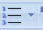 Enumeration

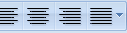
Alignment of the text

 Adjust the space between lines to enhance readability Modify the interline

Add a colour of background

B- Styles:
- Predefined Styles: Use predefined styles to apply consistent formatting throughout your document. This includes heading styles, body text, and quotes.
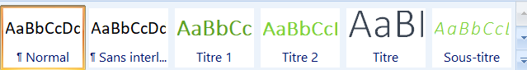
- Custom Styles: Create and save custom styles to suit your specific needs.
C- Layout:
- Page Setup:
Configure page margins, 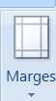

orientation (portrait or landscape), 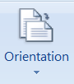
page size 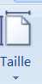
- Columns: Divide text into columns for newsletters, brochures, and more. 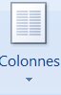
- Manage the background of pages by adding a watermark, a colours and borders
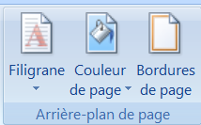

- Inserting Images, Tables, and Charts
Enhance your document by incorporating various visual elements:
a- Insert a cover-page: Word offers several cover pages 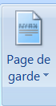

b- Insert Images/ photos: 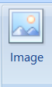

- Inserting Images: Add images from your computer or online sources. Click "Insert" > "Pictures" or "Online Pictures."
- Formatting Images: Adjust image size, position, and apply styles such as borders and effects.
b- Tables:
- Creating Tables: Insert tables to organize data in rows and columns. Click "Insert" > "Table" and choose the desired dimensions. 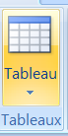
- Formatting Tables: Customize table design, including borders, shading, and cell alignment. Use table styles for a polished look.
c- Charts (Graphics) :
- Inserting Charts: Visualize data by inserting charts. Click "Insert" > "Chart" and select the chart type (bar, line, pie, etc.).
- Customizing Charts: Modify chart elements such as titles, labels, and data series to fit your needs.
d- Insert a header, a footer, and page numbers: 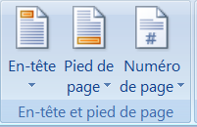
e- Insert an equation or a symbol: 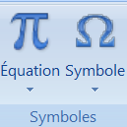
- Printing and Sharing Options
Once your document is ready, you have several options for printing and sharing:
a- Printing:
- Print Preview: Before printing, use Print Preview to see how your document will look on paper. Click "File" > "Print."
- Print Settings: Adjust print settings such as print range (specific pages), number of copies, and orientation.
b- Sharing:
- Email: Share your document via email directly from Word. Click "File" > "Share" > "Email."
- Cloud Services: Save and share your document using cloud services like OneDrive. Collaborate with others in real-time by generating a shareable link.
c- Exporting:
- Save as PDF: Save your document in PDF format for easy sharing and compatibility. Click "File" > "Save As" and choose PDF.
- Other Formats: Export your document to other formats such as HTML, plain text, or XML as needed.

