Mohammed Lamine Debaghine University Setif 2
English Department
Module: Phonetics Level 1st year LMD
Teacher: Mrs Tiaiba Imane
Chapter Three: English Long Vowels, Diphthongs and Triphthongs

- In this chapter we look at other types of English vowel sound. The first to be introduced here are the five long vowels; these are the vowels which tend to be longer than the short vowels in similar contexts.
- To remind you that these vowels tend to be longer, the symbols consist of one vowel symbol plus a length mark made of two dots We will now look at each of these long vowels individually
- The five long vowels are different from the six short vowels described in Chapter 2, not only in length but also in quality.
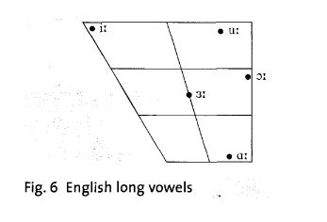
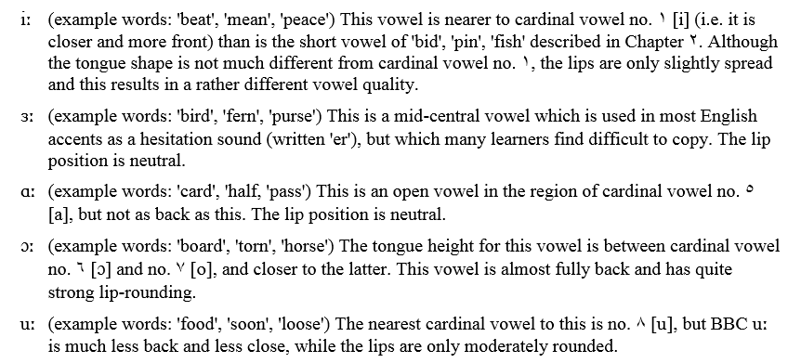
2 DIPHTHONGS
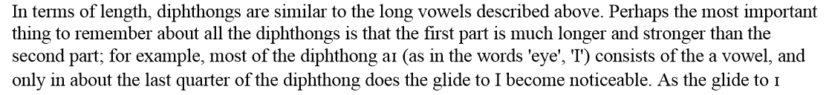
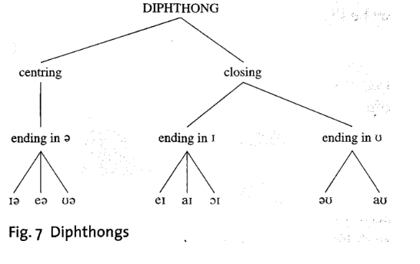
Centring Diphthongs:
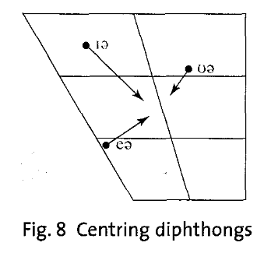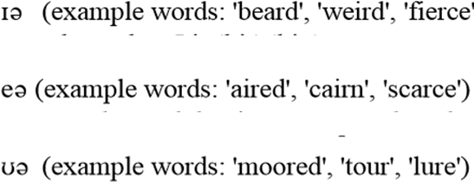

Closing Diphthongs:
Towards u | Towards i
 | 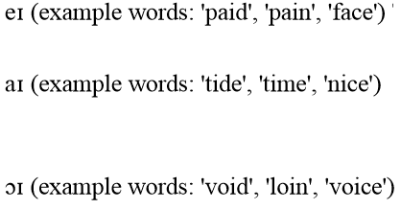

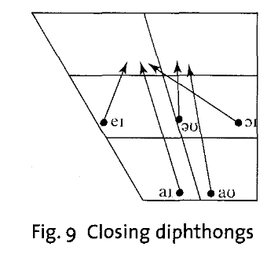
Triphthongs
The most complex English sounds of the vowel type are the triphthongs. They can be rather difficult to pronounce, and very difficult to recognise. A triphthong is a glide from one vowel to another and then to a third, all produced rapidly and without interruption.
Examples:
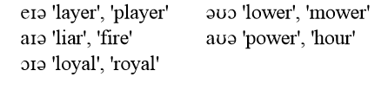
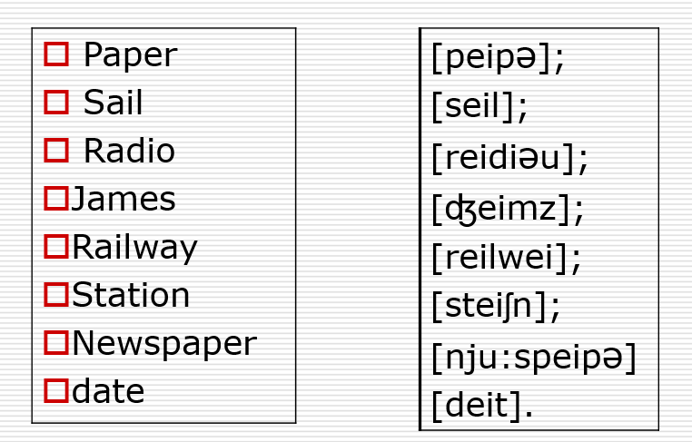
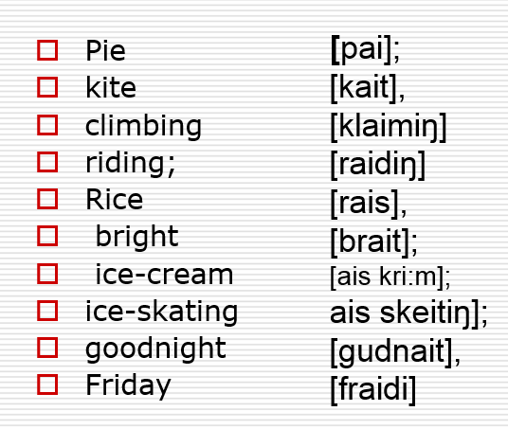
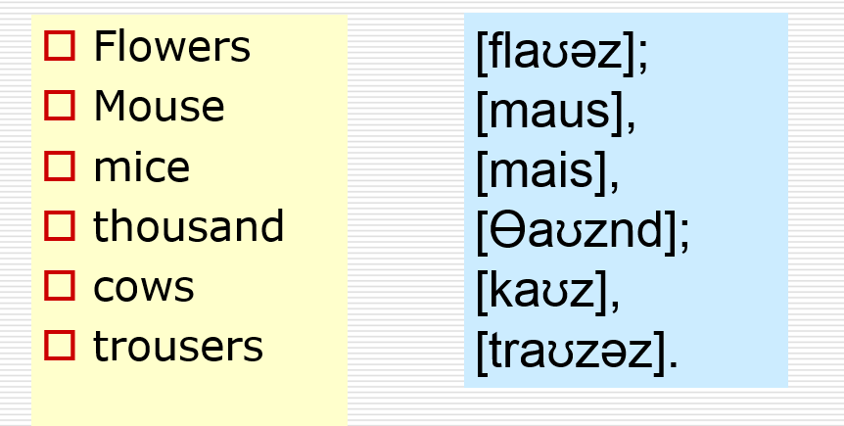
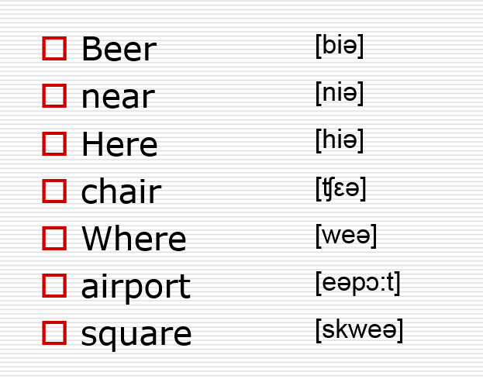

transcription | spelling | transcription | spelling

