Mohammed Lamine Debbaguine University- Setif02
English Department
Module: Phonetics Level: 1st year LMD

Chapter Seven: Nasals

- The basic characteristic of nasal consonants is that the air escapes through the nose.
- The soft palate is lowered. The air cannot pass through the mouth, it is prevented by complete closure in the mouth at some point.
- The three types of closure are
 | bilabial | alveolar | velar
Voiced /lenis | m | n | Ƞ
 | The soft palate is lowered. The lips are slightly spread, pressed together forming a complete obstruction to the air stream through the oral cavity. The air passes through the nose. | The soft palate is lowered, the tip of the tongue touches the alveolar ridge, forming a complete obstruction to the flow of air through the oral cavity. The air passes through the nose. | A closure is formed in the mouth between the back of the tongue and the velum as for /k/ and /g/. The soft palate is lowered.

- The consonants m, n are simple and straightforward with distributions quite similar to those of the plosives. There is in fact little to describe.
- The consonant m, n can occur initially, medially or finally.
Eg: men, imagine, calm
Nail, enjoy, fun
- [ŋ]: Symbol called engma or long n
- [ŋ] can end words (sing [sɪŋ]; lung [lʌŋ], bang [beŋ], etc.) or appear in the middles of words (singer [sɪŋɚ], sinker [sɪŋkɚ], languid [leŋgwɪd]), but [ŋ] cannot begin words.
- /η/ occurs before a following g or k

- When we find the letters nk, k is always pronounced
e.g. think, bank
- /η/ is pronounced with the following plosive g if the word cannot be divided into two morphemes: verb + ending and not pronounced if the word can be divided into a verb + ending
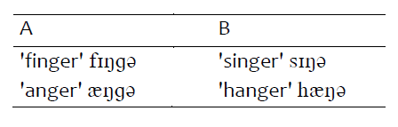
- We can say that within a word containing the letters 'ng' in the spelling ᵑ occurs without a following g if it occurs at the end of a morpheme; if it occurs in the middle of a morpheme it has a following of g
- words ending orthographically with 'ng’ , ᵑ is not followed by g eg sing /si η /

- g is also pronounced after /η/ before suffixes -er and -est of comparative and superlative degrees of adjectives
longer – the longest
Exerises:
1- Give the spelling forms to the following words
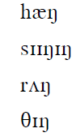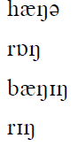
2- transcribe the following words:

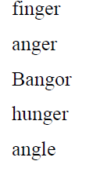

Column
Biggest
Knowing
Working
Enjoy
comb

